

Pedro Bobião Costa

**RTLS Tag – Dispositivo móvel de posicionamento em espaços interiores**

RTLS Tag – Indoor mobile positioning device



Pedro Bobião Costa

**RTLS Tag – Dispositivo móvel de posicionamento em espaços interiores**

RTLS Tag – Indoor mobile positioning device

Dissertação de Mestrado

Mestrado Integrado em Engenharia e Gestão de Sistemas de Informação

Ano Letivo 2021/2022 – 5º Ano Curricular

Trabalho efetuado sob a orientação dos

**Professor Adriano Moreira**

**Professor Filipe Meneses**

RTLS TAG – DISPOSITIVO MÓVEL DE POSICIONAMENTO EM ESPAÇOS INTEREIORES

RESUMO

Quando se refere o conceito de serviços móveis, umas das classes mais populares são os serviços baseados na localização (LBS), uma vez que estes têm um grande impacto nas vidas quotidianas, por exemplo quando é necessário encontrar a posição exata de uma pessoa ou objeto no mundo real. Esses serviços estão disponíveis, na sua maioria, em espaços ao ar livre, normalmente utilizando o *Global Positioning System* (GPS). O GPS apresenta benefícios diariamente, contudo, e apesar de apresentar níveis de exatidão e precisão altos, estes sistemas requerem acesso de linha de vista com os satélites em órbita, pelo que em espaços interiores o sinal fica comprometido. Desta forma, as técnicas de posicionamento para ambientes interiores estão a tornar-se num segmento de mercado que proporciona novas oportunidades de negócios.

O objetivo deste estudo é desenvolver um pequeno dispositivo (designado por *tag*), que incorpore as tecnologias Wi-Fi e BLE e traga uma solução para o problema de Localização *Indoor*. Entre outros, o trabalho inclui uma revisão de literatura sobre a localização *indoor*, sobre as diferentes técnicas existentes, uma análise comparativa de algoritmos, uma análise de tecnologias, a exploração de soluções no mercado e análises comparativas de desempenho e aplicações, e a proposta de uma nova *tag* e a sua avaliação. Para tanto, seguiram-se as orientações de um método de pesquisa, contemplando quatro etapas: familiarização com a área de posicionamento e navegação em espaços interiores, identificação de características desejáveis (ótimas) para a *tag* e possíveis soluções de *hardware*, desenvolvimento da *tag* (*hardware* e programação) e avaliação do desempenho da solução desenvolvida. Espera-se que esta nova *tag* permita um melhor desenvolvimento da localização *indoor*, ultrapassando a dificuldade sentida em outras soluções e respondendo à necessidade de um produto de localização *indoor*, potenciando uma maior capacidade.

**Palavras-chave**: *Fingerprinting*; Localização *Indoor*, *Bluetooth Low Energy* e Wi-Fi

RTLS TAG – INDOOR MOBILE POSITIONING DEVICE

ABSTRACT

Regarding mobile services, one of the most popular classes is location-based services (LBS), as they significantly impact everyday lives, for example when it is necessary to find the exact position of a person or object in the real world. These services are primarily available outdoors, typically using the Global Positioning System (GPS). GPS has benefits daily, however, and despite high accuracy and precision, these systems require line-of-sight access to orbiting satellites, and therefore, indoors, the signal is compromised. As a consequence, positioning techniques for indoor environments are becoming a market segment that provides new business opportunities.

This study aims to develop a small device (named tag) that incorporates the Wi-Fi and BLE technologies and brings a solution to the problem of Indoor Localisation. Among others, the work includes a literature review about indoor localisation, the different existing techniques, a comparative analysis of algorithms, an analysis of technologies, the exploration of solutions on the market and comparative analysis concerning performance and applications, and the proposal of a new tag and its evaluation. To this end, the orientations of a research method were followed, contemplating four steps: familiarisation with the area of positioning and navigation in indoor spaces; identification of desirable (optimal) characteristics for the tag and possible hardware solutions; tag development (hardware and programming) and performance evaluation of the developed solution. It is expected for this new tag to allow better development of indoor localization systems, overcoming the difficulty felt in other solutions and responding to the need for an indoor localisation product, enhancing more excellent capability.

**Keywords**: Fingerprinting; Indoor Localisation, Bluetooth Low Energy and Wi-Fi

ÍNDEX

1. Introduction 1

1.1. Project Context and Motivation 1

1.2. Project Objectives, Success Criteria and Expected Results 1

1.3. Document Structure 1

2. Literature Review 3

2.1. Research Strategy 3

2.2. Tools 3

2.3. State of the Art 4

2.3.1. Indoor Localisation 4

2.2.2 Indoor Positioning Techniques 5

2.3.3. Signal Properties 6

2.3.4. Positioning Algorithms 10

2.2.5 Indoor Localisation Technologies 11

2.2.6 Performance 15

2.2.7 Applications 16

2.4. Critical View of State of the Art 18

3. Case Study 20

3.1. RLTS Tag – Specifications and Requirements 20

3.2. RLTS Tag – Core Skills 21

3.3. Microcontroller Boards Selection 22

3.4. Flash Powerbank 2200mAh 24

4. Demonstration 27

4.1. Programming the ESP32 27

4.2. Partition Schemes 31

4.3. Apache Server Implementation 32

4.4. Interface Communication 35

4.5. Testing with Postman 38

4.6. Use Cases 39

4.7. Negative Response Codes 40

4.8. Exception Stack Trace Decoder 42

5. Evaluation 45

5.1. Test Environment 45

5.2. Test Case 45

5.3. Testing 46

6. Activity Plan 86

6.1. Gantt chart 86

6.2. Risk Table 87

7. Conclusion 90

7.1. Summary 90

7.2. Contributions 90

7.3. Future Research 90

LIST OF ACRONYMS

**AP** - Access Point

**BLE** - Bluetooth Low Energy

**GPS** - Global Positioning System

**IoT** - Internet of Things

**LBS** – Location-Based Services

**RSSI** - Received Signal Strength Indicator

**WLAN** - Wireless Local Area Network

**JSON** - JavaScript Object Notation

**HTTP** - HyperText Transfer Protocol

**ILS** - Internet Locator Service

**IPv4** - Internet Protocol version 4

RTLS –

AOA –

TOA –

TDOA –

GNSS –

API –

ISM –

UWB –

IMU –

PDR –

INS –

SMD –

PTH –

LIST OF FIGURES

Figure 1 - Flow diagram of Navigation 5

Figure 2 - Indoor Positioning Techniques2 6

Figure 3 - Localisation based on Angle of Arrival (AOA) measurement3 7

Figure 4 - Localisation based on Time of Arrival (TOA) measurement4 7

Figure 5 - Time Difference of Arrival (TDOA) technique5 8

Figure 6 - RSS based Fingerprinting Approach6 9

Figure 7 - 2200mAh Powerbank 24

Figure 8 - Charging the powerbank 25

Figure 9 - DFR0575 microcontroller 27

Figure 10 - Arduino Download 28

Figure 11 - Arduino Preferences 28

Figure 12 - Arduino Boards Manager 29

Figure 13 - Arduino Boards Manager 2 29

Figure 14 - Step 4 30

Figure 15 - Board connected 31

Figure 16 - Oversized Sketch 31

Figure 17 - Firebeetle32 31

Figure 18 - Arduino partition 32

Figure 19 - Apache Lounge 33

Figure 20 - Apache Command Prompt 33

Figure 21 - Apache Service 34

Figure 22 - Local server IPv4 34

Figure 23 - INDEX.html File 34

Figure 24 - Inserting the server's IPv4 35

Figure 25 - ILS Uminho Interface 36

Figure 26 - Scan data stored in the ILS server 37

Figure 27 - 200 OK Status Code 38

Figure 28 - Server Log 38

Figure 29 - No data on Post error 39

Figure 30 - Case 1 39

Figure 31 - Case 2 39

Figure 32 - Case 3 40

Figure 33 - Case 4 40

Figure 34 - Negative HTTP Response Codes 41

Figure 35 - Negative Response Codes 42

Figure 36 - Releases page 43

Figure 37 – Tools directory 43

Figure 38 - Runtime error 44

Figure 39 - Exception Decoder 44

Figure 40 - ESP32 connected to the Powerbank 45

Figure 41 - Firmware Flash 45

Figure 42 - Gantt Chart 87

LIST OF TABLES

Table 1 - Tools 3

Table 2 - Summary of Signal Properties7 9

Table 3 - Summary of Positioning Algorithms8 11

Table 4 - Preliminary Research 22

Table 5 - Outlining Possibilities 23

Table 6 - Final Decision 23

Table 7 - Powerbank Specifications 26

Table 8 - JSON Structure 36

Table 9 - Test Case Specifications 46

Table 10 - Risk Table 89

# Introduction

This chapter briefly introduces the project and the motivations behind its development. It also explains how the document is structured and its objectives.

## Project Context and Motivation

Indoor positioning consists of locating an object or a person inside buildings. In an outdoor space, the GPS, or other Global Navigation Satellite Systems (GNSS), can be used to estimate the position of something with reasonable accuracy. However, in an indoor area, without a direct line of sight to the satellites, it is impossible to use the GPS to know the position of something accurately. Thus, and thanks to this problem, indoor localisation has suffered a great demand from companies and researchers over time.

Several application examples can be mentioned: storage companies, where there is a constant concern to know where the articles are inside the warehouse; in health, to know the location of patients and medical/nurse staff and in shopping centres and car parks, to know how to reach the desired stores and empty spaces, respectively. In short, it is necessary to resort to positioning and navigation systems for indoor environments.

## Project Objectives, Success Criteria and Expected Results

Regarding the objectives and expected results, it can be mentioned that despite the positioning technology in indoor environments has evolved a lot in recent years, it continues to be verified that few mobile positioning devices (commonly called tags) are available for integration into other systems. Additionally, it appears that the capabilities of existing tags are reduced and, above all, limited in communication with open systems.

Therefore, this work aims to design and implement a tag for indoor positioning systems. The tag must be able to identify existing Wi-Fi and BLE networks in a location and report the collected radio information to an existing service. The tag should be built using low-cost computing platforms (Arduino style), and its implementation will be supported by the experience already developed within the scope of ongoing research projects. Additionally, at the end of the project, it is expected that one or more scientific articles will be written and submitted describing the innovative parts of the work that was carried out.

## Document Structure

The remainder of this document is organised as follows. Chapter 2 briefly describes the Indoor Localisation techniques and technologies in general. It also presents some related work, briefly describing prior work on Indoor Localisation. Chapter 3 describes the process of device selection. Chapter 4 provides an overview of evaluation planning and testing. Detailed information on all the work carried out so far is presented in chapter 5. Chpater 6 gives an overview of the work plan development, describing the activities that will be conducted, and Chapter 7 concludes the document.

# Literature Review

An overview of the research strategies for constructing the literature review is presented in this chapter. In this chapter, topics related to Indoor Localisation are discussed, and finally, a quote on the critical view of the state of the art is presented, where the author shares his personal thoughts.

## Research Strategy

The Research Strategy is the step-by-step action plan that directs the thought process. It enables to conduct the research systematically and on schedule. The primary purpose is to introduce the principal components of the study, such as the research topic, areas, central focus, research design and methods. At first, the topic was proposed by the advisors, and research had to be conducted to fully understand the topic of Indoor Localization since it was the first time the author would cover it. Research strategy involves the analysis of available information, such as articles covering the topic of indoor localisation that were recommended by the advisors or were found to be related to the topic and relevant for gaining insight into the topic. Human experience provided by the advisors was also crucial to better understand the research problem and critically analyse and investigate other researchers' prior findings to formulate a solution to the problem.

## Tools

The work products shown in Table 1 are the tools needed to support the software development effort.

Table 1 - Tools

| **Tool** | **Type** | **Functionality** |
| --- | --- | --- |
| **Excel** | Spreadsheet software program | Data visualisation and analysis tool |
| **Word** | Word processing software | Word processing and document creation |
| **Arduino IDE** | Open-source Software | Write code and upload it to the boards |
| **Apache Lounge** | HTTPD Server | Apache Webserver module |
| **ILS Server** | Internet Locator Service | Lightweight Directory Access Protocol (LDAP) |
| **Postman** | API platform | Testing APIs |

## State of the Art

Several key and essential concepts are explained in state-of-the-art to support all the work proposed in the dissertation. As such, this section is divided into subsections that tackle different components of the topics, such as Indoor Localisation and Signal Properties.

### Indoor Localisation

Indoor localisation is a method used to determine or estimate the location of a user or a device in an indoor environment. Indoor location systems have made it easier to locate people or objects. Global Navigation Satellite Systems (GNSS) can provide reasonable location estimates in an outdoor environment. However, GNSS-based solutions cannot be used indoors. In this kind of environment, typically called a GPS-denied environment, the satellite signals are inferior because of the lack of line of sight between the satellites and the receiver. There has been an increased demand for indoor localisation due to its vast number of applications. Therefore, another solution had to be made using sensors and technologies to enable localisation (Zghair et. al, 2019).

Due to the vast number of applications that can benefit from a location service in indoor environments, indoor location systems have been an essential topic of research and development in recent years. More than a hundred companies are working on positioning, tracking and navigation technologies and systems. Fig. 1 illustrates the concept of navigation.

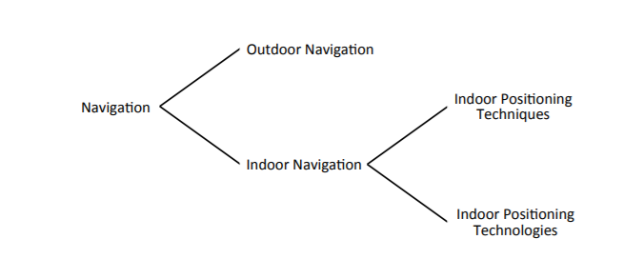[1]

Figure 1 - Flow diagram of Navigation

There are many applications of indoor localisation: detection of the location of products in the warehouse; monitoring patients, staff, and equipment in hospitals to improve navigation; helping customers locate stores or products in a shopping mall; detecting the location to find the place where the car was parked in a parking lot.

### 2.2.2 Indoor Positioning Techniques

Positioning techniques for indoor environments can be based on estimating the distance to anchor nodes with known positions and on internode measurements. Node cooperation enhances position estimation and is primarily beneficial when traditional localisation techniques fail to produce accurate estimation (Yassin et al., 2016).

This section divides the positioning techniques by signal properties and positioning algorithms, as shown in Fig. 2.

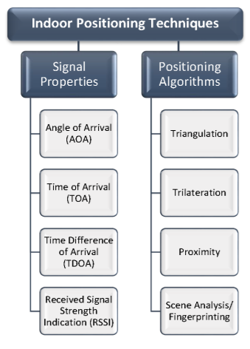[2]

Figure 2 - Indoor Positioning Techniques2

### Signal Properties

It is necessary to use geometrical parameters such as angle, distance and signal intensity, known as signal properties, to calculate the position of a device (Sakpere et al., 2017).

**Angle Of Arrival (AOA)**

The Angle Of Arrival technique uses antenna arrays at the receiver’s end to calculate the angle by which the transmitted signal affects the receiver by employing and calculating the time difference in the arrival at individual antenna array elements. The position is estimated through the intersection of direction lines starting at the reference points (Sakpere et al., 2017).

The angle of arrival's main advantages is that the device or the user’s position can be measured in a 2D environment with as few as two measuring units or three measuring units in a 3D environment and that no synchronisation of time is required between the measuring units. However, the drawback is that it has relatively complex hardware requirements, and location estimate deterioration will happen as the mobile target moves away from the units of measurement. Fig. 3 illustrates the concept of the Angle of Arrival.

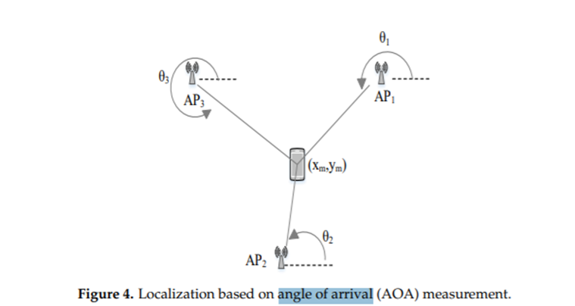[3]

Figure 3 - Localisation based on Angle of Arrival (AOA) measurement3

**Time Of Arrival (TOA)**

Time of Arrival is used to measure the distance between the transmitter and the receiver by using the signal propagation time. It is possible to find the distance between the reference node and the device by multiplying the propagation speed with the TOA value. Time of Arrival requires strict coordination between the transmitter and the receiver, which adds to the system’s cost (Subedi & Pyun, 2020). It has been recognised that with the aid of ultra-wideband technology, the time of arrival technique could best support the fine-time resolution. Frequency domain resolution techniques are widely used to achieve a high-resolution Time of Arrival from the channel frequency response. Fig. 4 shows an example of the Time of Arrival technique.

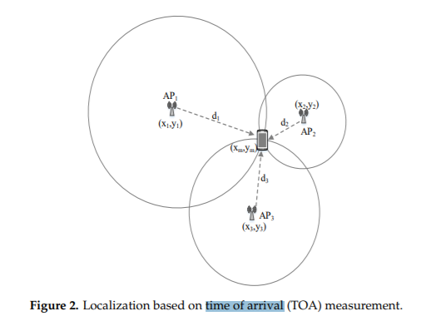[4]

Figure 4 - Localisation based on Time of Arrival (TOA) measurement4

**TDOA (Time Difference of Arrival)**

The Time Difference of Arrival technique takes advantage of the difference in signal transmission times measured at the receiver from different transmitters. TDOA differs from the time of arrival technique, where total signal propagation time is used. In contrast, the latter time measurements are used instead of optional time measurements at each receiving node. The transmitter must be in a hyperboloid with a constant difference in the range between the two units of measurement for each TDOA measurement. The time difference of the arrival technique does not require the receiver’s synchronisation; however, the transmitters need to be synchronised (Yassin et al., 2016). TDOA is usually implemented, as shown in Fig. 5.

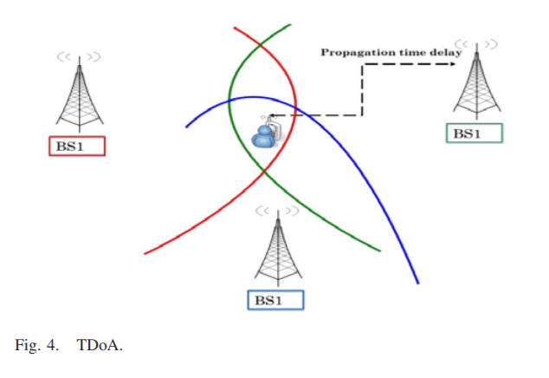[5]

Figure 5 - Time Difference of Arrival (TDOA) technique5

**RSSI (Received Signal Strength Indicator)**

Received Signal Strength Indicator, as shown in Fig. 6, is one of the most used techniques for indoor localisation. It is based on measuring the strength of a signal received from an access point at a client device. It can be assumed that as the number of available access points increases, a more significant amount of information can be collected. Hence, accuracy can be increased over the information obtained. However, it also works as a trade-off, as more access points would increase the interference between different signals (Yassin et al., 2016). RSSI techniques are among the cheapest and easiest methods to implement, but they do not provide the best accuracy. Filtering is necessary to improve system accuracy using RSSI-based localisation.

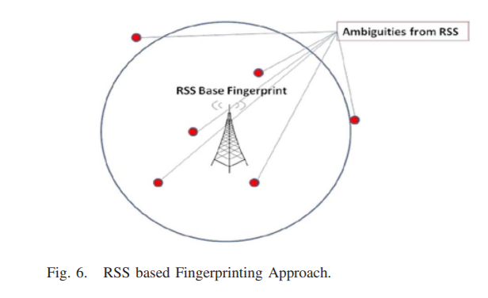[6]

Figure 6 - RSS based Fingerprinting Approach6

**Advantages and Disadvantages**

Every positioning technique has advantages and disadvantages, but most lack accuracy (Yassin et al., 2016).

The advantages and disadvantages of the position techniques are listed in Table 2[7].

Table 2 - Summary of Signal Properties7

| **Signal Property** | **Measurement Metric** | **Pros** | **Cons** |
| --- | --- | --- | --- |
| **Angle Of Arrival (AOA)** | Angle-based | High accuracy at room level | Complex, expensive and low accuracy at wide coverage |
| **Time Of Arrival (TOA)** | Distance-based | High accuracy | Complex and expensive |
| **Time Difference Of Arrival (TDOA)** | Distance-based | High accuracy | Expensive |
| **Received Signal Strength Indicator (RSSI)** | Signal-based (RSS) | Low cost | Medium accuracy |

### Positioning Algorithms

In order to calculate the position of an object, positioning algorithms are used. These process the signal property and output a position so that, this way, the positioning algorithms allied to the signal property determine the position of an object. It is also important to note that positioning algorithms have advantages and disadvantages, so using multiple of them will improve position accuracy and performance (Sakpere et al., 2017).

**Triangulation**

The triangulation technique is used in conjunction with the geometric concept of triangle angles to determine the receiver’s position. Rather than measuring distances between nodes like trilateration, triangulation-based positioning is based on angle measurements. Although they work similarly, the position of the target node can be determined by intersecting several pairs of angle direction lines with triangulation.

This approach requires only two measuring devices to estimate the location in a two-dimensional plane (Subedi & Pyun, 2020). Three or more devices are usually used for location estimation to enhance accuracy. It requires highly directive antennas or antenna arrays to measure the direction.

**Trilateration**

The trilateration technique estimates the object’s location by measuring the distance from three reference points based on the triangle’s geometric properties. In trilateration, at least three fixed points are needed to determine a position in 2D. Depending on three non-collinear distance measurements, the target object’s absolute location is calculated (Subedi & Pyun, 2020).

The target object's location is determined by the intersection of imaginary circles in a 2D dimension plane.

**Scene Analysis / Fingerprinting**

Scene analysis refers to the type of algorithms that first collect features that are the fingerprints of a scene and then estimate the location of an object by matching online measurements with the closest prior location fingerprints. RSSI-based location fingerprinting is commonly used in scene analysis (Subedi & Pyun, 2020).

Fingerprinting technique uses radio signals to learn the user or device’s location. It works by collecting the signal values (fingerprints) during an offline phase, measuring the different calibration points throughout the area of interest, and recording it in a database which will then be compared with the online measurements where the system is deployed to estimate the user’s location. During the online part, the constructed radio map will be used to approximate the tracked object's position (Eisa et al., 2013). Online positioning, therefore, requires a selection process for the access points. A range of algorithms is presented to match offline calculations with online calculations. It is essential to know that fingerprinting techniques can provide accurate localisation estimates; however, they are susceptible to environmental changes over time.

**Characteristics of Positioning Algorithms**

The characteristics of each Positioning Algorithm are described in Table 3[8].

Table 3 - Summary of Positioning Algorithms8

|  |  |  |  |
| --- | --- | --- | --- |
| **Positioning algorithm** | **Signal property** | **Pros** | **Cons** |
| **Triangulation** | AOA | Simple, low-cost and high accuracy at room level | Complex, expensive and low accuracy at wide coverage |
| **Trilateration** | TOA/TDOA | High accuracy | Complex and expensive |
| **Scene analysis/fingerprinting** | RSSI | High performance | Complex, expensive, medium accuracy and time consuming |

### 2.2.5 Indoor Localisation Technologies

Numerous technologies can ensure that someone does not get lost geographically. There are artificial and natural techniques, such as satellite and radio signals, celestial bodies and natural landmarks, respectively (Sakpere et al., 2017).

This section demonstrates several existing technologies that aim to provide indoor location services. This theme presents a diversity of algorithms and techniques. Many technologies have evolved to respond to positioning and navigation. However, in this section, indoor environments will be the main focus.

* Wi-Fi

The Wi-Fi technology, also known as IEEE 802.11 standard, operates in the Industrial, Scientific, and Medical (ISM) band. It is mainly used to provide networking capabilities and access to the Internet to various devices in personal, public, and industrial environments. Wi-Fi nowadays has a reception range of about 1 kilometre (km) in special conditions and using high-gain antennas.

Most of the newest laptops, smartphones and other mobile user devices are Wi-Fi enabled, making it the best suitable for indoor localisation and one of the most examined technologies. Existing Wi-Fi networks are typically deployed for communication purposes rather than location; therefore, new and efficient algorithms are needed to improve their location accuracy (Zafari et al., 2017).

Challenges in Wi-Fi-based Localisation System

Wi-Fi based location systems are time-consuming (surveying the site), cumbersome and multipath is influenced by physical objects, which may interfere with other applications on the 2.4GHz ISM band. It is also important to mention that the variation of the signal strength concerning time is considered a weakness of this system, causing deterioration in the location accuracy. Frequent updating of the signal strength map is crucial, as the movement of people, doors and furniture often causes a variation in signal strength. It is therefore considered the most significant disadvantage of Wi-Fi fingerprint systems (Yassin et al., 2016).

* Bluetooth

Established as IEEE 802.15.1, it comprises the specification of physical and MAC layers to connect various fixed or moving wireless devices within a particular personal space. Bluetooth Low Energy (BLE), commonly defined as Bluetooth smart, the latest version of Bluetooth, delivers an increased data rate of 24Mbps and more energy efficiency with a coverage range of 70-100 meters. While BLE can be used with different localisation techniques, such as RSSI and AoA, most existing BLE-based localisation solutions rely on RSS-based inputs as RSS-based systems are less complex (Zafari et al., 2017).

One of the advantages of using Bluetooth technology in indoor localisation is that devices are small and easy to find.

Challenges and drawbacks of Bluetooth-based positioning

Problems associated with BLE make such positioning systems difficult. The range (coverage) and signal of radio waves are limited, and they are prone to disturbances such as storms and organic matter, which can disturb or distort radio signals. As an RF signal travels through air and other media in an indoor environment, it exhibits certain propagation behaviours or effects, such as absorption, reflection, scattering, refraction, interference, multipath, and attenuation. These behaviours are signal impediments that affect the transmission of a signal between two locations, causing significant loss and degradation of the received signal. Its effects can sometimes be useless and harm performance and accuracy.

* Ultra-Wide Band (UWB)

This technology works in the microwave band, where the high frequencies can penetrate building materials like walls. The technology is used mainly for short-range communication systems like laptop peripherals and alternative indoor applications.

The ultra-Wide band has been a very enticing technology for indoor localisation because of its resistance to interference from different signals, low power consumption, and effective penetration through dense materials (Subedi & Pyun, 2020).

Challenges in UWB-Based Localisation System

UWB technology faces numerous challenges induced by extremely cluttered operating environments that cause multipath, NLOS and shadow artefacts. These challenges are cited in the following list:

1. Broadband radio devices are hard to implement for a bandwidth greater than 500 MHz. The advancement of technology has enabled some studies to develop platforms with accuracies of 10 to 15 centimetres or more.
2. Incorrect configuration and propagation of the UWB signal over the bandwidths that contain the frequency of the existing narrowband system lead to interference with the ultra-wide spectrum.
3. For its implementation, at least three receivers with a direct path unlocked to the transmitter are required for the standard ToA positioning algorithm.
4. For the system to be effective and achieve maximum accuracy, it is necessary to perform the acquisition, tracking and signal synchronisation with high precision concerning the pulse rate.

All these problems are currently being studied and analysed towards the evolution of technology (Yassin et al., 2016).

* Ultrasound

Ultrasound-based location systems are referred to as delicate grain systems with centimetre-level location accuracy. They depend on the time of arrival calculation of the ultrasound signal measured using sound velocity. Ultrasound networks which have been built are either narrowband or wideband. Relatively to the ultrasound positioning system, it has high room-level accuracy. Some ultrasound positioning systems use narrowband or wideband signals that have shown high accuracy during implementation. These involve the use of ultrasonic tags or nodes on users and objects. These tags or nodes serve as receivers or transmitters; when one is stationary or fixed, the other is in motion (Sakpere et al., 2017).

Ultrasound position systems deliver various benefits like low device cost, accuracy, reliability, scalability, and high-power performance.

Challenges and drawbacks of Ultrasound

Large-scale implementation will degrade the advantages of this system. Ultrasonic positioning systems are expensive to deploy and maintain on a large scale. They are usually cheap on the room level.

In addition, ultrasound systems experience multipath effects such as noise, reflection, and interference. Thus, system accuracy and performance are degraded (Sakpere et al., 2017).

* Dead Reckoning

The dead Reckoning technique estimates the current position based on the last calculated position and motion information. Here two techniques can be used to estimate a person’s travelled distance. The first is pedometer-based dead reckoning, in which step detection and step length are estimated, and then steps are counted to measure the distance travelled. The other is pedestrian dead reckoning which calculates the distance travelled directly. The inertial measurement unit (IMU) is attached to a person’s foot and calculates the acceleration and angular velocity changes. The data obtained is then analysed and transformed into referential motions, and the movement’s distance and orientation are measured. The advantages of this system are numerous. It is simple, low-cost and accurately estimates position in real-time. It is autonomous and does not require external references to determine its position, orientation, or velocity once it has been initialised. In addition, because of the inertial sensors inherent therein, it can smoothly and efficiently be used in a hybrid method with other positioning systems for pedestrian navigation. It is not affected by signal issues, does not emit nor receive signals or radiation, and does not require a network to work.

Challenges and drawbacks of Pedestrian Dead Reckoning

A significant problem with PDR and INS is the gradual drift in operation due to the progressive accumulation of errors over time during motion, which gradually leads to low accuracy due to sensor noise, bias, and magnetic disturbances. There is the possibility of using a hybrid system with a GPS satellite system or other positioning systems to eliminate this error. Thus, the system's complexity increases, as does the cost (Sakpere et al., 2017).

### 2.2.6 Performance

The development of indoor positioning and navigation has been studied and analysed, and consequently, evolving to guarantee scalability, complexity, privacy, usability and precision, among others. Several issues, challenges and limitations have been explored to respond to the need for progress in these systems.

* Accuracy

Good accuracy is a significant user prerequisite for positioning systems. Different systems can have different accuracies. However, accuracy is still a very challenging area of interest for many researchers. As mentioned earlier, indoor environments provide a challenging space for location systems to operate due to obstacles and multipath effects. Therefore, the system needs to limit the impact of multipath effects and other ambient noise to achieve highly accurate systems that require extensive signal processing and noise mitigation which is a highly challenging task. The location system must locate the user or object of interest, ideally with an accuracy of 10 cm (known as micro-location) (Zafari et al., 2017).

* Cost

Another challenge is the monetary value of the system. Localisation systems require additional infrastructure that giant corporations might be able to afford, whereas smaller organisations are limited in the matter of costs. Hence, some of the infrastructures’ equipment and bandwidth can therefore be avoided by using the existing infrastructure. Therefore, the location system can easily penetrate the consumer market and be widely adopted while keeping costs low (Zafari et al., 2017).

* Energy Efficiency

The indoor localisation system's energy efficiency is critical for widespread acceptance. Most current localisation systems use incredible energy to deliver higher precision. In today’s localisation systems, achieving high precision without draining the device's battery is challenging, leading to user dissatisfaction. Therefore, there is a need to improve the energy consumption of the localisation systems. Technologies such as BLE can be applied as it has lower power consumption, offloading the computational aspect of the location algorithm to a server and any entity that has access to the uninterruptible power supply and has high processing power. The fundamental compromise is between the location system's energy consumption and latency (Zafari et al., 2017).

* Scalability

One of the essential requirements is that the system must be scalable. That is to be capable of simultaneously finding or providing facilities to many users in a large area. Low scalability can lead to poor system performance. A scalable positioning system functions correctly when its scope gets larger. Usually, localisation performance reduces with increased distance between the transmitter and receiver.

Further, a positioning system may require scaling on two axes, density and geography. Geographic scaling represents an area or volume coverage, whereas density scaling represents the number of units positioned per unit geographic space or area per period. Wireless signal channels may become congested as more area is covered or the units in such an area are crowded; hence, further computation or communication infrastructure may be required for localisation. In addition, the dimension of a system is another metric for scalability. A positioning system may locate objects in 2-D space, 3-D space or both (Liu et al., 2020). Because of all these challenges, there is much room for improvement in this field.

### 2.2.7 Applications

The LBS service is required for both indoor and outdoor environments. In this section, a detail of the main applications of indoor location is presented. Indoor positioning and navigation for mobile devices occupied 4 billion dollars in 2018, meaning that this is a reliable, easy-to-use and accurate solution for indoor positioning and navigation that has the potential to open the door to new applications. Creating new business opportunities in numerous scenarios is a cornerstone in realising the vision of the Internet of Things (Yassin et al., 2016).

**A. Asset Management and tracking: Detection of the location of products in the warehouse**

Location-based services include asset tracking and enable factory automation to ensure workplace safety. Asset management will also allow for better inventory management and optimised operation management.

Additionally, personnel and asset tracking analytics and motion data collection have proven outdated. Using novel energy-efficient techniques and algorithms will eliminate the need for expensive proprietary hardware (Khanh et al., 2020).

**B. Health Services: Monitoring patients, staff, and equipment in the hospitals to improve navigation**

The health sector can significantly benefit from indoor localisation as it can help save valuable lives. It can help both the hospital staff, the patients as well as the visitors. If a patient needs medical assistance, the current protocol requires broadcasting the message or paging a specific doctor or staff member who may not be in the vicinity of the patient. The staff's arrival delay might even cause the patient's death. Similarly, broadcasting the message will cause other staff members to receive irrelevant messages. A location-based solution would allow tracking of the position of the staff members. In an emergency, the localisation system would find the staff member close to and with the necessary qualifications to handle the emergency (Marques et al., 2012), avoiding delay and not spamming the other staff members. Indoor localisation can also allow doctors to track various patients and their mobility to ensure patient safety. Visitors who intend to visit patients can find their destination using a localisation system without any hassle.

**C. Contextual Aware Location-based Marketing: Help customers locate stores or products**

There are several types of usability of these applications. However, they can direct users to a store located inside a building, access a specific book in a library, or the boarding gate at an airport, which benefits this system. iBeacons provide proximity-based services for travellers to enhance their experience. In this way, JFK in New York, Heathrow in London, Miami International and many other airports have started to use it so that all their tourists feel integrated with the whole space. As well as for public transport, such as buses, there is the LBS app that can be used at bus or train stations to navigate the bus stop (Zafari et al., 2017).

**D. Location-Based Services: Detecting the location to find the place where the car was parked in a parking lot**

With the growth of cities observed in recent decades, some spaces and buildings have become vast and complex, which is the case for large shopping centres and parking spaces. In these spaces, finding a particular car is not always easy, especially if the visitor is not a regular user of the same space. These problems can be minimised using navigation systems for indoor environments. These tools are like the standard GPS used to find the way to a specific destination. It facilitates navigation within the parking lot. The primary function of these solutions is to indicate the shortest way to a particular car.

## Critical View of State of the Art

This point is critical as it reflects the entire theoretical framework where the essence of this work fits. At first, it was sought to analyse other studies related to indoor localisation and several applications to obtain comparative information regarding the critical success factors present in a process of this nature. What values a tag from the users' perspective is the effectiveness of delivering quality services. Together, these services must provide the accurate geographical location of the user. The fundamental principle of indoor localisation is that it does not have access to satellites to know a user's location. As an indoor device, this tag does not focus on GPS or other outdoor technologies that enable localisation but instead on indoor technologies to provide a location in an indoor structure.

The main conclusions drawn from the state-of-the-art study were the following:

* Indoor localisation services are an integral part of localisation systems.
* Localisation is critical and knowing the whereabouts of any asset or user in an indoor environment is an untapped niche market.
* There is scientific evidence that effective solutions have been implemented for indoor localisation processes, but there is room for improvement.
* There are several good practice frameworks and standards for managing localisation. Several studies prove the benefits of increasing the different number of technologies and techniques, improving the efficiency and effectiveness of location services, noise effect reduction and improvement of the productivity of the solutions when implemented successfully.
* The most commonly used technology is the IEEE 802.11 standard, commonly known as Wi-Fi.
* The target technologies of this study case are Bluetooth and Wi-Fi to be implemented within a tag and using the fingerprinting technique. The literature review found studies that prove the existence of a high probability that this choice will lead to reaching the expected benefits.
* However, there are common mistakes that can lead to the failure of a tag development and implementation, which should be avoided.

The study case to be developed will focus on measuring the impact of the indoor localisation processes and this tag's efficiency, effectiveness, and robustness.

# Case Study

Real-time location systems (RTLS) tags are wireless devices that equip people, objects, or material things to digitally track their real-time location and movements throughout extensive facilities or localised areas. For example, in environments like intelligent factories, businesses will use tags in a real-time location system to digitally track workers, powering critical safety use cases such as collision avoidance or safety zoning. They will also track critical assets like production equipment, vehicles, and inventories to support enterprise asset management, automation, workflow optimisation and more. Other industries, like healthcare, use clinical-grade RTLS tags to help track staff, patients, and critical medical equipment like defibrillators for real-time visibility that helps them deliver vital care in urgent scenarios.

## RLTS Tag – Specifications and Requirements

* Effectiveness

The tag must receive and send data with good transfer speeds, and there should be no information losses.

* Cost

The tag must be inexpensive in order to be economical to have multiple tags on various objects.

* Autonomy (energy consumption & battery)

The tags’ autonomy must be pretty high (for example, several months), so there is no need to recharge the tags’ batteries constantly.

* Size and Weight

The size and weight of the tags must be minimal and light to be able to place them on any object.

* Operating System Limitations (privacy and energy)

The Operating System should not be a hindrance because of its device's data privacy and power consumption restrictions.

* Start & stop (with accelerometer), hibernate

The tag must have a start and stop system with the help of an accelerometer. When it is verified that the object in which the tag is inserted is not being used, the tag will be able to transition to a "hibernate" state that limits its operation to save energy. Likewise, it must transition from this state to "active" as soon as the object starts to move.

* Channel Duality (the server communicating with the tag and the tag with the server)

The tag must be able to communicate with the server as well as receive data from the server.

* Shifting communication protocols (from UDP to TCP and vice-versa)

The tag should be able to transition from mode UDP to mode TCP. In mode UDP, it communicates through the UDP protocol that uses less energy and resources in exchange for less reliability and, in mode TCP it communicates via a TCP/IP protocol, has more excellent information reliability at the cost of higher energy costs.

* Openness

The system's openness is determined primarily by the degree to which new resource-sharing services can be made available to the user. It is based on a uniform communication mechanism and published interface to access shared resources.

* Standalone

The device must be able to function independently of other hardware, which means it is not integrated into another device. It can act as a standalone reader and transmitter of data.

## RLTS Tag – Core Skills

Developing a tag requires special skills, some of them described next.

* Soldering

Soldering is not a skill detained, so it is difficult to do the soldering of a particular product. It might be a few simple solder joints or require special reflow tools.

It might be required to do some reflow or essential rework with SMD components. A heat gun, Heaterizer or other tools might be required, and a good understanding of SMD soldering and PTH soldering are required.

* Programming

If a board needs code or communication, it must know how to program or interface with it. Programming skill is all about communication and code.

The toolchain for programming is complex, and examples may not be explicitly provided. It will be required to have a fundamental knowledge of programming and be required to provide its code. It may be necessary to modify existing libraries or code to work with specific hardware.

* Electrical Prototyping

If it requires power, it is needed to know how much, what all the pins do, and how to hook it up. References to datasheets, schematics, and know the ins and outs of electronics are required.

Consulting a datasheet for calculations to determine a component’s output format and linearity and doing a little math to get what is needed is central. It will be used as a datasheet or schematic beyond basic pinouts.

## Microcontroller Boards Selection

The tag to be considered should deliver 2-4 meters level accuracy via Wi-Fi and BLE and positioning up to 500 m for high-performance location tracking that supports diverse RTLS needs. Featuring low-power consumption, wireless configuration and industrial-grade reliability, deployment-ready hardware can be easily set up, configured and maintained—supporting ranging, real-time tracking and bi-directional communication.

It was decided to build the tag around a microcontroller board to minimise the hardware development effort. At first, many microcontroller boards were considered that could be used as the main component of a tag, bearing in mind that they would later be disregarded based on the essential functional requirements. Table 4 shows the first set of boards that were considered.

Table 4 - Preliminary Research

| **Name** | **Wi-Fi** | **Bluetooth** | **Price Range** |
| --- | --- | --- | --- |
| **Arduinos** | Yes | Yes | Low |
| **Beaglebones** | Yes | Yes | High |
| **SparkFuns** | Yes | Yes | Medium |
| **ESP32 Modules** | Yes | Yes | Low |

A table listing all the specifications of each microcontroller board is available in the section Preliminary Research.

After the initial consideration, many more microcontroller boards were explored, and a few previous considered ones were disregarded. That is because of functional requirements. A focus on the size and weight of the boards and more extensive research drove this next section to consider the following, as shown in Table 5.

Table 5 - Outlining Possibilities

| **Name** | **Length** | **Width** | **Soldering** |
| --- | --- | --- | --- |
| **Arduinos** | Medium | Medium | No |
| **SparkFuns** | Medium | Medium | No |
| **ESP32 Modules** | Small | Small | Yes |
| **ESP32 Development Boards** | Medium | Medium | No |

In the section Outlining Possibilities, an extended analysis is displayed to get a complete picture.

Finally, a verdict had to be reached regarding functional aspects of the board and extras that would be practical and useful for the work to be developed. These four boards were considered optimal and suited for the project. The four boards that were selected for purchasing and worked upon are listed in Table 6.

Table 6 - Final Decision

| **Name** | **Justification** |
| --- | --- |
| **Beetle** | A small-scale electronic device with a great range of benefits such as low power consumption, an enticingly small form factor, a surprising amount of functionality and much computational power |
| **SparkFun Thing Plus** | A powerful Wi-Fi and Bluetooth MCU module, scalable and adaptive, easy to use, and utilises the Qwiic Connect System, meaning no soldering or shields are required to connect it. |
| **Arduino Nano RP2040 Connect** | A versatile plug & play board with dual-core, connectivity, audio and machine learning capabilities. It also takes less time to compile with the benefits of a full Arduino Cloud support |
| **ESP32 Module** | Based on its value for money, wide range of features, small size and relatively low power consumption, it is well suited to the IoT application. A good understanding of soldering is required. |

There is a whole perspective given in the Final Decision about the microcontroller boards.

## Flash Powerbank 2200mAh

A battery with a capacity of 2200 mAh provides enough power to charge a mobile device (Figure 7). The Powerbank charges in 3-5 hours with a USB cable and turns red when charging, off when charged or blue when used (Figure 8). The instructions suggest fully charging up the powerbank before using it (Planetpromo, 2022).

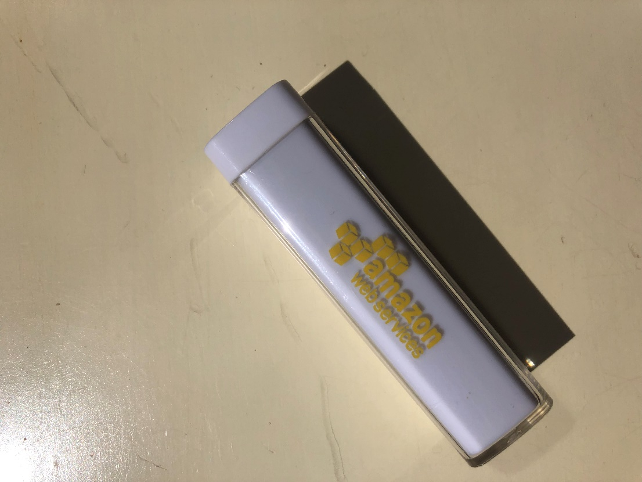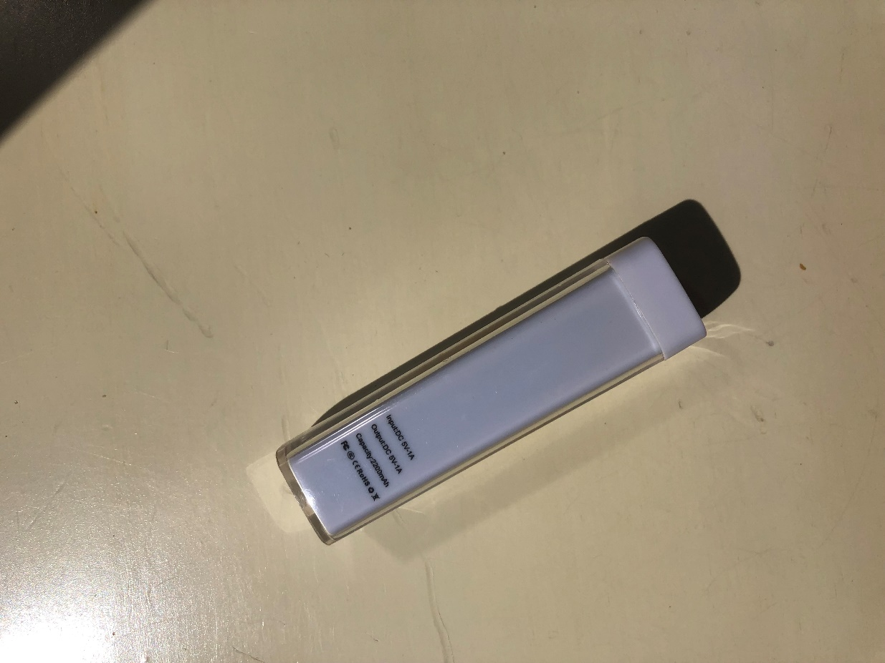

Figure 7 - 2200mAh Powerbank

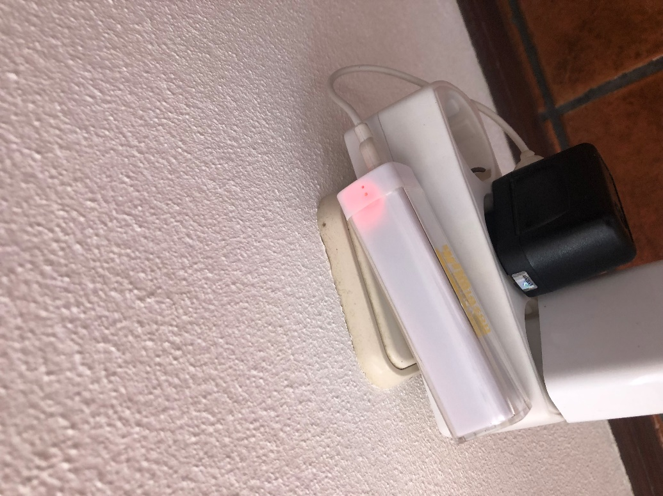

Figure 8 - Charging the powerbank

In the following table (Table 7), the specifications of the powerbank are listed.

Table 7 - Powerbank Specifications

|  |  |
| --- | --- |
| **Specification** | **Details** |
| **Material** | Plastic |
| **Dimensions** | 92 × 26 × 26 mm |
| **Weight** | 190 g |
| **Potency** | 2200 mAh |
| **Interface** | 2.0 |
| **Certificates** | FCC, RoHS, CE, UL (qualitylogoproducts, 2022) |
| **Input** | 25V/800mA, Output: 5V/1A |
| **Battery cell Type** | Battery cell type: Lithium-ion Grade A Non-Recycled |
| **Input port** | Micro USB (A), Output port: USB Type (B) |
| **Charging time** | 3-5 hours |
| **Safety protection** | Over-charge, over-voltage, short-circuit (eSpares, 2021) |

# Demonstration

This chapter corresponds to the “Demonstration” step of the research method. This step should demonstrate that the artefact solves one or more instances of the problem. Therefore, several approaches shall be used: first, how to set up the ESP32 and the programming environment. Then, how to model a web server architecture. Afterwards, how to implement the interface communication and perform an architecture-based evaluation. These demonstrations are also consistent with observational, experimental (simulation) and descriptive (scenarios) design evaluation models.

## Programming the ESP32

This document section is intended to help set up the software development environment for the hardware based on the ESP32 chip (Figure 9) by Espressif. After that, a simple example will show how to use ESP-IDF (Espressif IoT Development Framework) for menu configuration and then for building and flashing firmware onto an ESP32 board (Maker Tutor, 2018).

Figure 9 - DFR0575 microcontroller

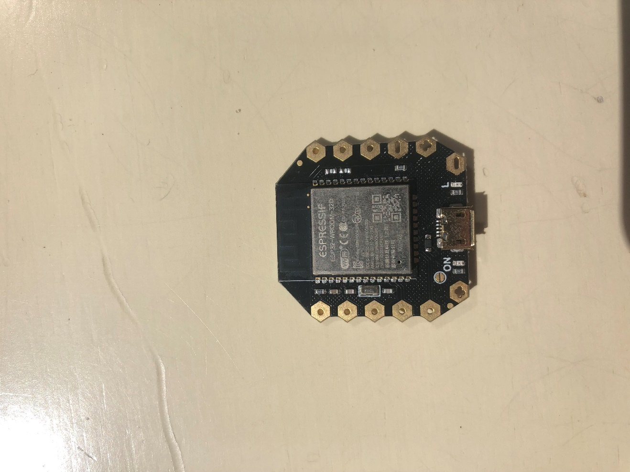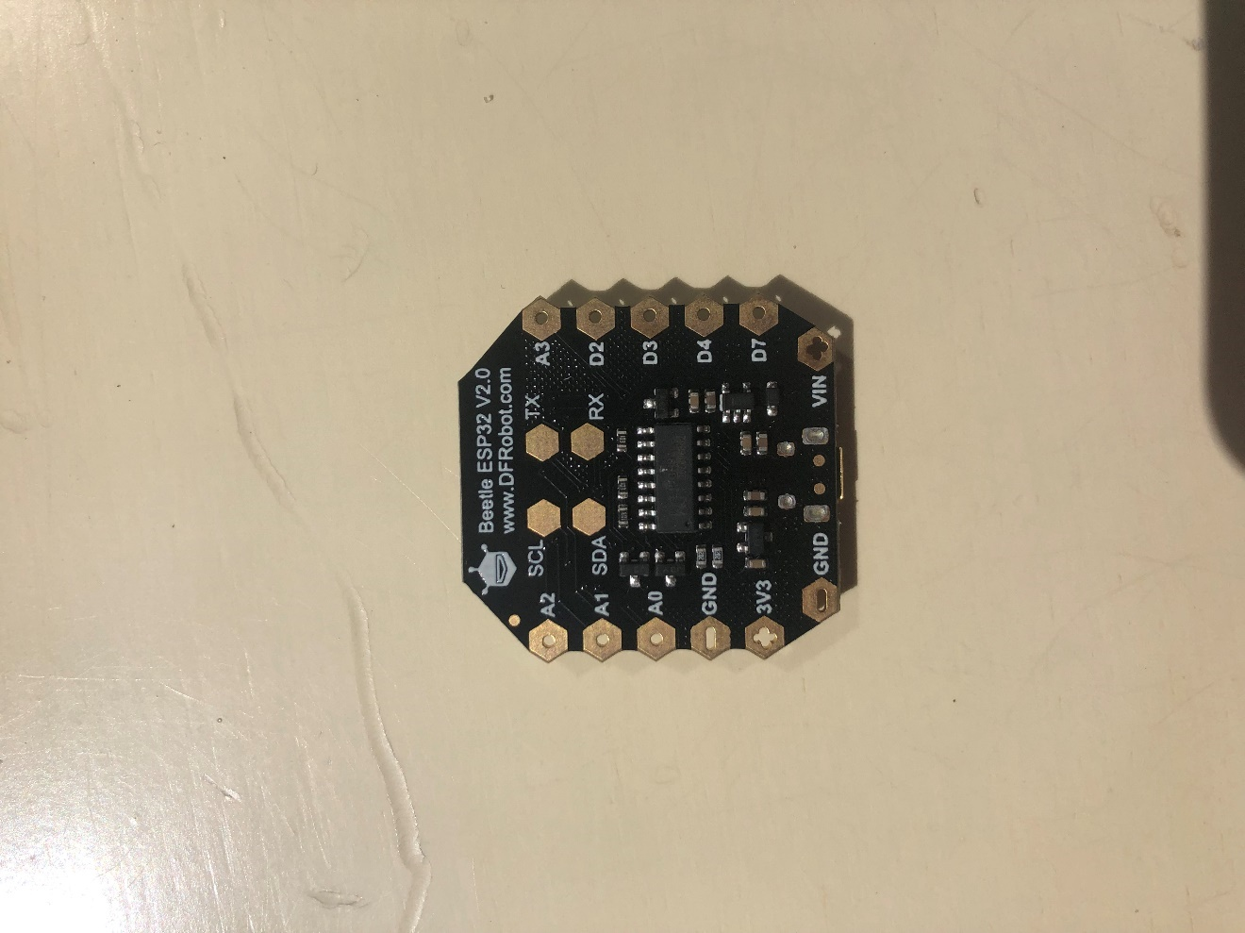

1. **Setup**

Using Arduino IDE is a more user-friendly approach[9] (Figure 10).

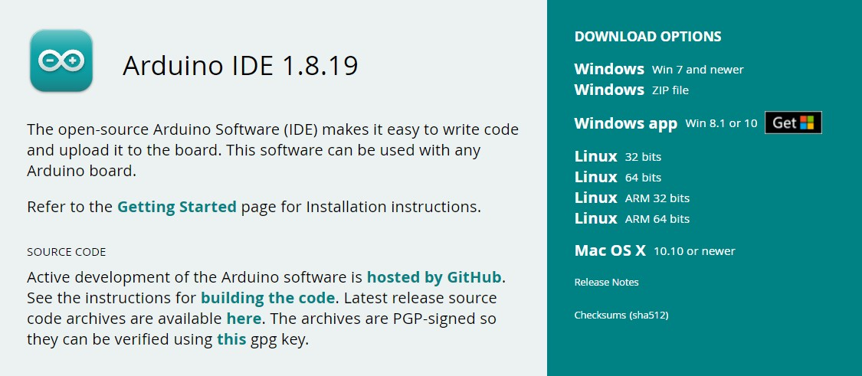

Figure 10 - Arduino Download

1. **Adding the Board URL to Arduino IDE**

Open Arduino IDE (version 1.8.19).

Navigate to file> Preferences and click the checked button as shown below (Figure 11):

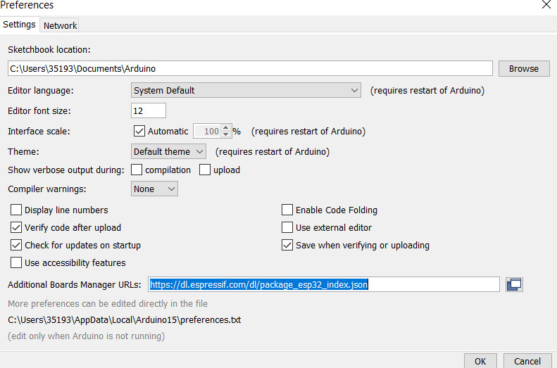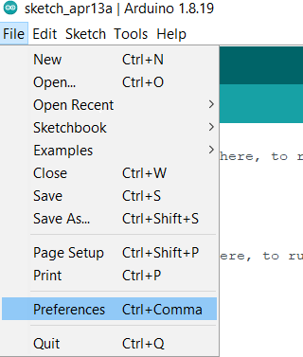

Figure 11 - Arduino Preferences

Enter the following URL in Additional Boards Manager URLs:

* <https://dl.espressif.com/dl/package_esp32_index.json>[10]

After the input is completed, click OK.

1. **Installing ESP32**

After adding the mainboard URL of [ESP32](https://www.dfrobot.com/product-1559.html) (ESP-WROOM-32) to Arduino IDE (DFRobot, 2022b), it is needed to update the board list and use [Arduino](https://www.arduino.cc/en/software) IDE to download ESP32 libraries (Arduino, 2022). It is possible to see this in Figure 12.

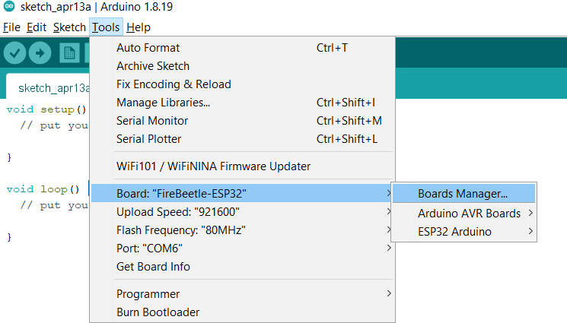

Figure 12 - Arduino Boards Manager

After opening the development board manager, the board list will automatically be updated. When the update is finished, type esp32, select it and click “Install”. The manager will automatically download the relevant libraries (Figure 13).

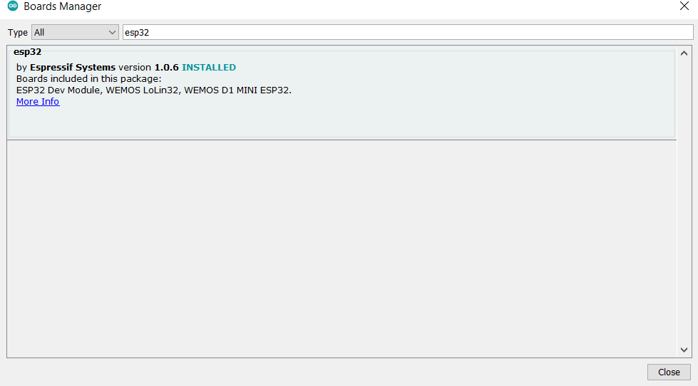

Figure 13 - Arduino Boards Manager 2

1. **Selecting the mainboard**

Open tools 🡪 board and select **FireBeetle-ESP32** as themainboard, as shown in the following (Figure 14):

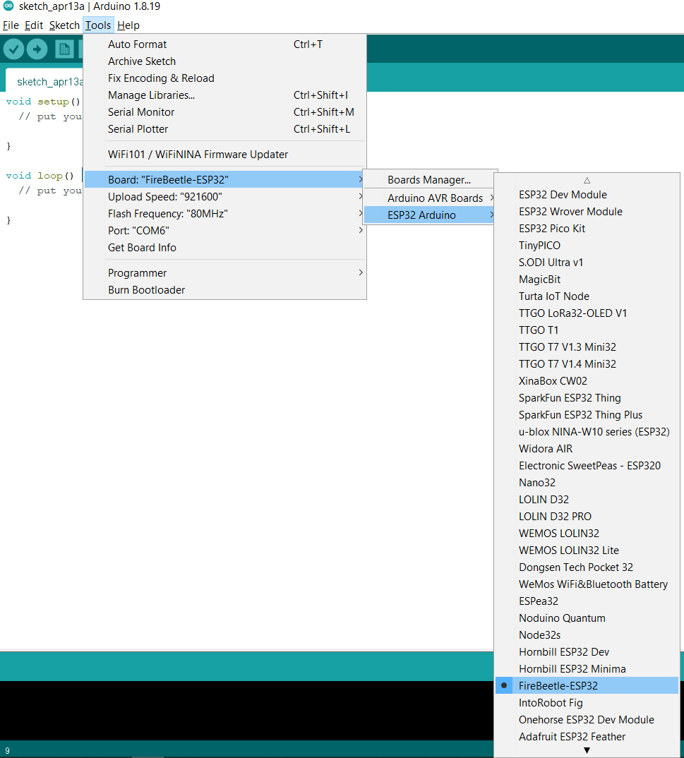

Figure 14 - Step 4

The board should then be ready for use (Figure 15).

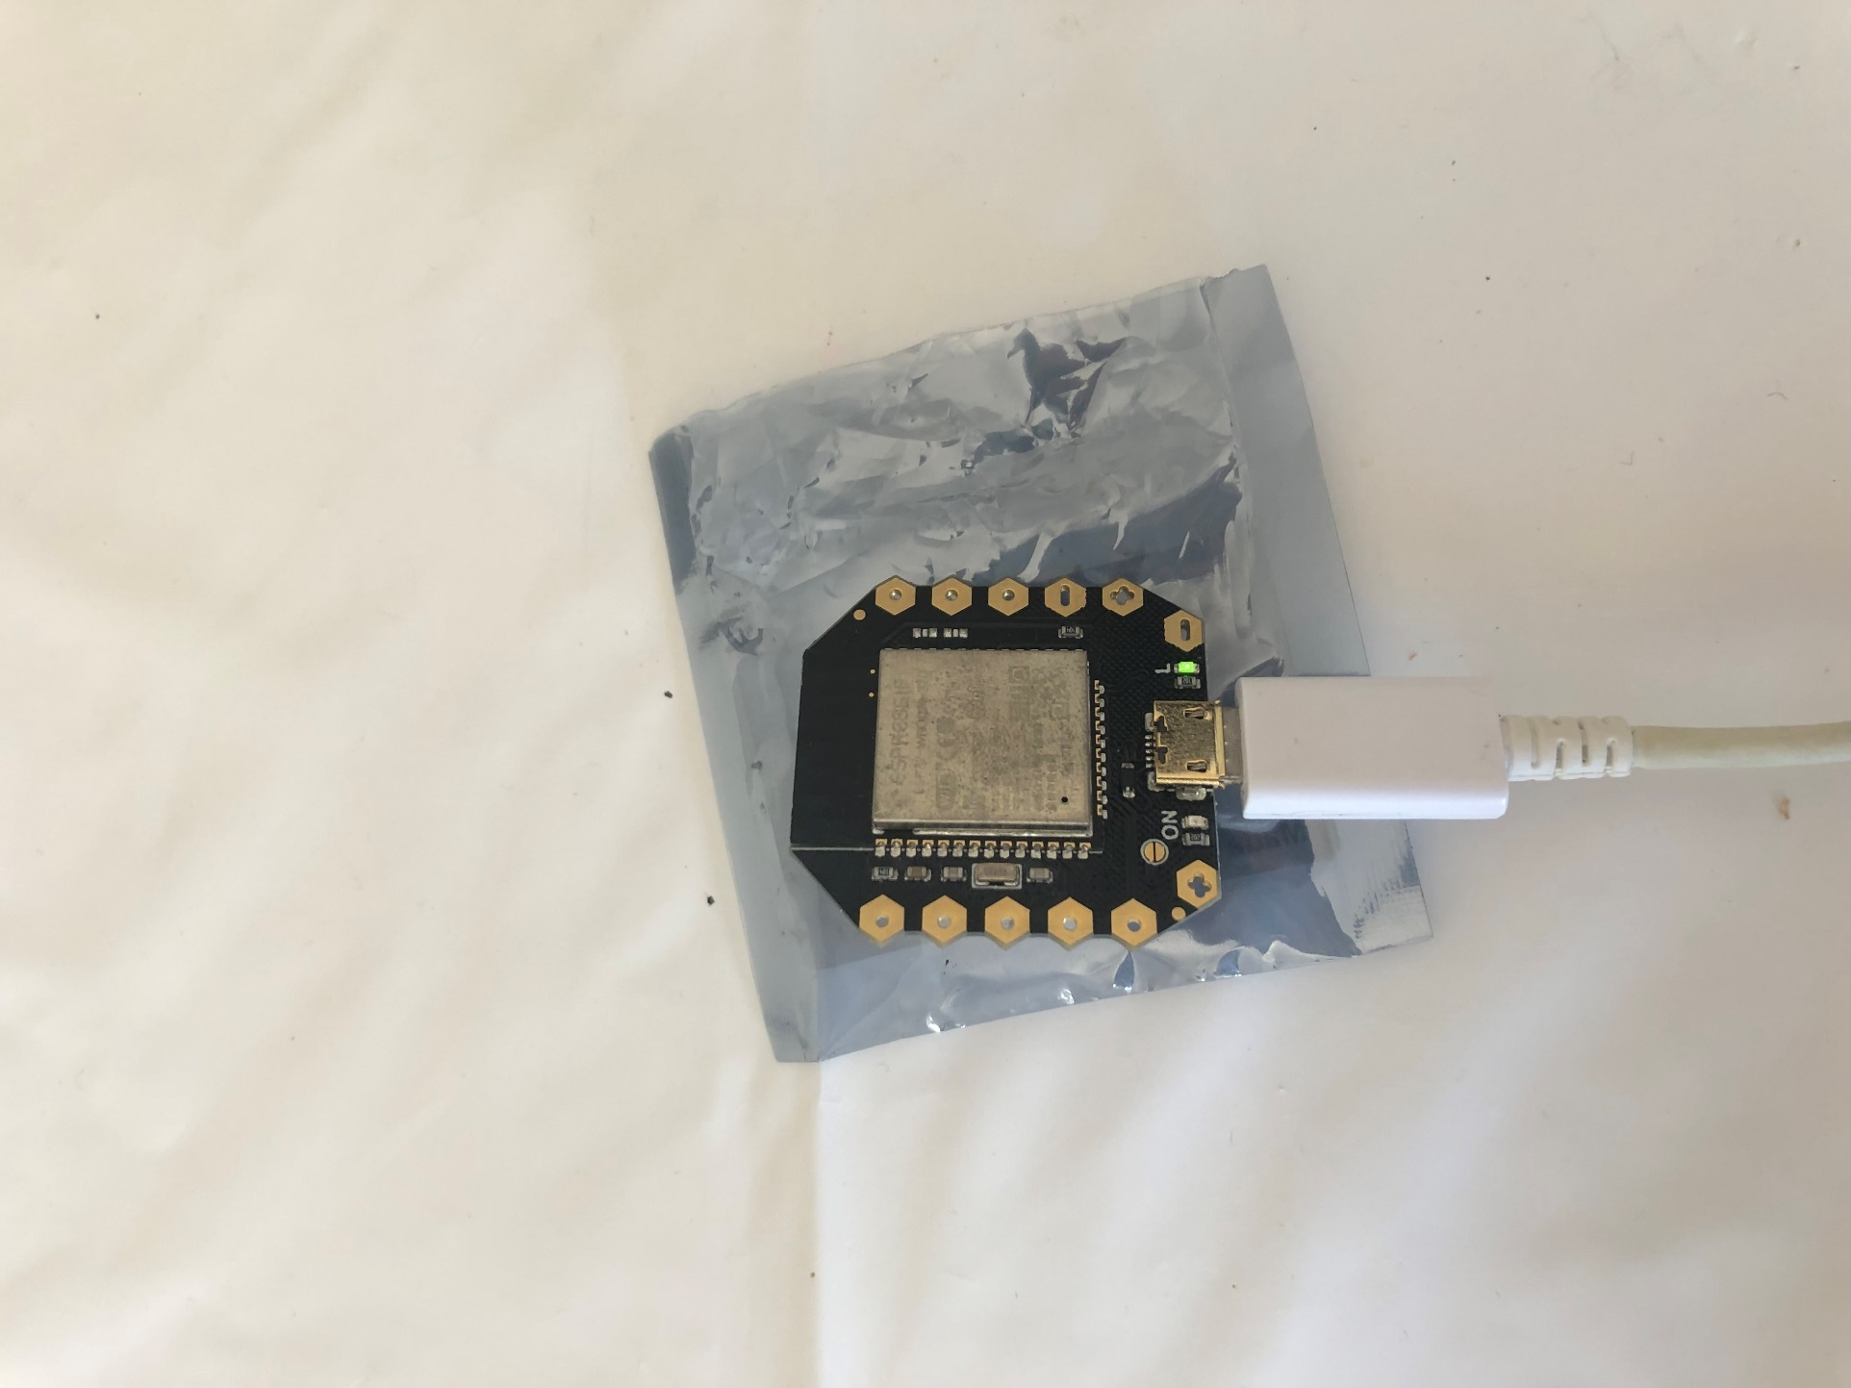

Figure 15 - Board connected

## Partition Schemes

A Partition table defines the flash memory organisation and the different kinds of data stored on each partition (XTronical, 2020). It is possible to run out of memory when creating a complex sketch, especially when using Wi-Fi or Bluetooth libraries. Errors like this can occur (Figure 16).



Figure 16 - Oversized Sketch

1. **First, it is needed to locate the boards.txt, which is in:**

C:\Users\35193\AppData\Local\Arduino15\packages\esp32\hardware\esp32\1.0.6

1. **Once the file is opened, locate the board that is being used, which, in this case, firebeetle32 (Figure 17):**

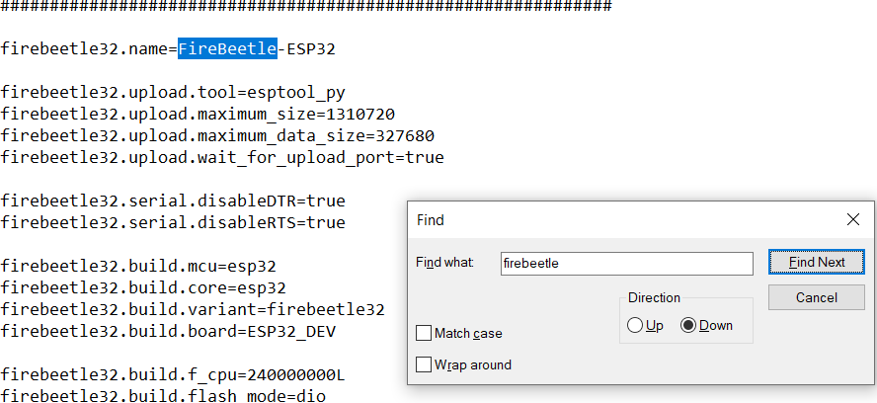

Figure 17 - Firebeetle32

1. **Add the partition schemes:**

firebeetle32.menu.PartitionScheme.default=Default

firebeetle32.menu.PartitionScheme.default.build.partitions=default

firebeetle32.menu.PartitionScheme.minimal=Minimal (2MB FLASH)

firebeetle32.menu.PartitionScheme.minimal.build.partitions=minimal

firebeetle32.menu.PartitionScheme.no_ota=No OTA (Large APP)

firebeetle32.menu.PartitionScheme.no_ota.build.partitions=no_ota

firebeetle32.menu.PartitionScheme.no_ota.upload.maximum_size=2097152

firebeetle32.menu.PartitionScheme.min_spiffs=Minimal SPIFFS (Large APPS with OTA)

firebeetle32.menu.PartitionScheme.min_spiffs.build.partitions=min_spiffs

firebeetle32.menu.PartitionScheme.min_spiffs.upload.maximum_size=1966080

firebeetle32.menu.PartitionScheme.fatflash=16MFat

firebeetle32.menu.PartitionScheme.fatflash.build.partitions=ffat

1. **Save the file and restart the Arduino IDE.**
2. **The partition scheme tab will be displayed in the IDE (Figure 18):**

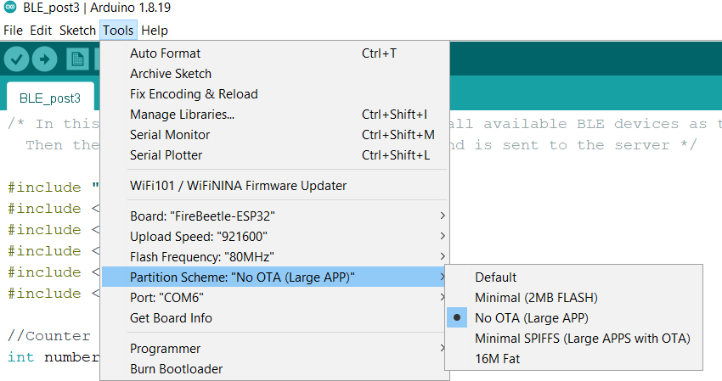

Figure 18 - Arduino partition

## Apache Server Implementation

[Apache](https://www.apachelounge.com/)[11] is the most widely used Web Server application. It can be used on almost all platforms, such as Windows, macOS, Linux and Raspberry.

It is a modular, process-based web server application that creates a new thread with each simultaneous connection. It supports several features; many of them are compiled as separate modules, extend its core functionality, and provide everything from server-side programming language support to authentication mechanisms (Figure 19).

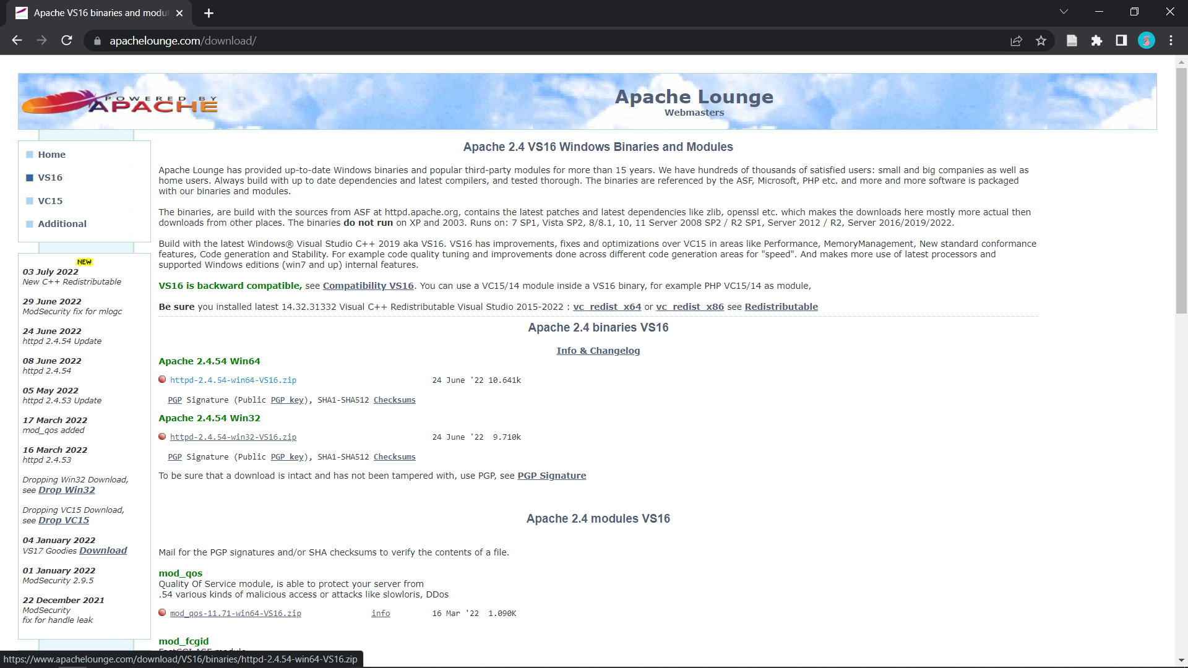

Figure 19 - Apache Lounge

* **Extract the download files and move them to (C:)[12]**
* **Install Apache using Command Prompt (Figure 20)**

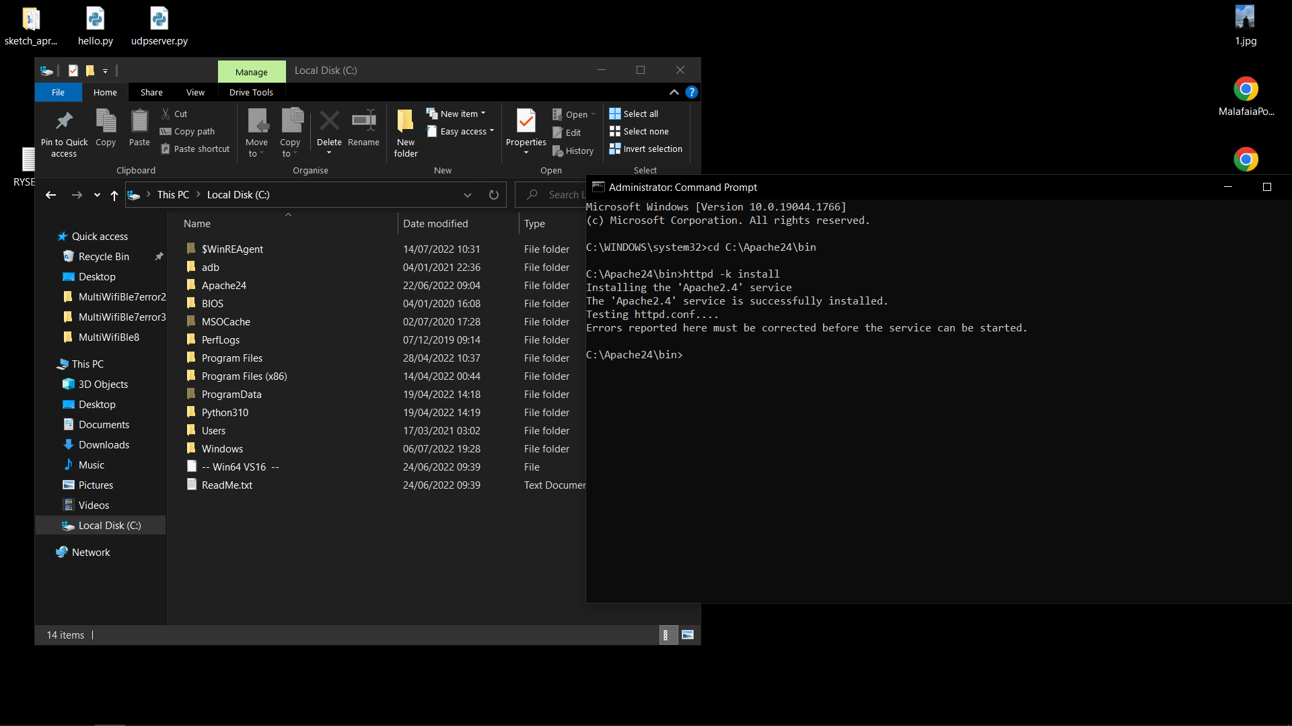

Figure 20 - Apache Command Prompt

* **Run the APACHE service (Figure 21)**

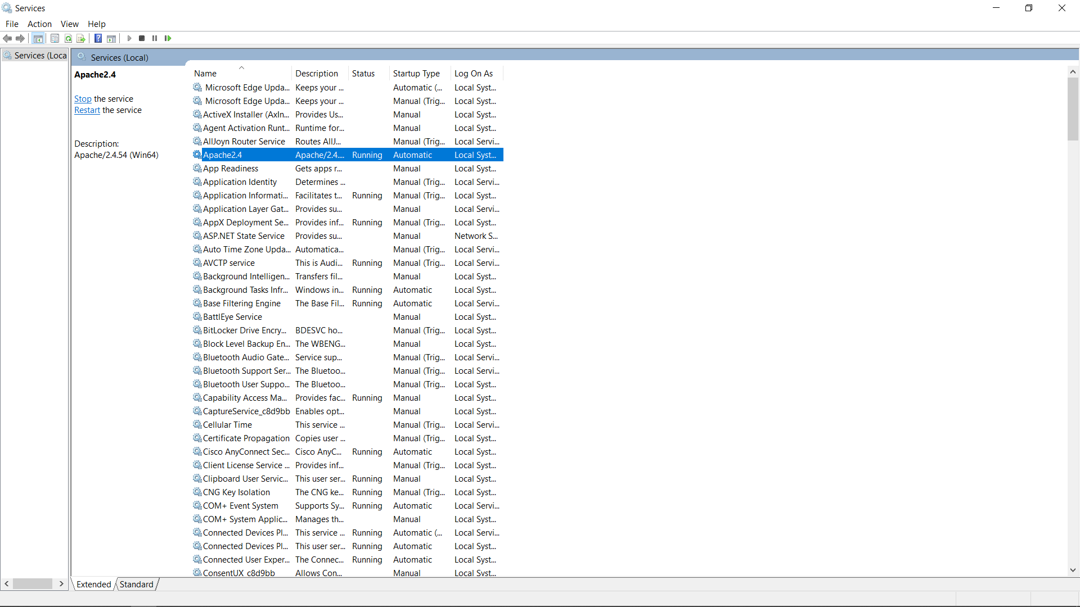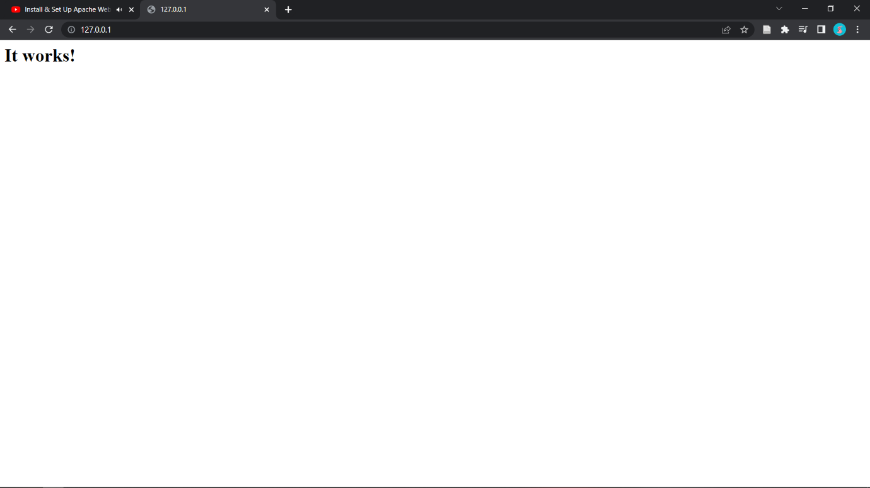

Figure 21 - Apache Service

* **Find out the local server’s IPv4 to access with other devices (Figure 22)**

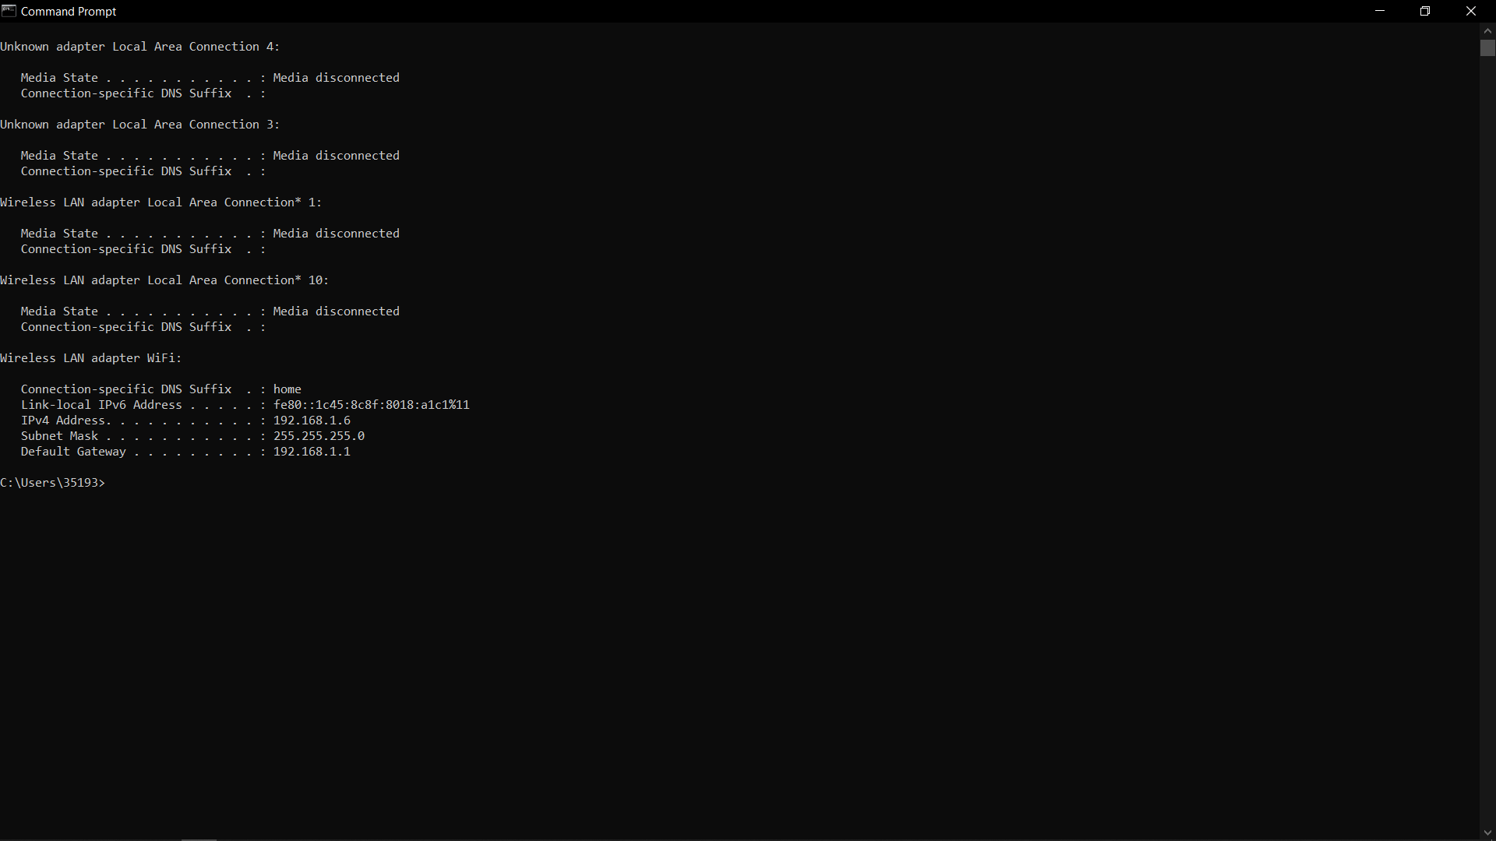

Figure 22 - Local server IPv4

* **Edit the INDEX.html File (Figure 23)**

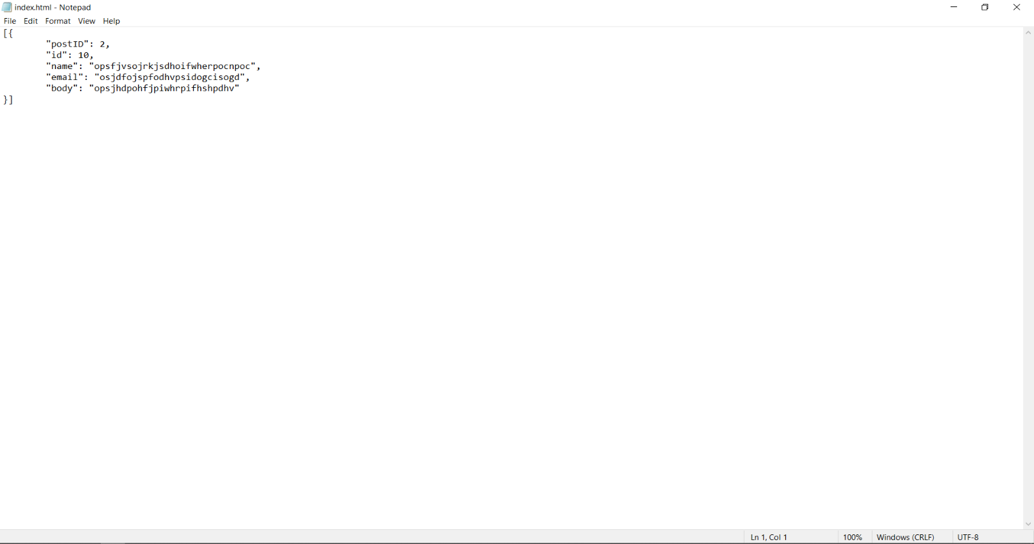

Figure 23 - INDEX.html File

* **Insert the server’s IPv4 in the Arduino file (Figure 24)**

Figure 24 - Inserting the server's IPv4

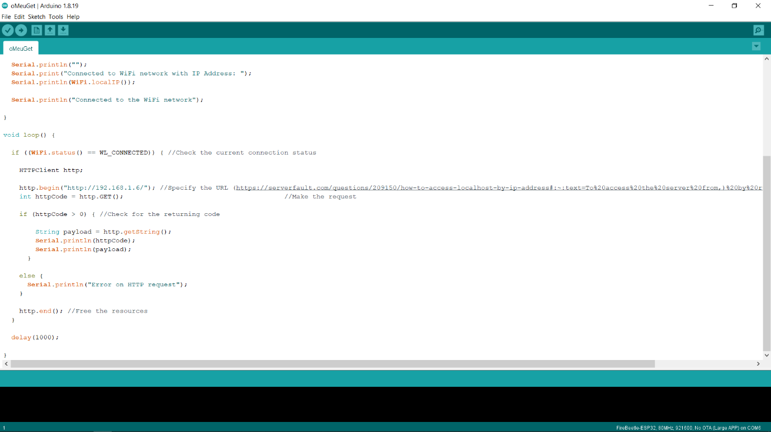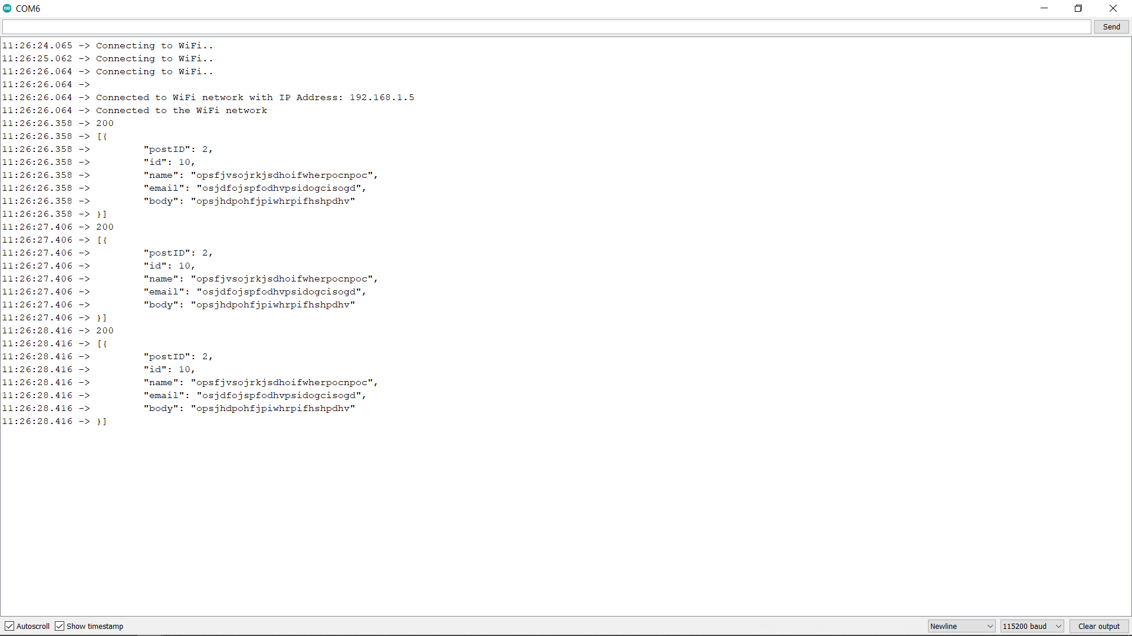

## Interface Communication

The i2a interface is intended for communication with tags. From there, it receives Wi-Fi and BLE radio samples (fingerprints) and status messages from the tags.

The interface specification for receiving radio samples is the following (Figure 25):

<http://ils.dsi.uminho.pt/ar-ware/S02/i2a/i2aSamples.php>[13]

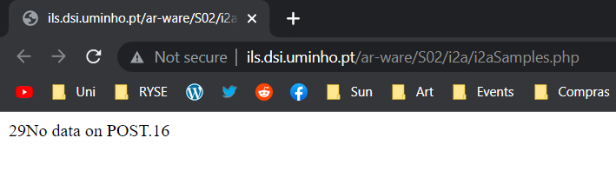

Figure 25 - ILS Uminho Interface

The requests are of the POST type, and only the scanData variable is sent in the request body. A scanData variable is a JSON object whose structure depends on the type of reading the tag performed. The semantics of the fields used in these JSON structures are described in the following table (Table 8):

Table 8 - JSON Structure

| **Field** | **Description** |
| --- | --- |
| **tagName** | String with a name assigned to the tag |
| **tagBSSID** | MAC address of the tag’s Wi-Fi interface (it uniquely identifies the tag) |
| **tagNetwork** | The Wi-Fi network the tag is connected to |
| **dataType** | Type of data being sent. There are two possible values: BLE and Wi-Fi |
| **scanMode** | “auto” – means the tag is in automatic mode, where it performs a scan every x seconds  “manual” – means that the tag is in manual mode. That is, it only reads the radio environment when the user asks (press the physical button on the tag) |
| **BLEData** | List of what was collected from the BLE radio interface. |
| **WiFiData** | List of what was collected from the Wi-Fi radio interface. |
| **bssid** | Address of a BLE device detected in the vicinity of the tag or  address of a Wi-Fi AP detected in the vicinity of the tag |
| **rssi** | The signal level of the BLE device detected or the Signal strength of a Wi-Fi AP detected in the vicinity of the tag |
| **name** | Name of the detected BLE device |
| **ssid** | Wi-Fi network name |
| **encrypt** | Type of encryption used on the Wi-Fi network |

At each POST request to send a sample, the i2aSamples interface responds with: - the string “No data on POST” if the request body is empty.

An initial version of a web interface is available to check what has been registered on the server (Figure 26):

<http://ils.dsi.uminho.pt/viewData/>[14]

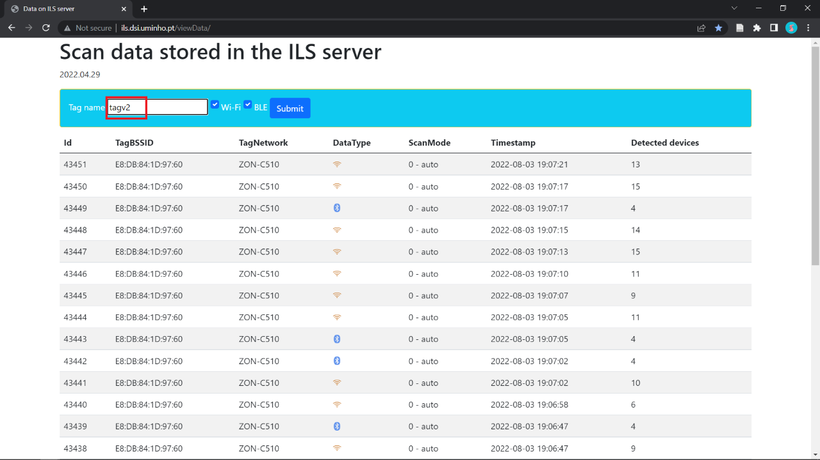

Figure 26 - Scan data stored in the ILS server

The system only displays the last 30 records.

## Testing with Postman

An example needed to test the communication as a server is obtained by importing a JSON file as a collection with Postman[15].

The request arrives at the web server but must be well formatted. The server returns a “200 OK” HTTP Status Code and an empty body text (Figure 27).

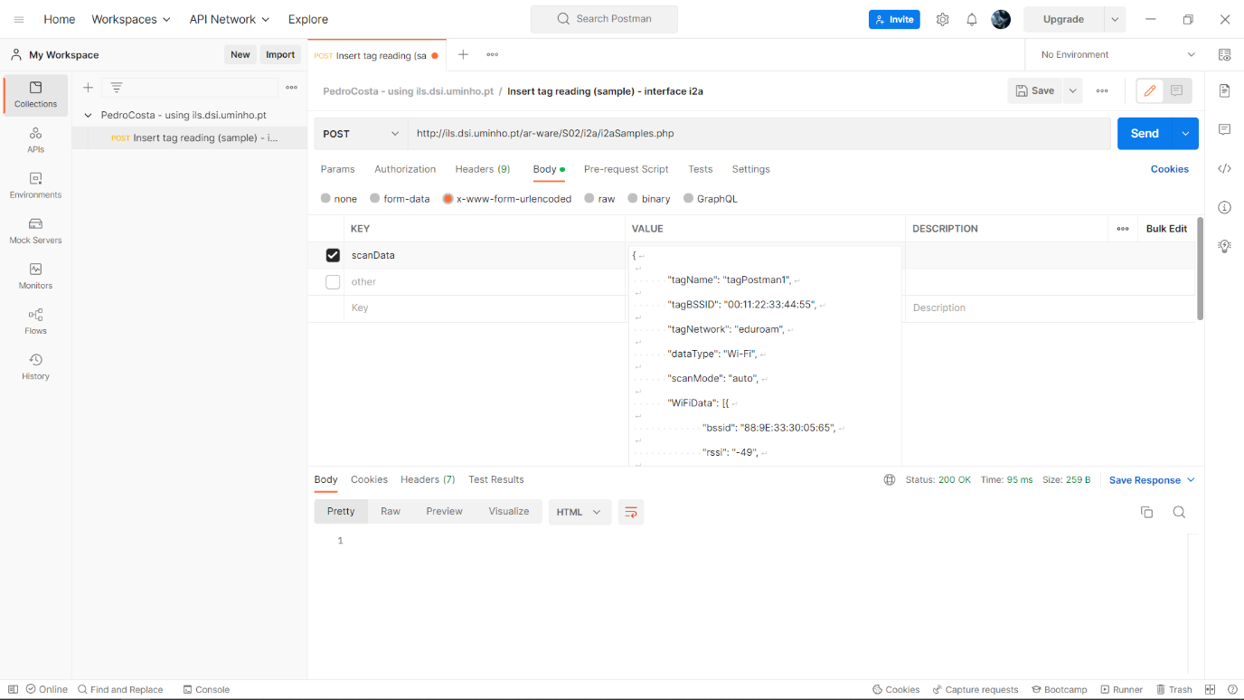

Figure 27 - 200 OK Status Code

View of the web server's registrations (Figure 28).

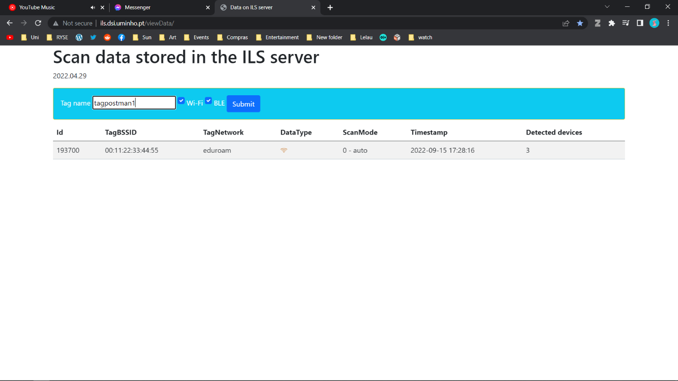

Figure 28 - Server Log

The system should display a warning if it does not find the data in the requested location, resulting in a “No data on post” error (Figure 29). This situation typically occurs when the JSON is not sent in a variable called “scanData”.

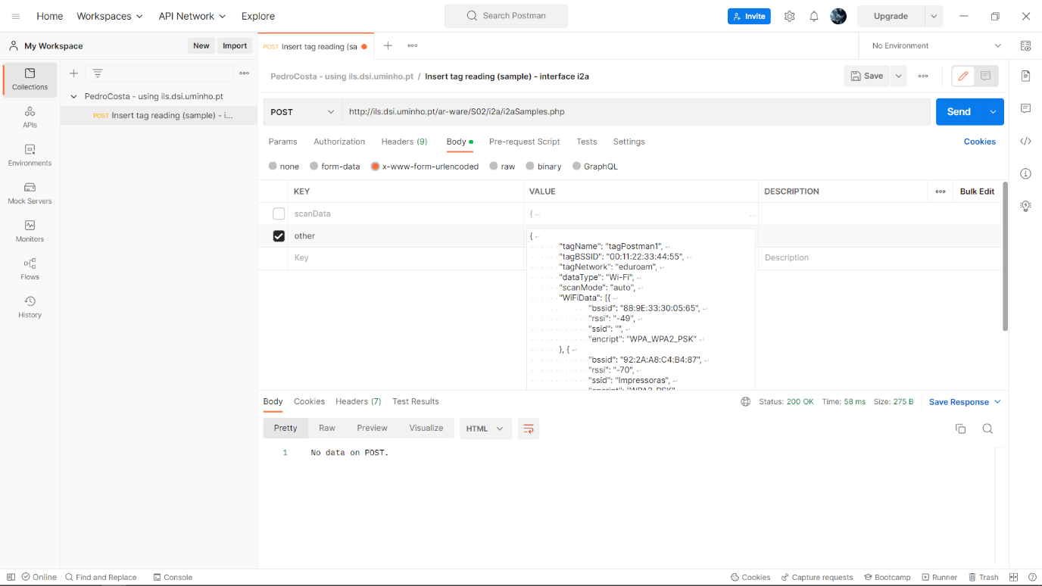

Figure 29 - No data on Post error

## Use Cases

This section describes how the tag interacts with the system. The use cases identify success and failure scenarios and any critical variations.

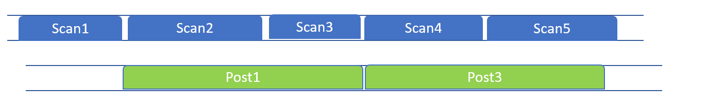**Case 1: Delayed Post (Figure 30)**

Figure 30 - Case 1

Case 1 is the standard procedure for the program. The post thread takes more time to complete than the scan thread. After a post is completed, information from the last scan will be in the queue, ready to be retrieved from the following post thread.

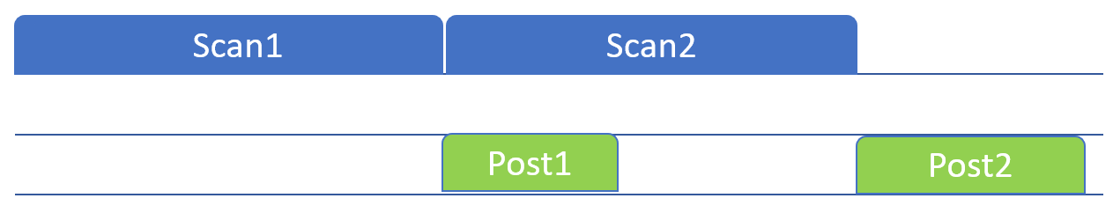**Case 2: Delayed Scan (Figure 31)**

Figure 31 - Case 2

Since the post thread starts after the scan is complete, it will wait until the scan is finished and the new information is available to be sent to the server.

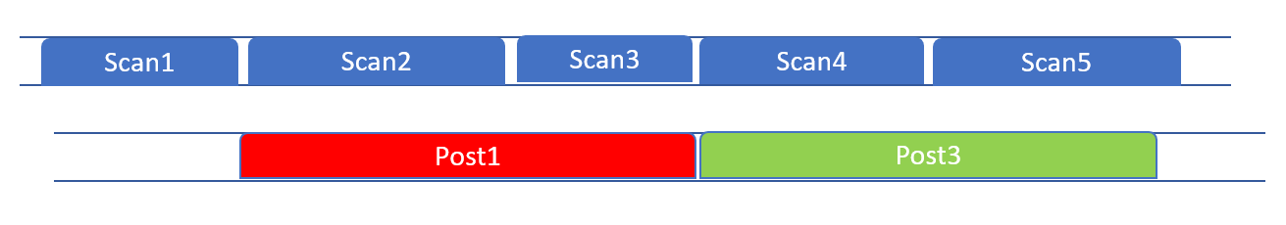**Case 3: Unsuccessful Post (Figure 32)**

Figure 32 - Case 3

Here it is explained how the program proceeds if a post is unsuccessful. The post thread will finish with an inadequate response from the server. Then, the information contained in the queue (from the last scan) will be retrieved from the following post thread and will be posted.

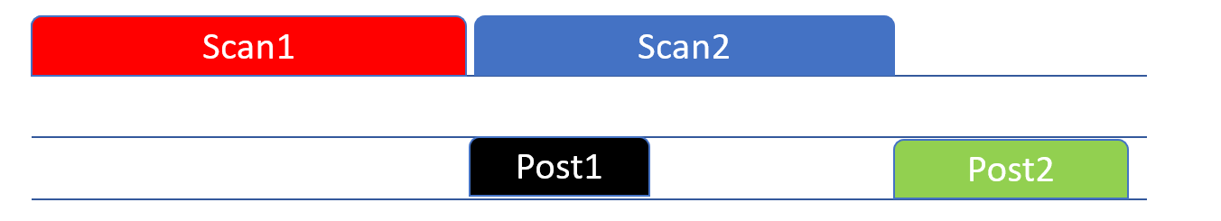**Case 4: Unsuccessful Scan (Figure 33)**

Figure 33 - Case 4

Over here, how the program will deal with an unsuccessful scan is explained. If a scan is unsuccessful, the queue will be empty, meaning the post must not be performed. The condition states that the post will not be performed if the scan information is empty. Therefore, the post thread will wait for the following scan to provide new data and post it.

## Negative Response Codes

It is possible to determine whether an HTTP request has been completed by looking at the response status code. Nevertheless, is there a meaning to negative response codes?

After implementing the project and verifying everything was working correctly, it was observed that the logs response occasionally is a negative code rather than a 200 OK.

For some Posts, an error arose [16] A negative response code is received, which could be -1 or -11[17] (Figure 34), resulting in the entire process getting terminated, so further investigation was required to handle this issue.

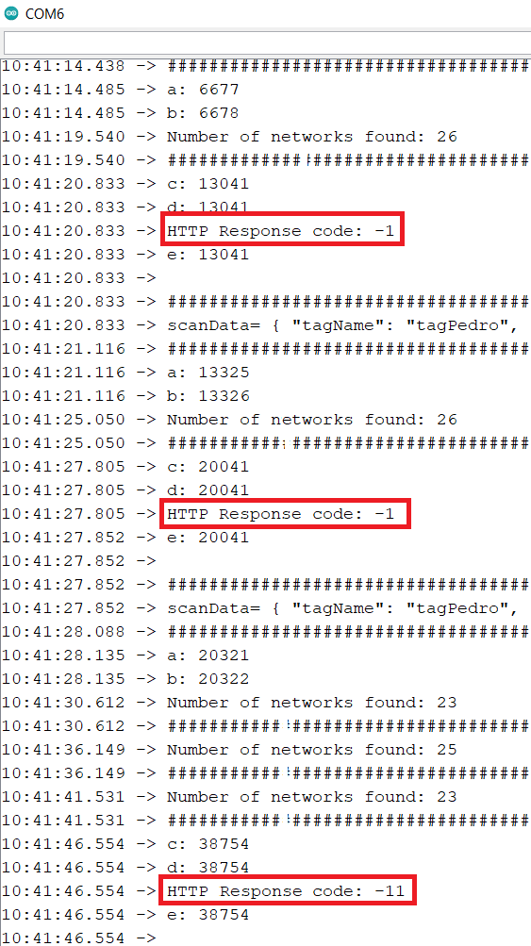

Figure 34 - Negative HTTP Response Codes

What could -1 mean? Should it be handled differently from -11?

There is a slight difference between the two, but it is unnecessary to prevent cookies from getting set in either case. It returns -1 if no code can be discerned from the response (i.e., it is not valid HTTP). It seems that the -11 response times out without responding due to the default time-out of 5000ms (Figure 35).

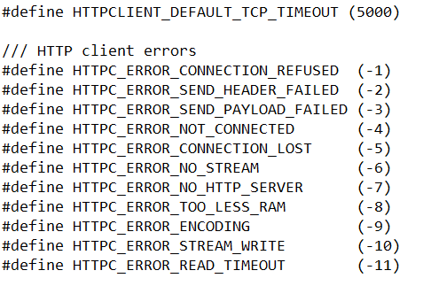

Figure 35 - Negative Response Codes

## Exception Stack Trace Decoder

It is challenging to pinpoint where a runtime error occurred. A tool must be installed to determine precisely where the problem is (G6EJD - David, 2018). With this Arduino plugin, the user can get a more descriptive explanation of the stack trace.

**Installation**

* The tool archive can be downloaded from the releases page[18] (Figure 36).

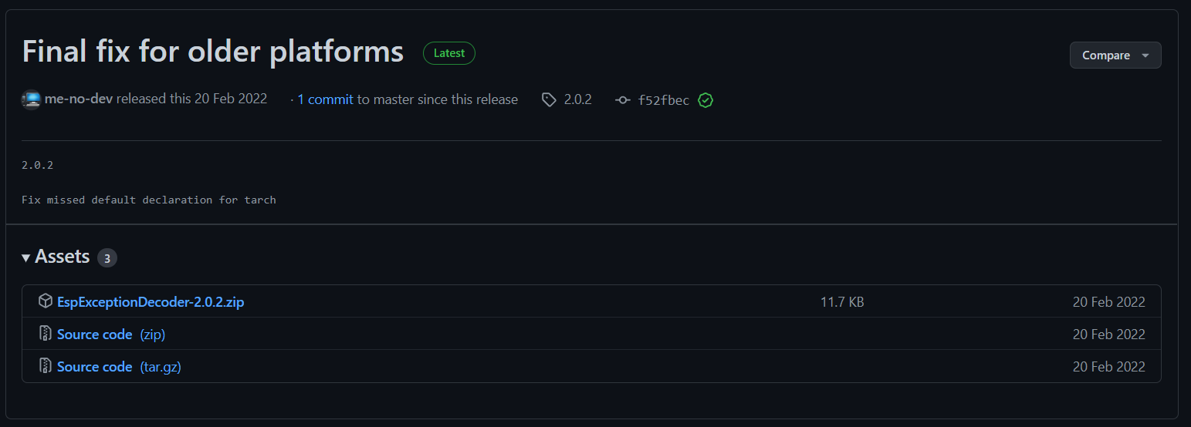

Figure 36 - Releases page

* The tool must be unpacked into the tools directory C:\Users\35193\Documents\Arduino\tools (Figure 37).

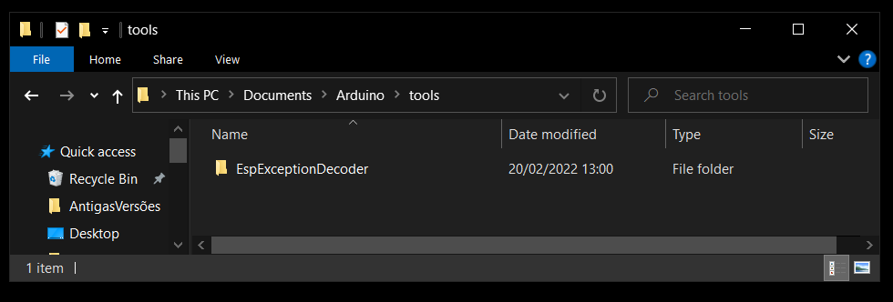

Figure 37 – Tools directory

* Arduino IDE should be restarted.

**Usage**

* Compile and upload a sketch.
* 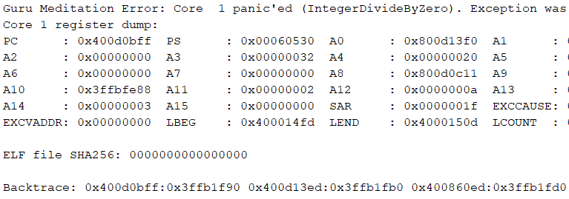Copy the backtrace line when it fails with a runtime error (Figure 38).

Figure 38 - Runtime error

* 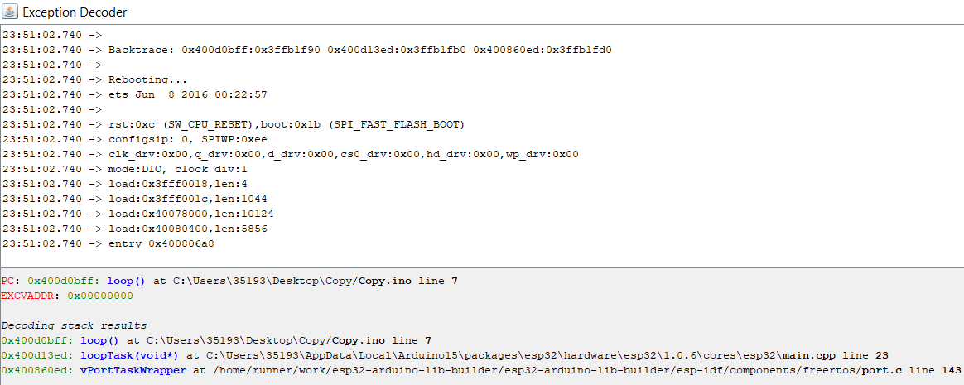The result will be displayed in the bottom pane of the exception decoder once the stack trace is pasted into the top pane (Figure 39).

Figure 39 - Exception Decoder

NOTA: A estrutura deste capítulo precisa de ser revista e é preciso acrescentar algumas secções. A estrutura que sugiro é a seguinte:

4.1. System requirements and arquitecture

- usar esta secção para descrever a arquitectura geral do sistema (tag + servidor) e para descrever os requisitos funcionais e não funcionais (ver notas no início deste capítulo); nesta secção pode incluir a descrição da interface i2a. Também deve incluir os use cases. Não esquecer de dizer que queremos fazer scans Wi-Fi e BLE em simultâneo.

4.2. Software development environment

- usar esta secção para descrever a instalação do IDE e tudo o que lhe está relacionado

4.3. Tag internal architecture

- usar esta secção para descrever: i) os recursos que existem no ESP32 (2 cores, etc.); ii) a arquitectura do software da tag (a parte das Preferences, a parte dos scans Wi-Fi, a parte dos scans BLE, a parte dos POSTs, a fila de espera, etc.); nesta parte deve descrever como é que aproveitou o facto de ter 2 cores; iii) o processo de arranque da tag e da alteração das configurações (arrancar em modo AP e criar um webserver co mum form HTML; mudar para modo STA; contactar o servidor para actualizer os parâmetros, etc.).

# Evaluation

This chapter intends to define how this project was evaluated, describing the implementations referred to in previous chapters and how they were validated to solve the problems exposed. The results of this assessment will then be incorporated into a single validation document.

## Test Environment

An environment for testing is a set of software and hardware that allows a team of testers to execute test cases. In other words, it allows the testing team to execute tests with hardware, software and network configurations that support test execution (LaunchDarkly, 2021).

The test environment is configured according to the needs of the test application. In this instance, the test bed comprises the test environment and data. A proper test environment ensures software testing success. An incorrect setup can lead to inconsistent results, resulting in extra costs and delays.

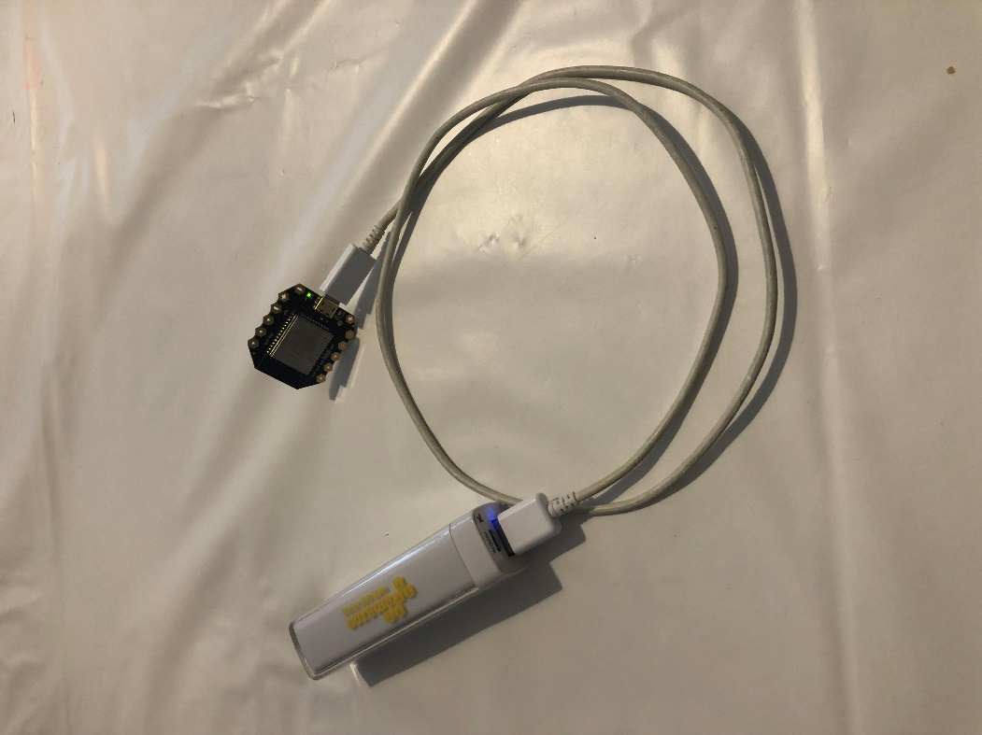ESP32 firmware is first built in the Arduino IDE before being flashed onto the board (Figure 41). The board is then connected to the powerbank and operates until its battery runs out (Figure 40).

Figure 40 - ESP32 connected to the Powerbank

Figure 41 - Firmware Flash

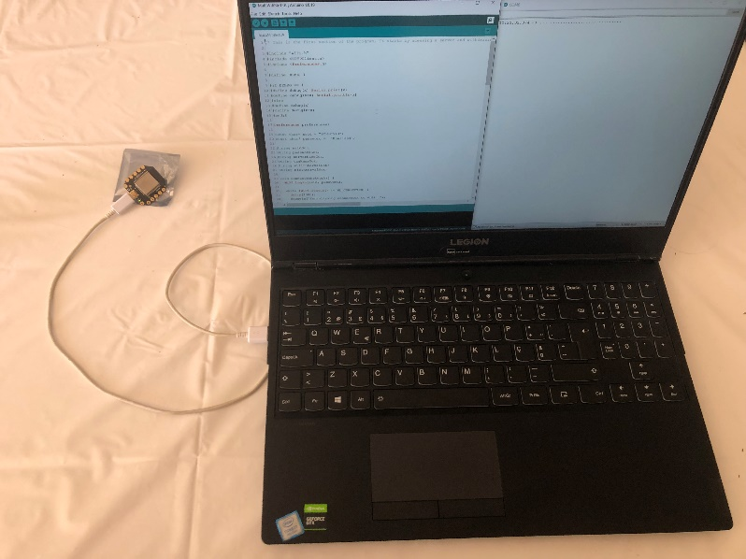

## Test Case

A Test Case is a well-designed document to develop and better understand the test case data for a particular scenario (Vijay, 2012). A good Test Case maintains test artefact consistency for the test team and makes it easy for all stakeholders to understand the test cases. Writing test case in a standard format lessen the test effort and the error rate (Rajkumar, 2016).

Irrespective of the test case documentation method chosen, any good test case template must have the following fields (Table 9):

Table 9 - Test Case Specifications[19]

| **Test Case Field** | **Description** |
| --- | --- |
| **Test case ID** | A unique ID is required for each test case. |
| **Test Created By** | Name of the Tester who executed the test |
| **Test Execution Date** | Date when the test was executed |
| **Description** | Describes the test objective in brief |
| **Pre-conditions** | Conditions that need to be met before executing the test case |
| **Test Steps** | Mentions all the test steps in detail and the order in how they could be executed from the user’s perspective |
| **Test Data** | Use of test data as an input for the test case. Different data sets are delivered with precise values to be used as an input |
| **Expected Result** | The result that is expected once the test cases are executed |
| **Actual result** | The result that the system shows once the test case is executed. The result is captured after the execution. |
| **Status** | Based on the result and the expected result, the status of the test case is set.  If the actual result is not as per the expected result, it is then marked as failed. Otherwise, updated as passed |

## Testing

Various models were built to test the solution—the analysis of these results considered how these models could provide a significant advantage for scanning and posting. Using the tag, we had to evaluate the results derived from the models. From retrieving data to posting, a significant penalty reduction resulted, which allowed posts without the occurrence of problems. The penalty for delays was minimised, practical and efficient. As a result, it is vital to compare methods, choosing the most effective one out of all available.

* **tagT1**

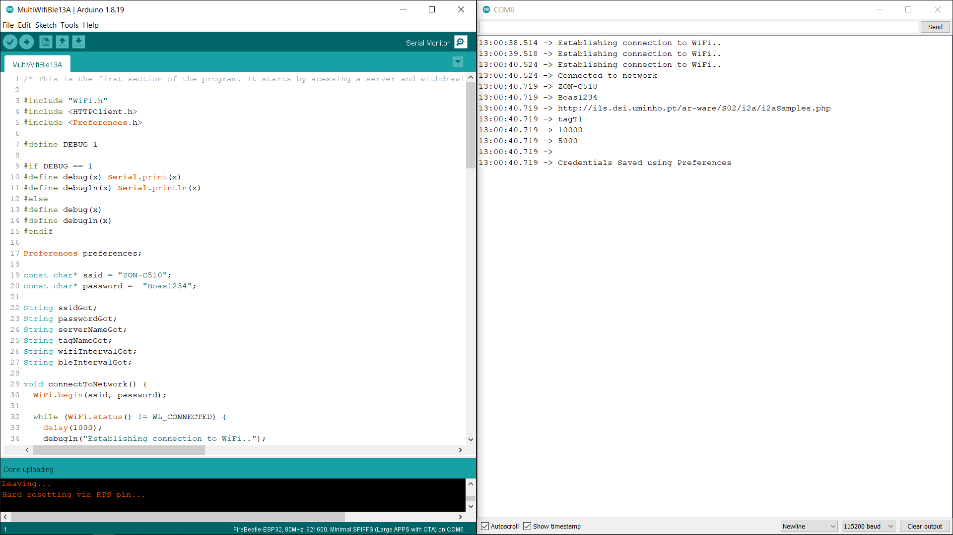

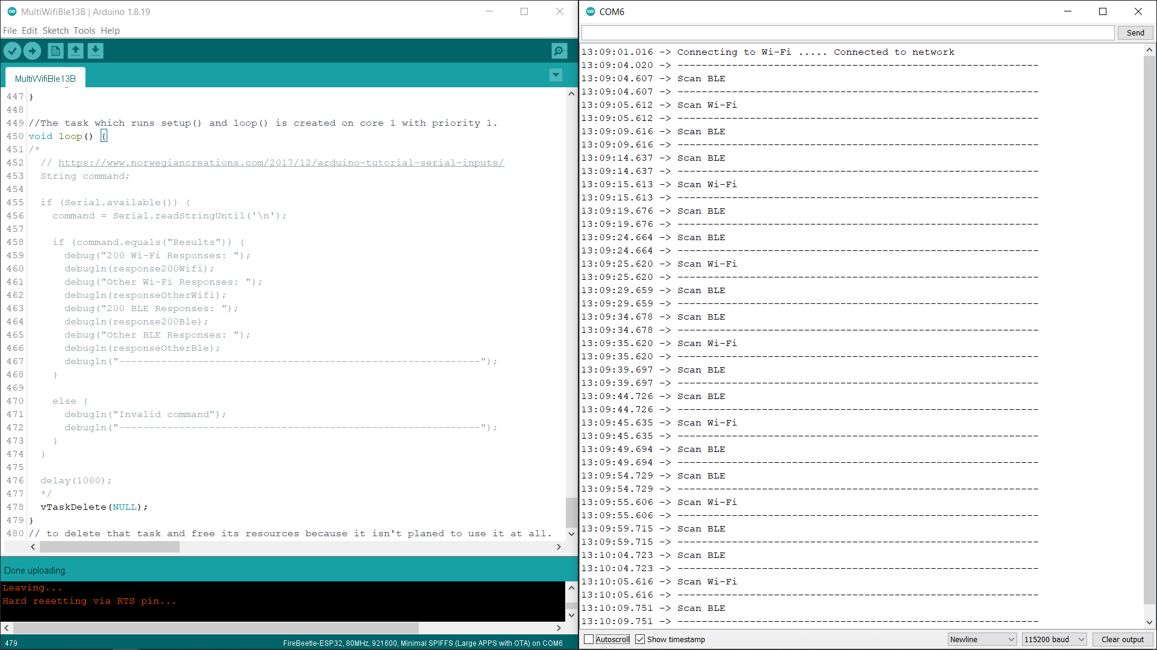

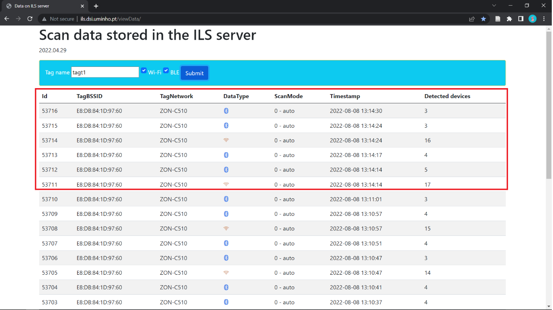

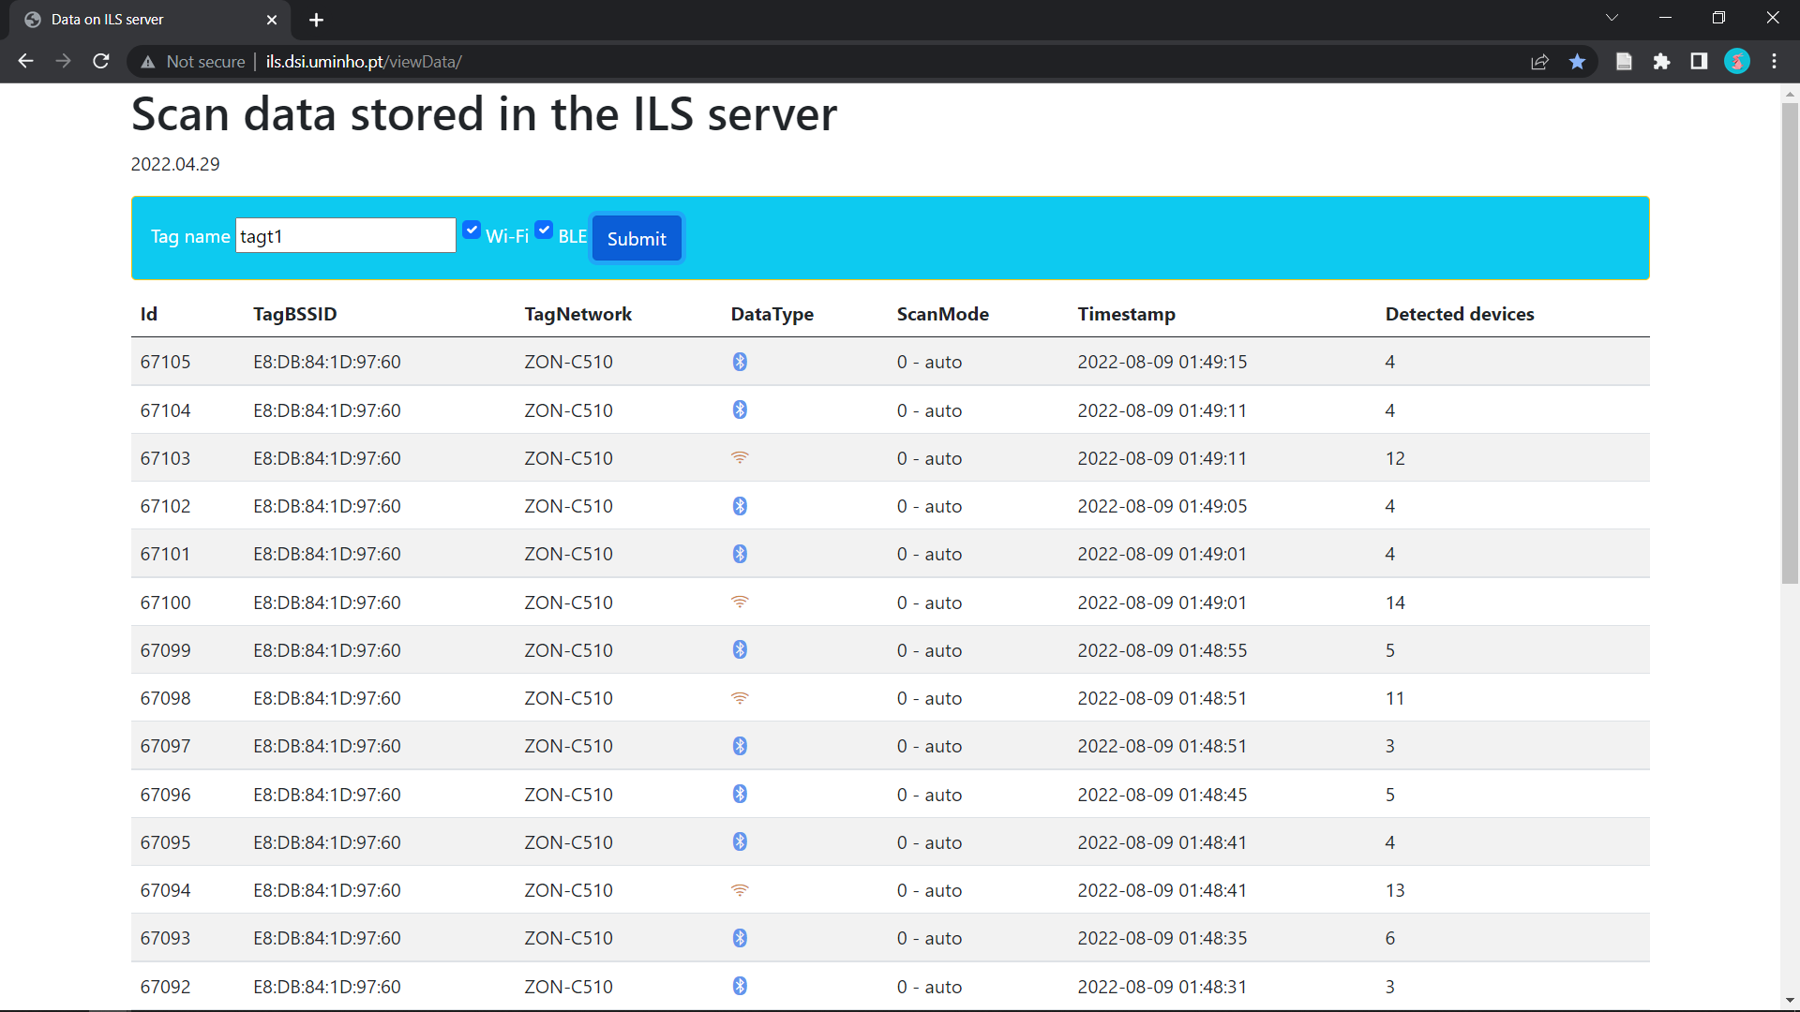

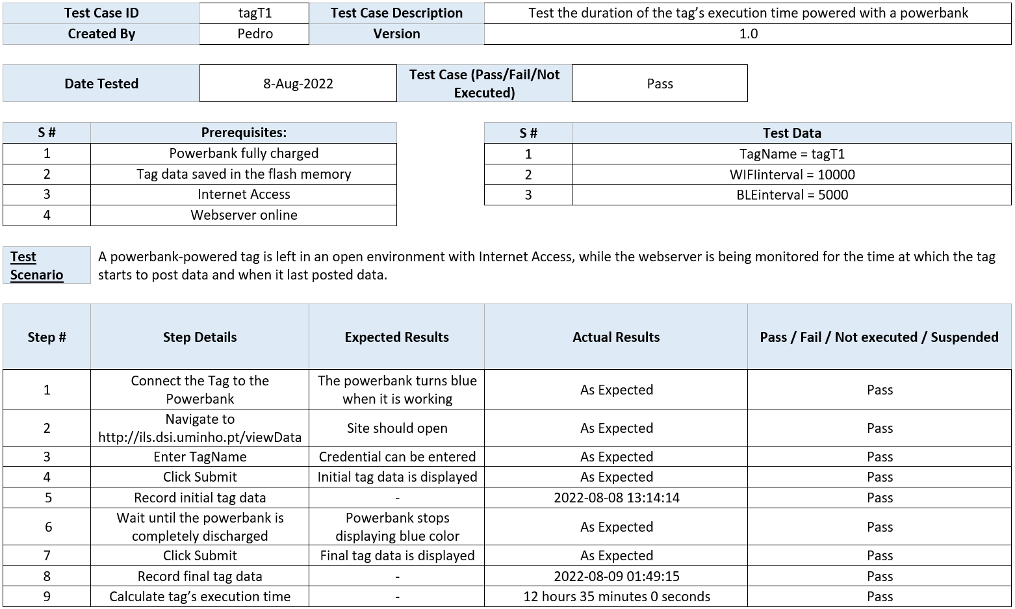

* **tagT2**

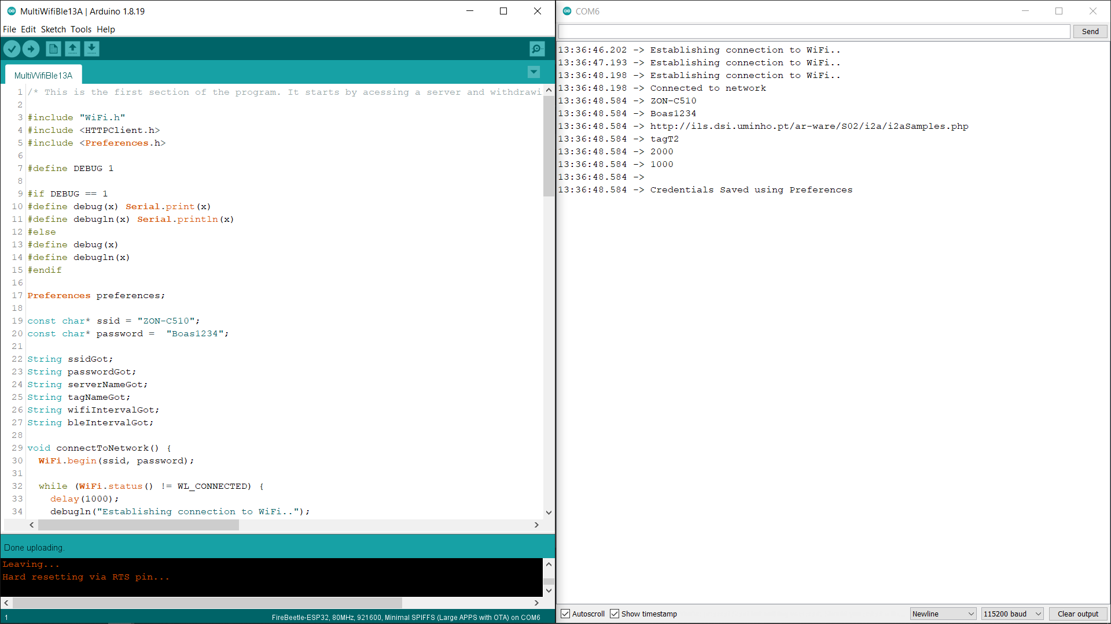

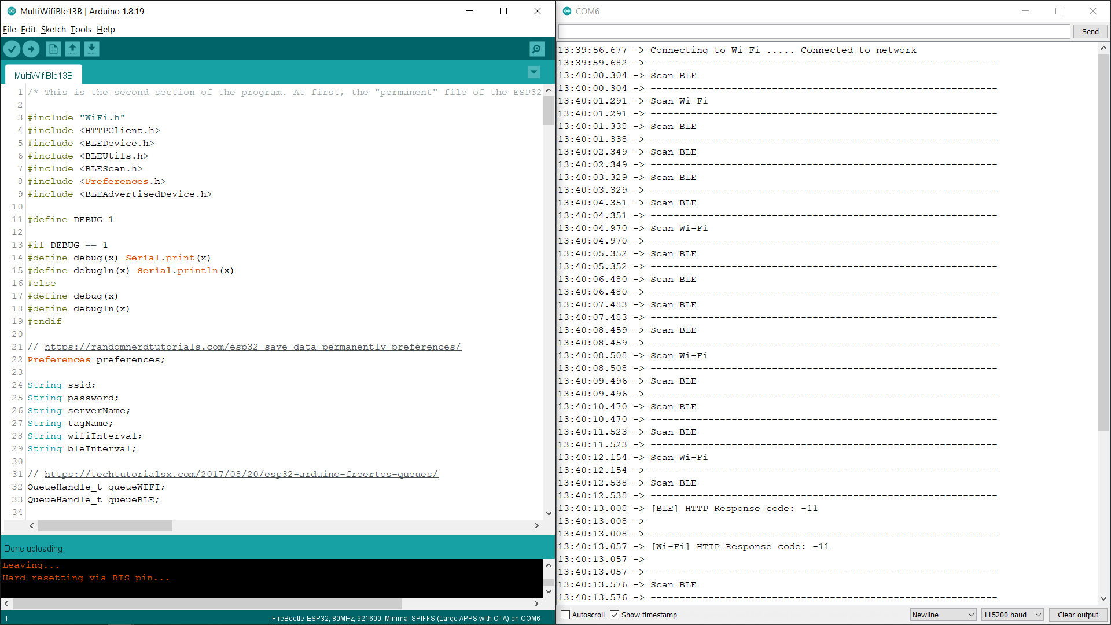

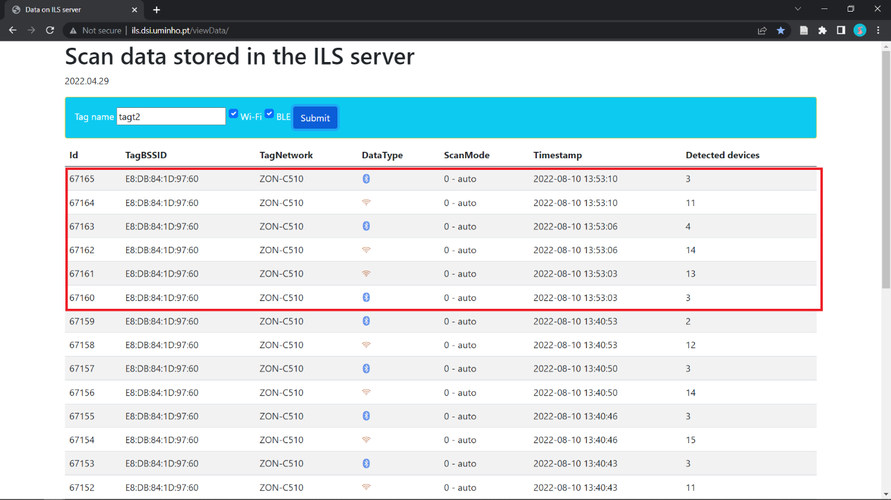

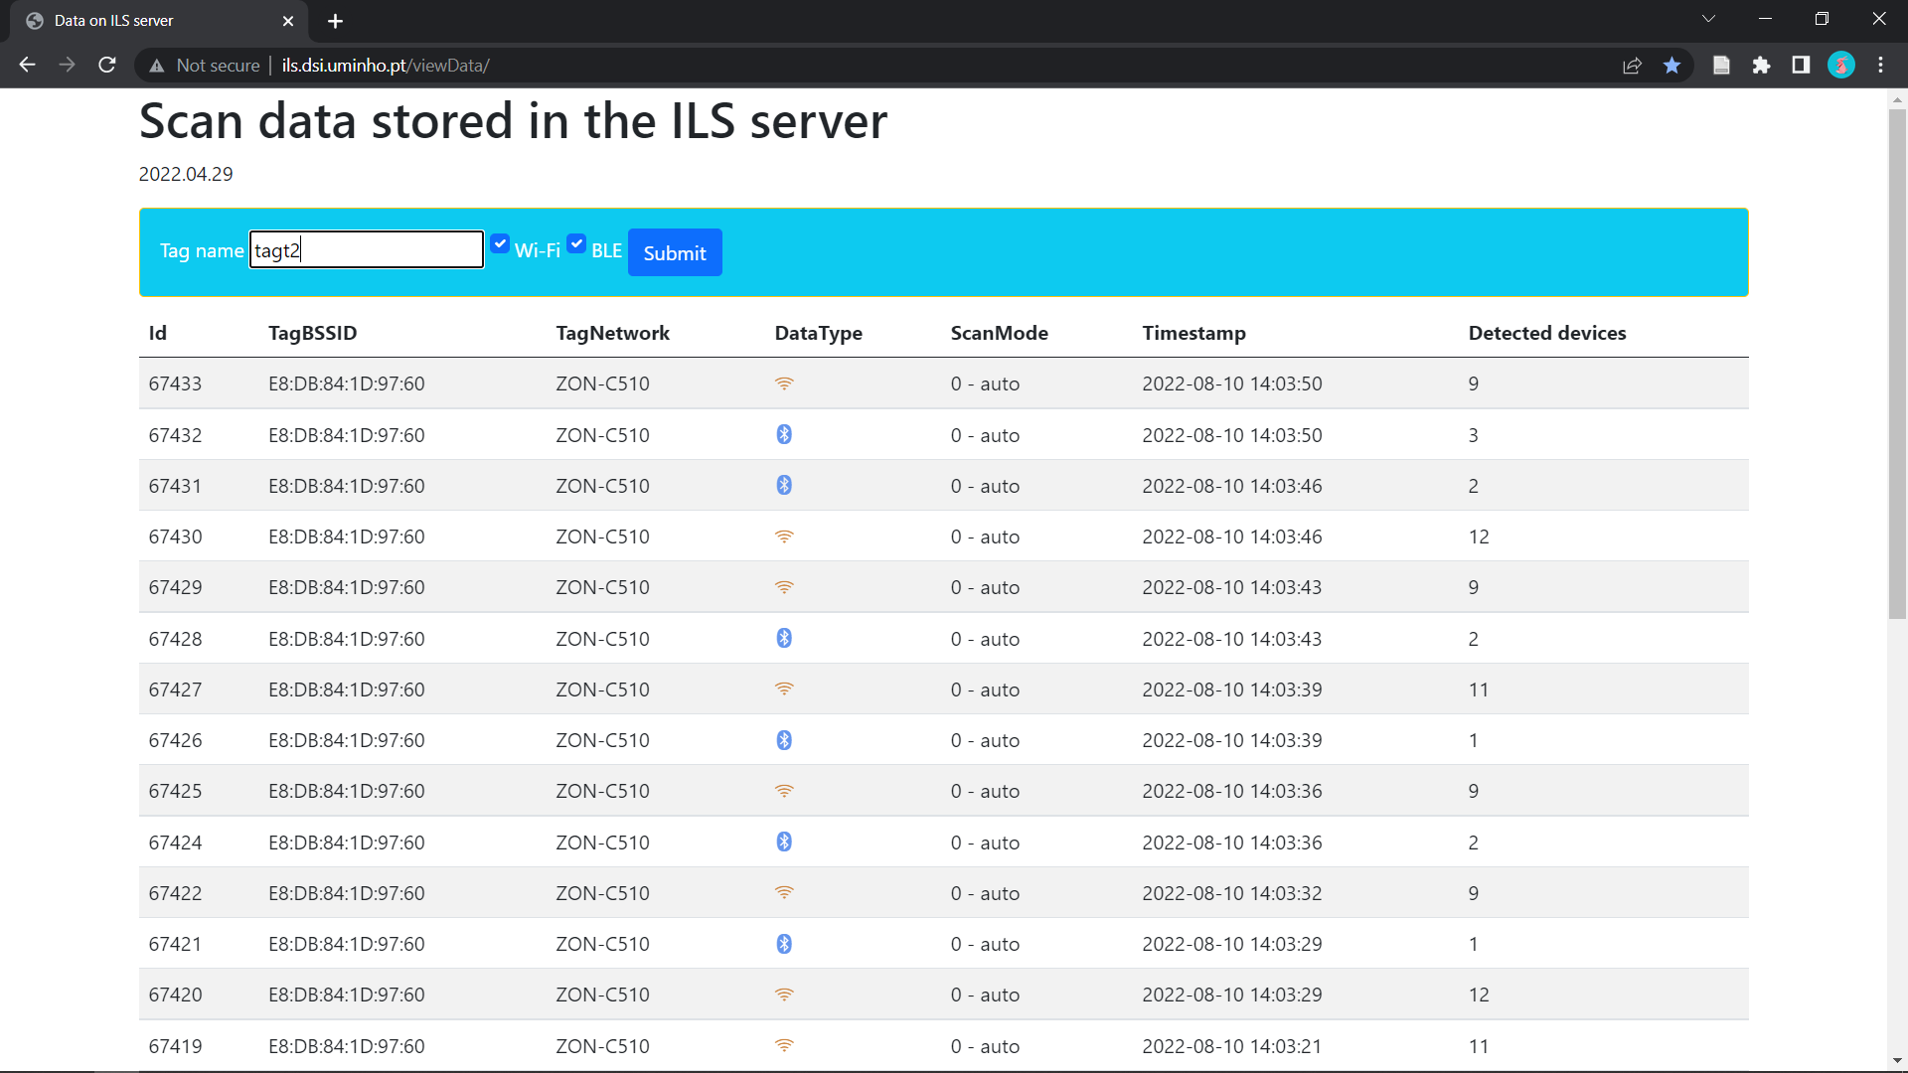

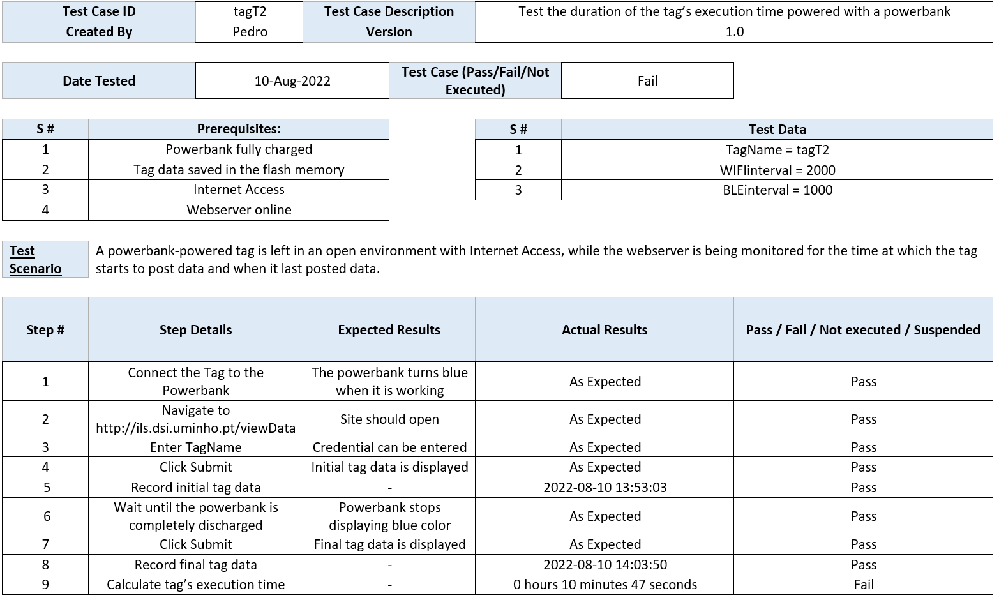

* **tagT3**

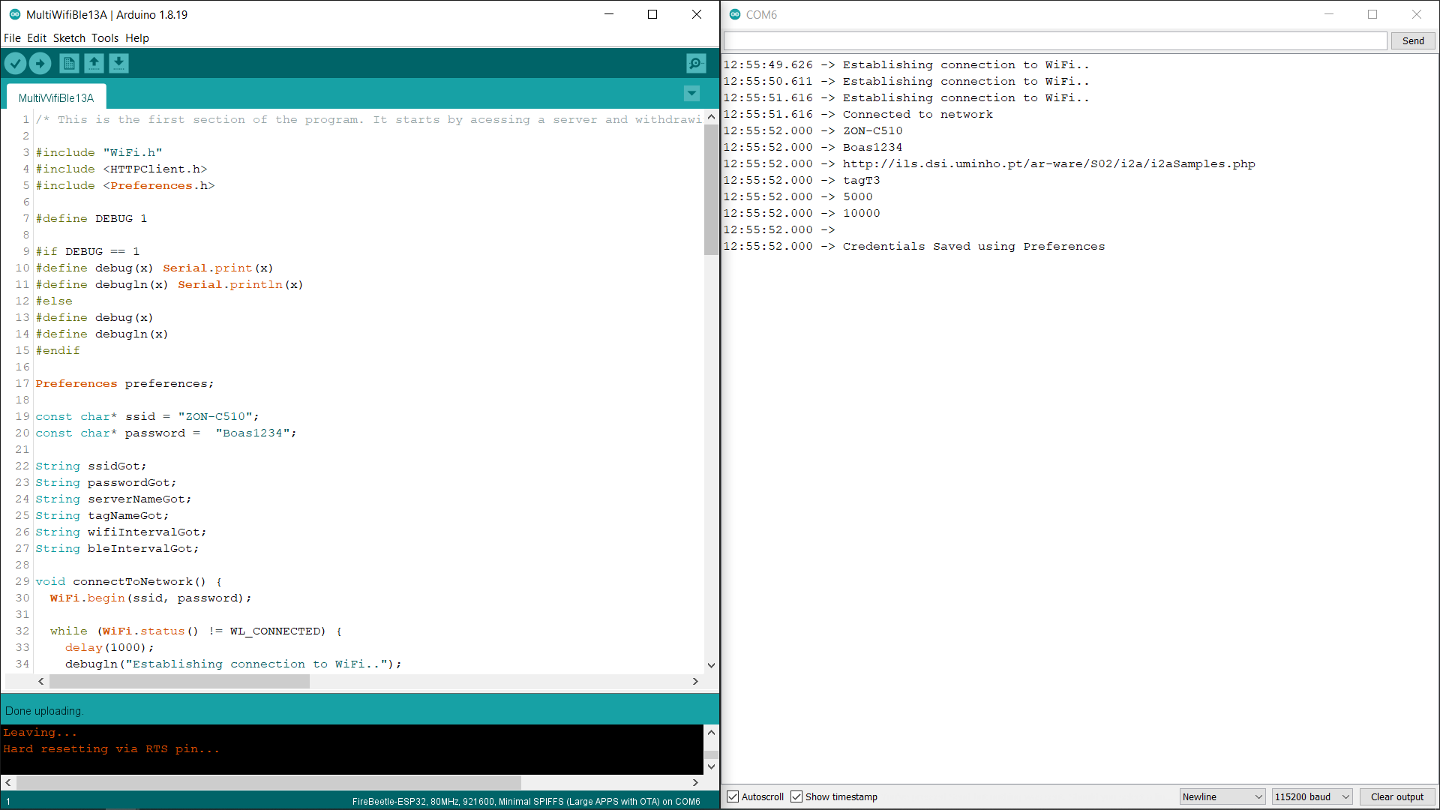

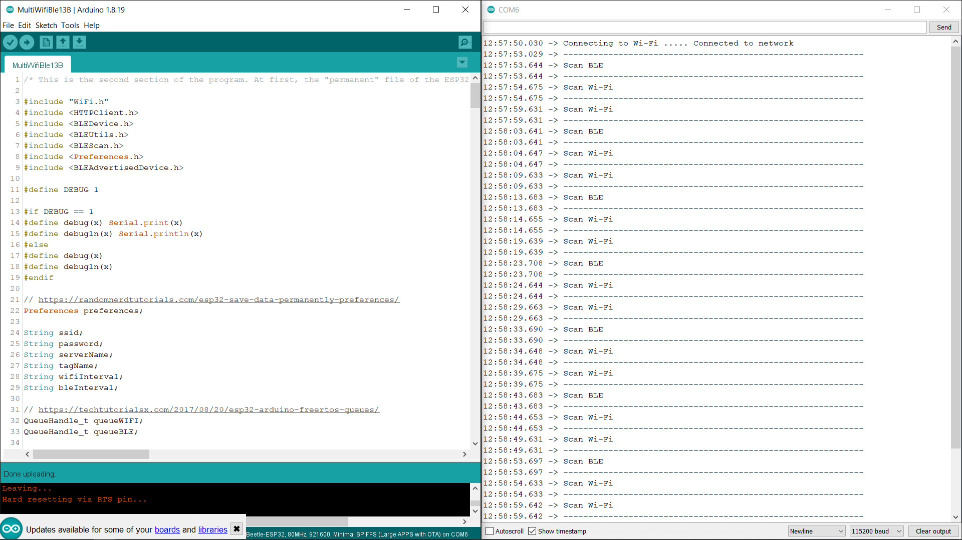

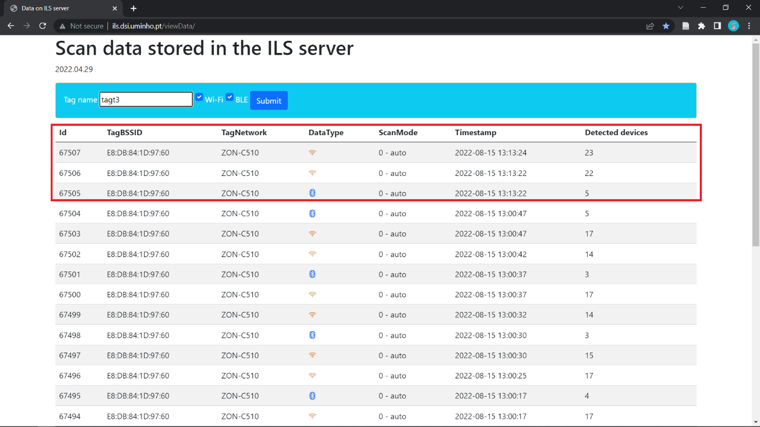

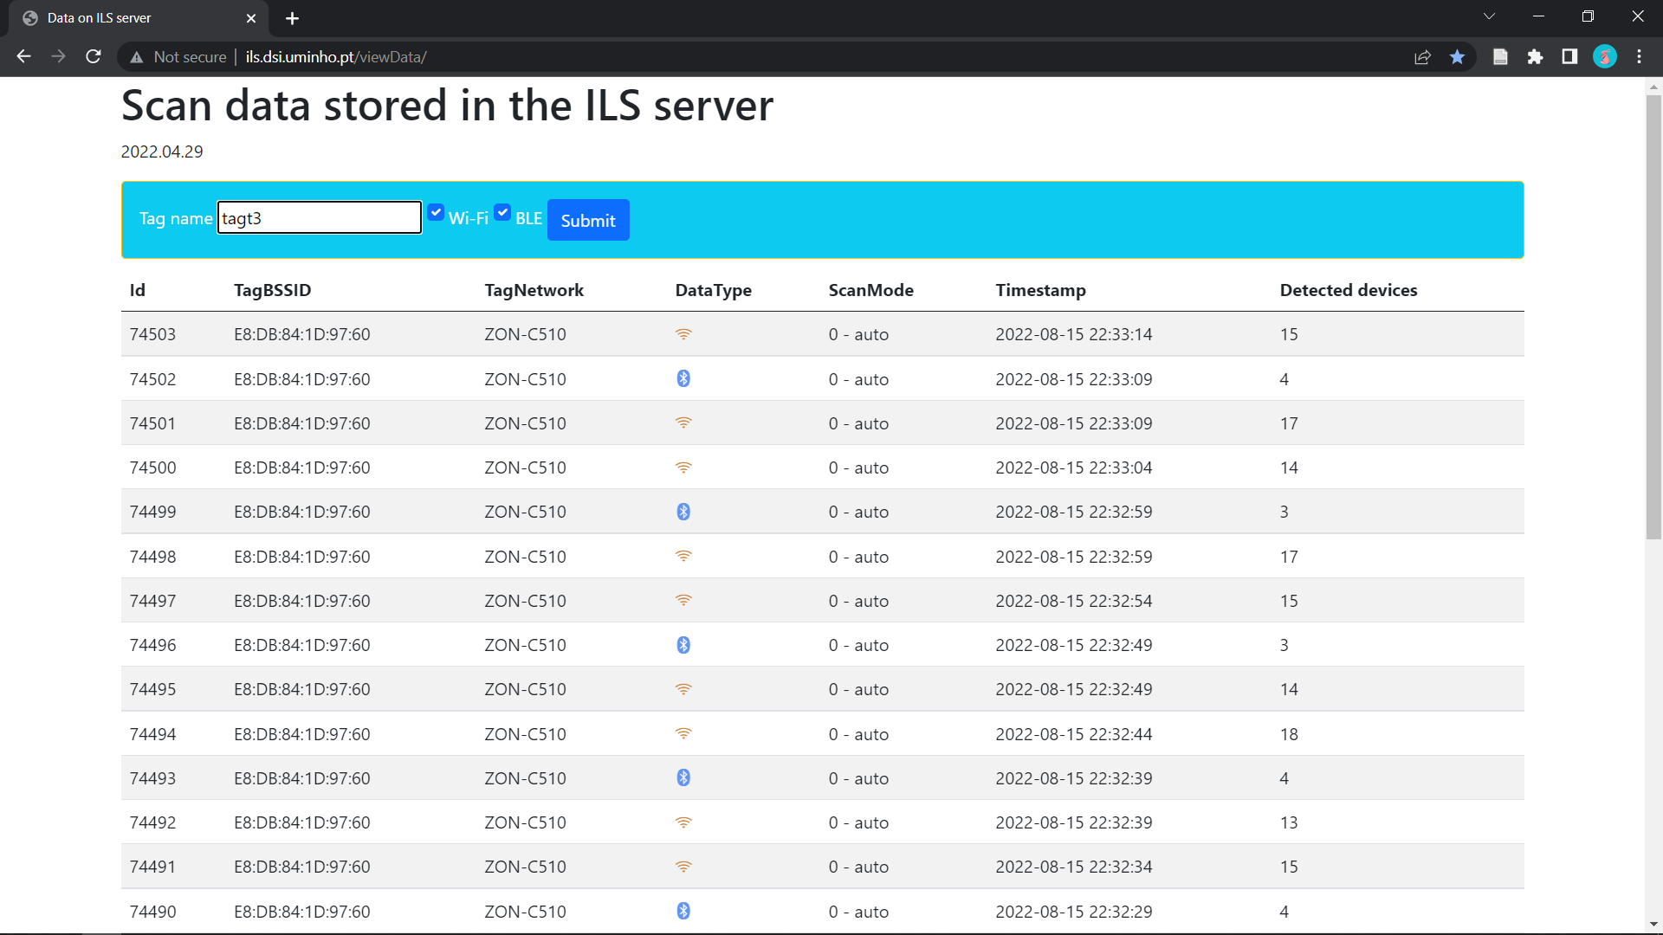

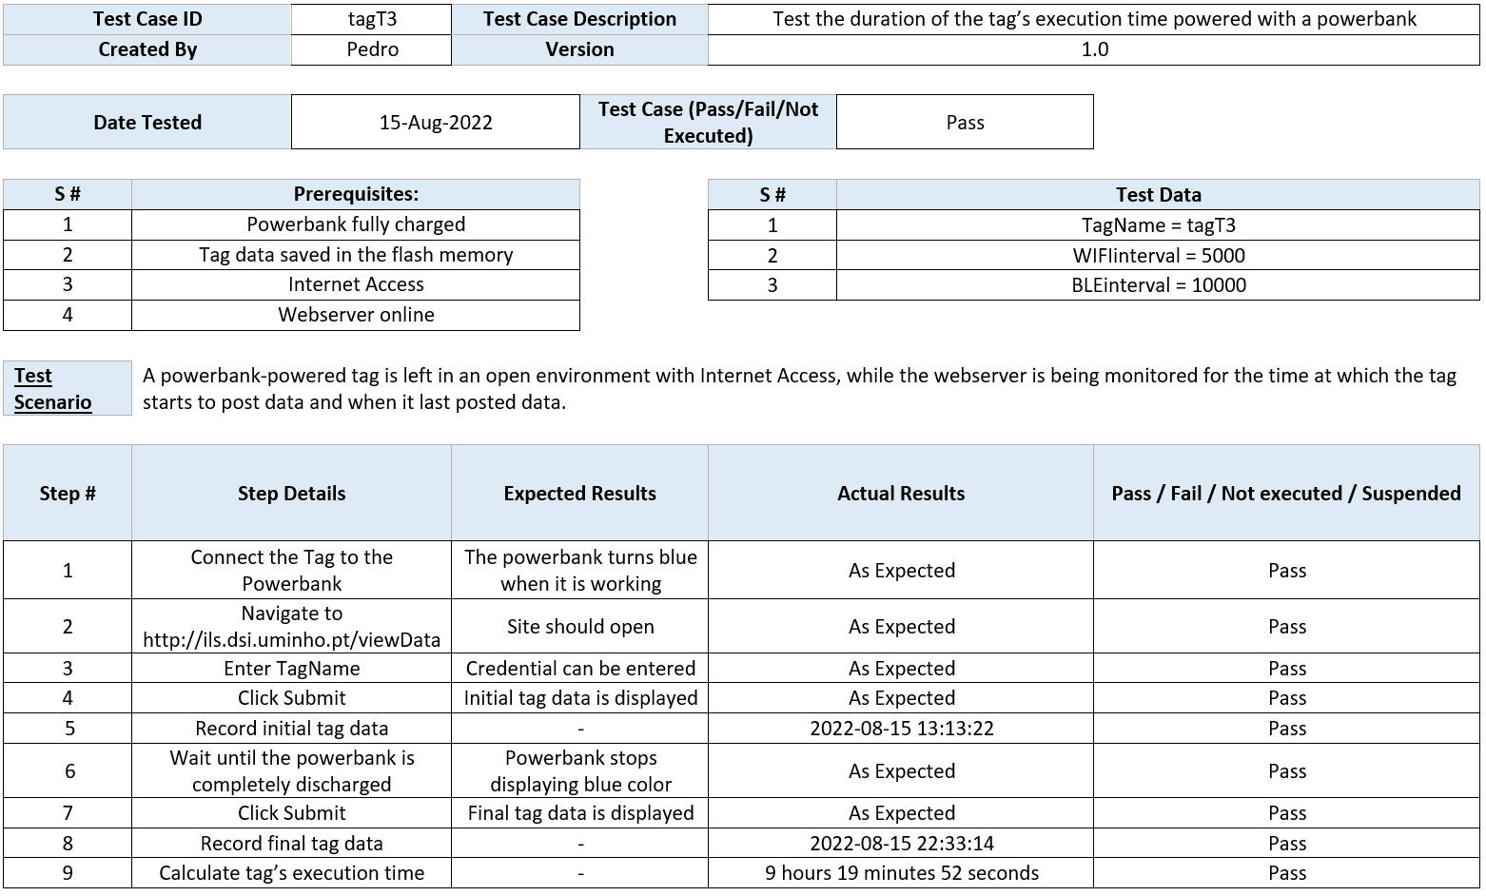

* **tagT4**

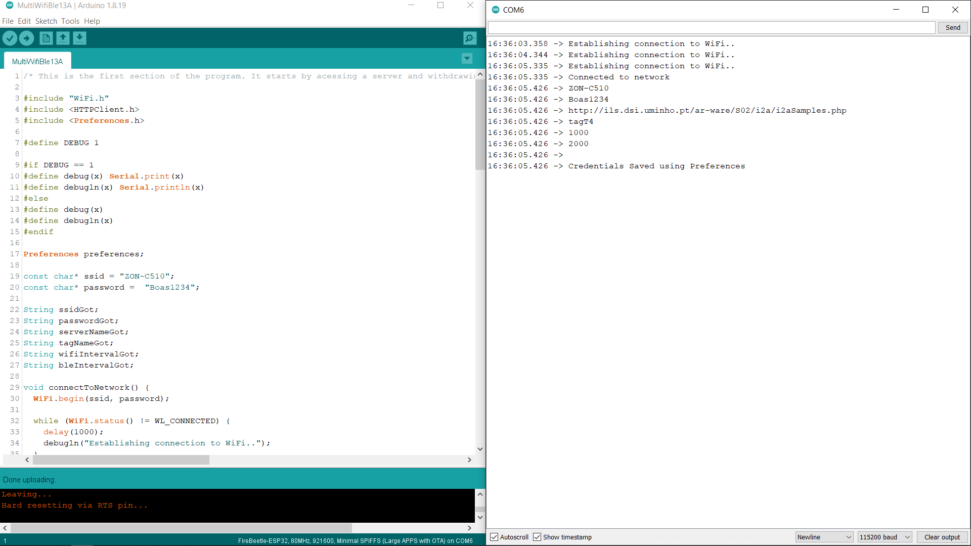

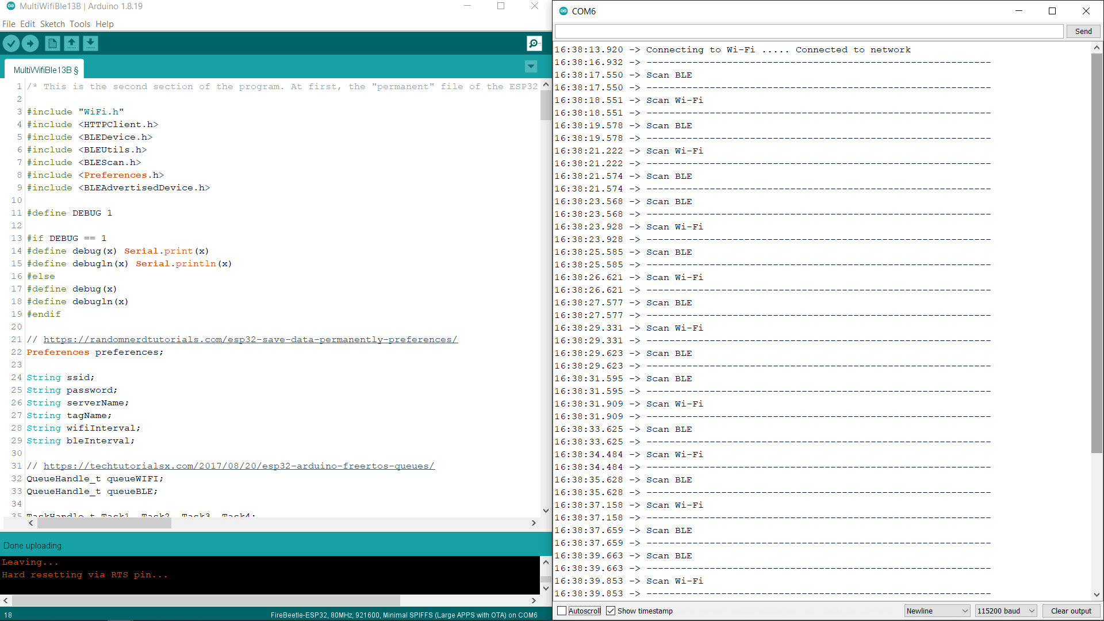

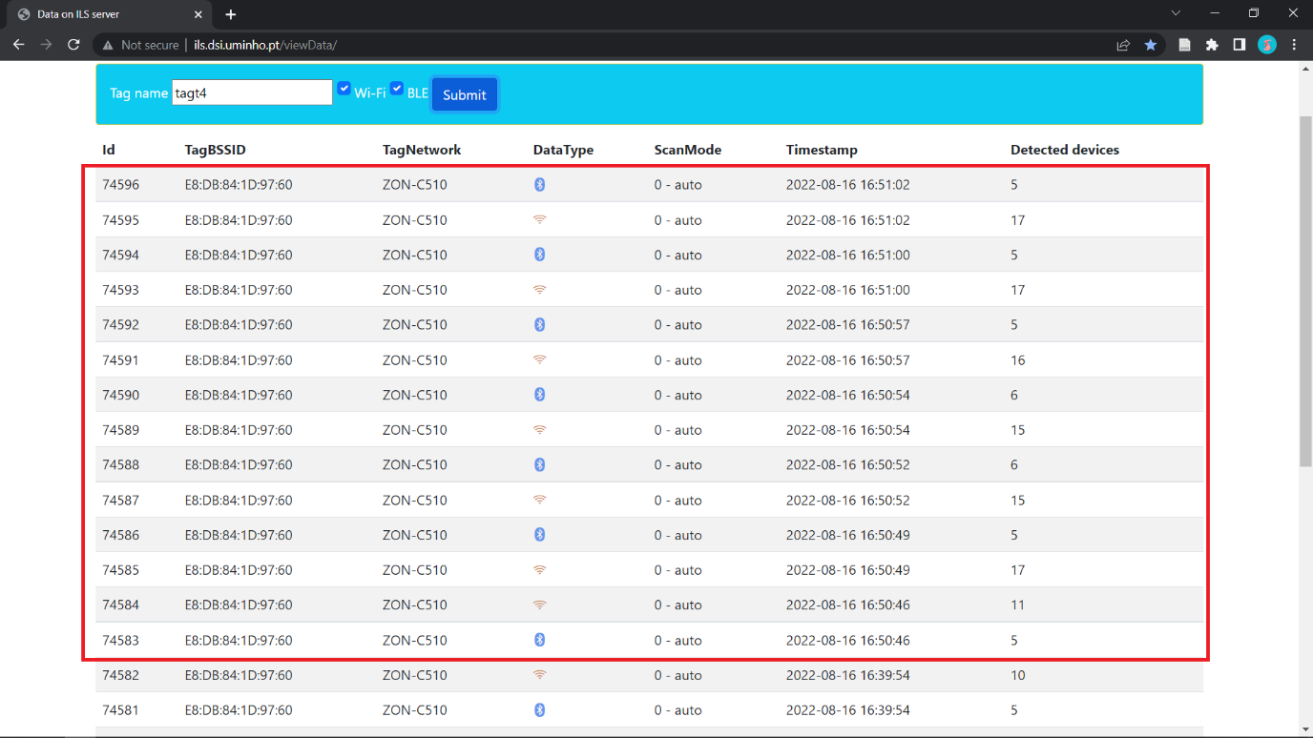

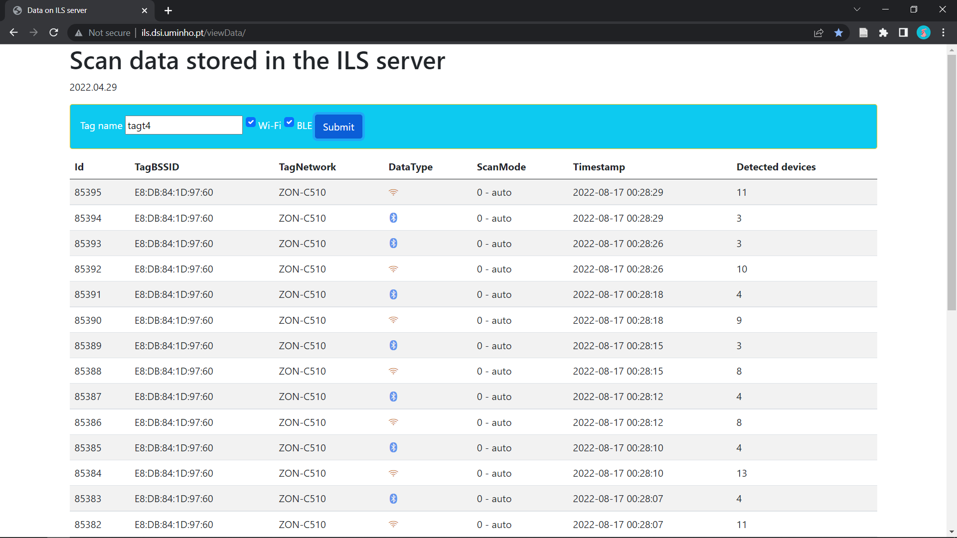

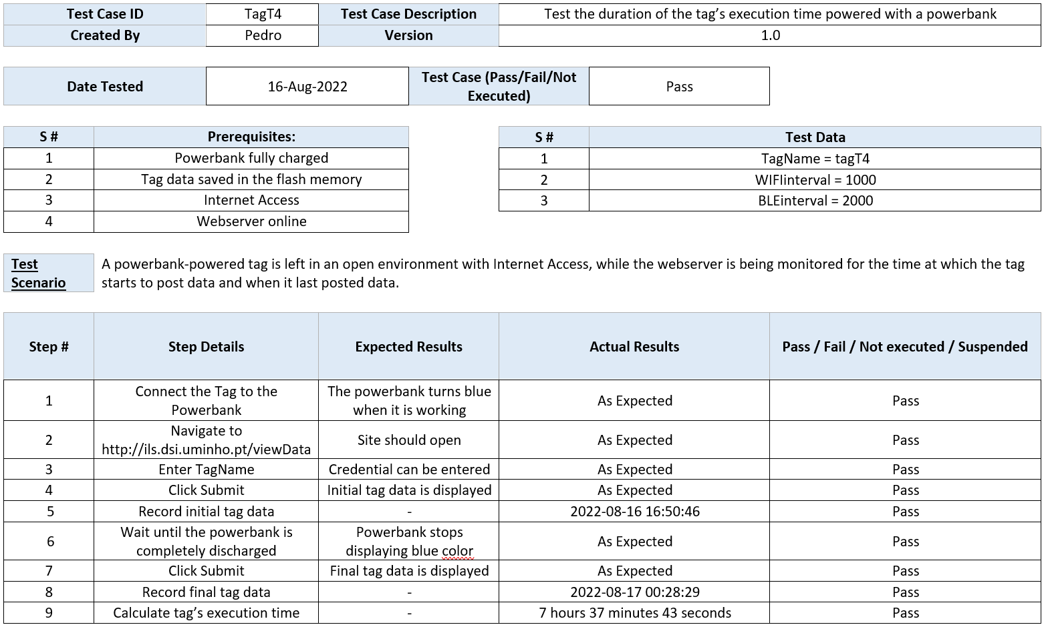

* **tagT5**

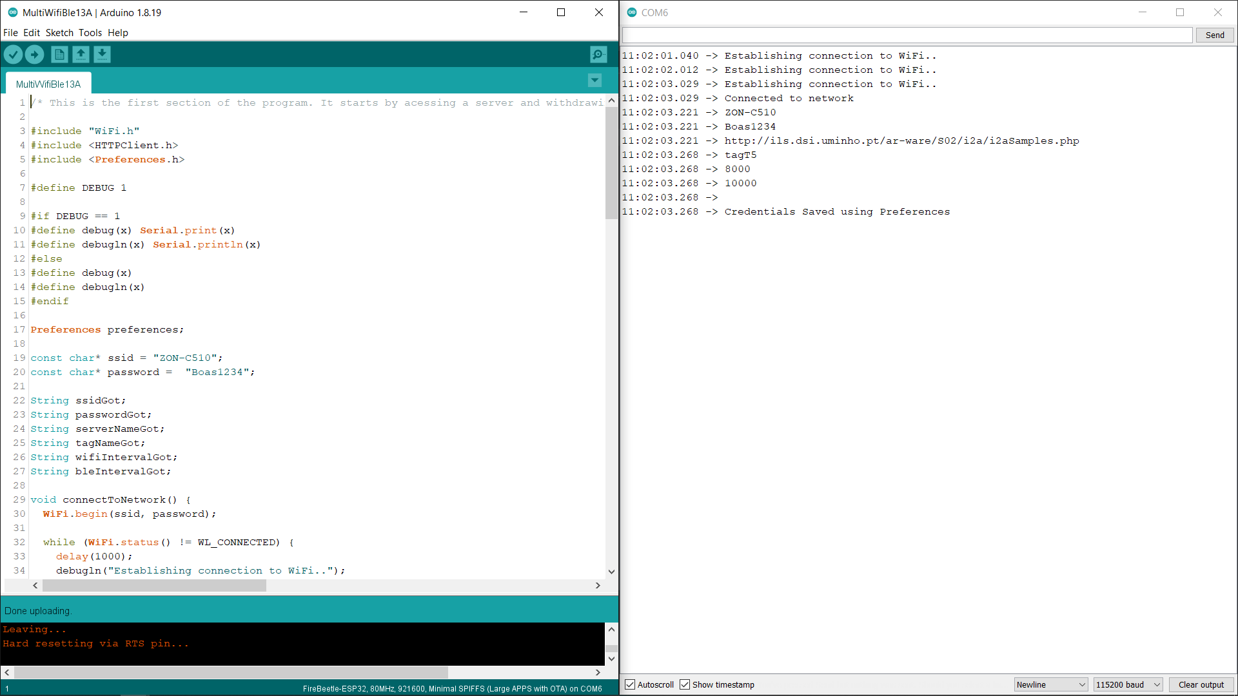

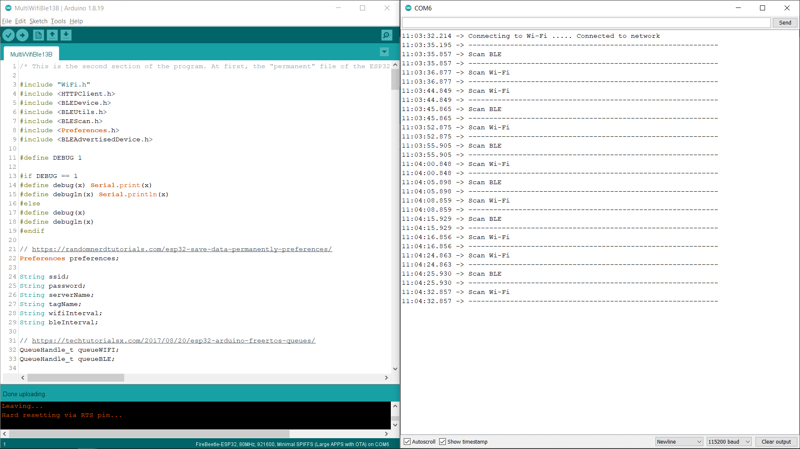

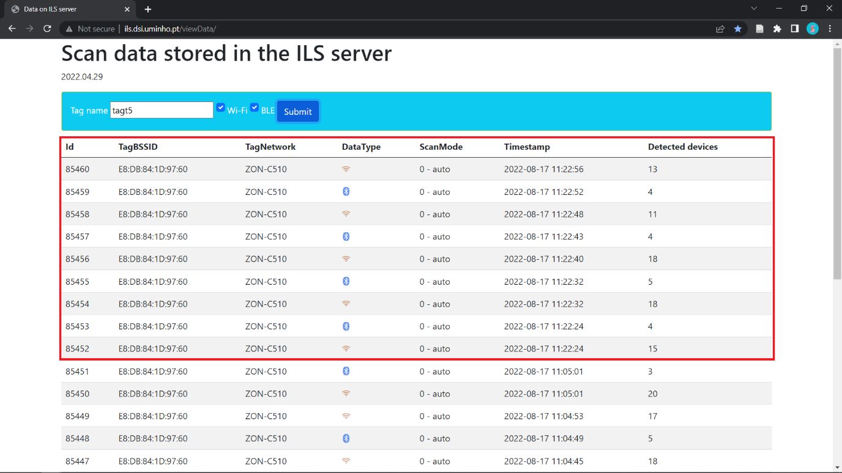

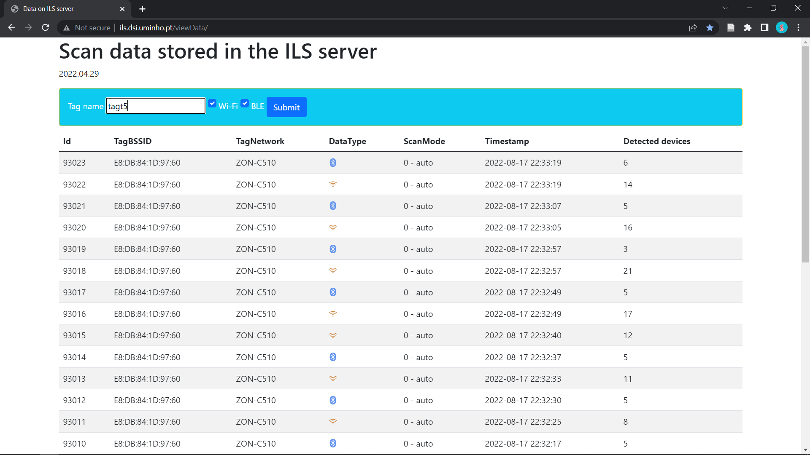

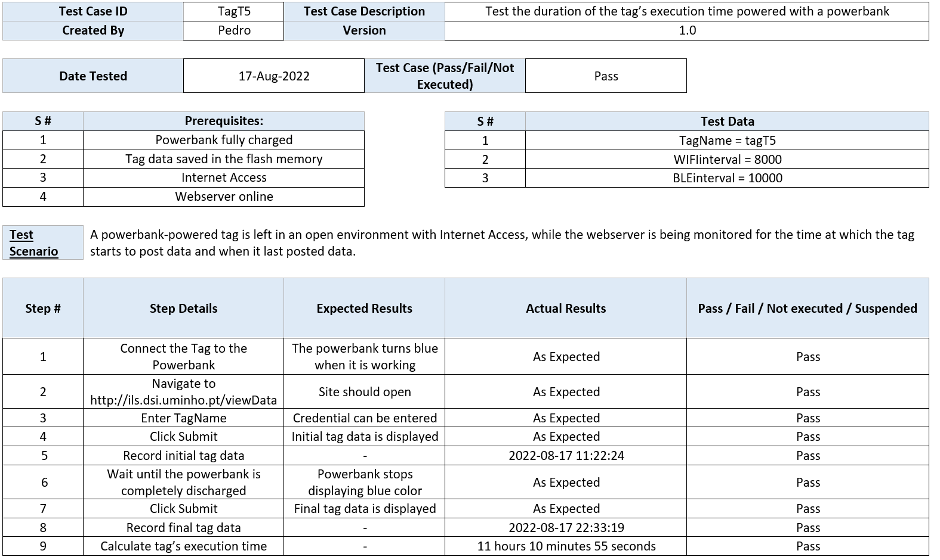

* **tagT6**

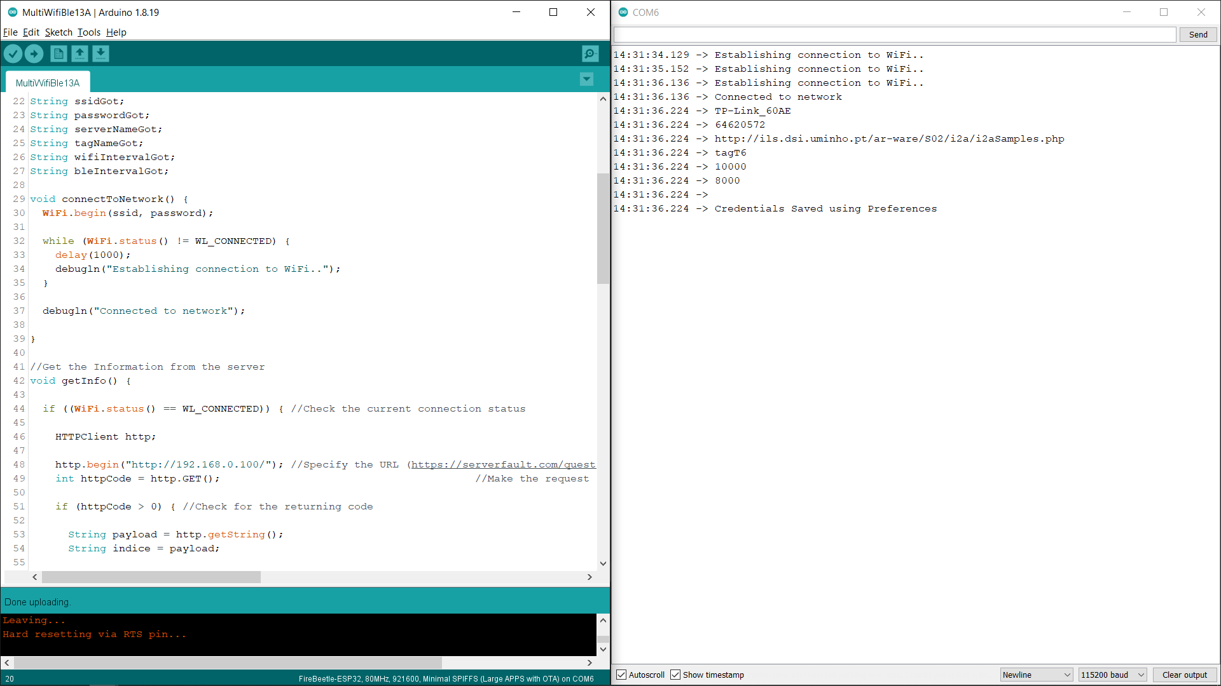

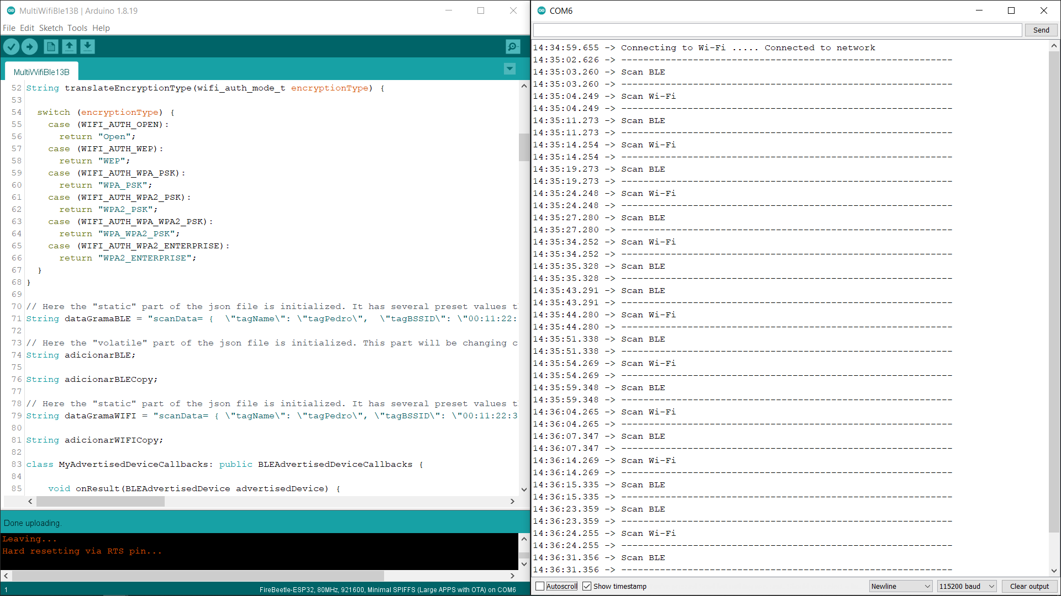

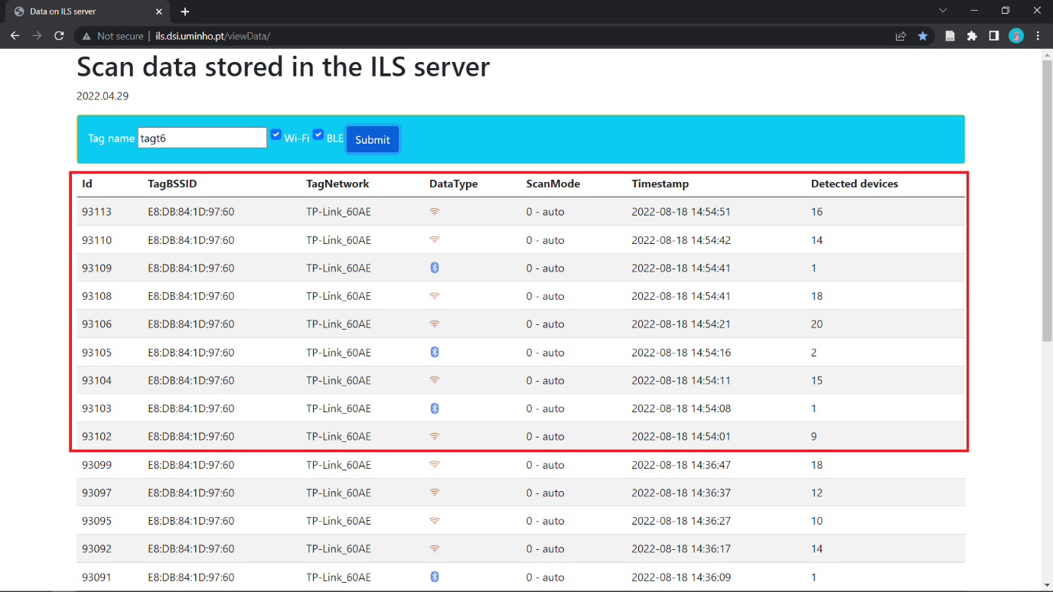

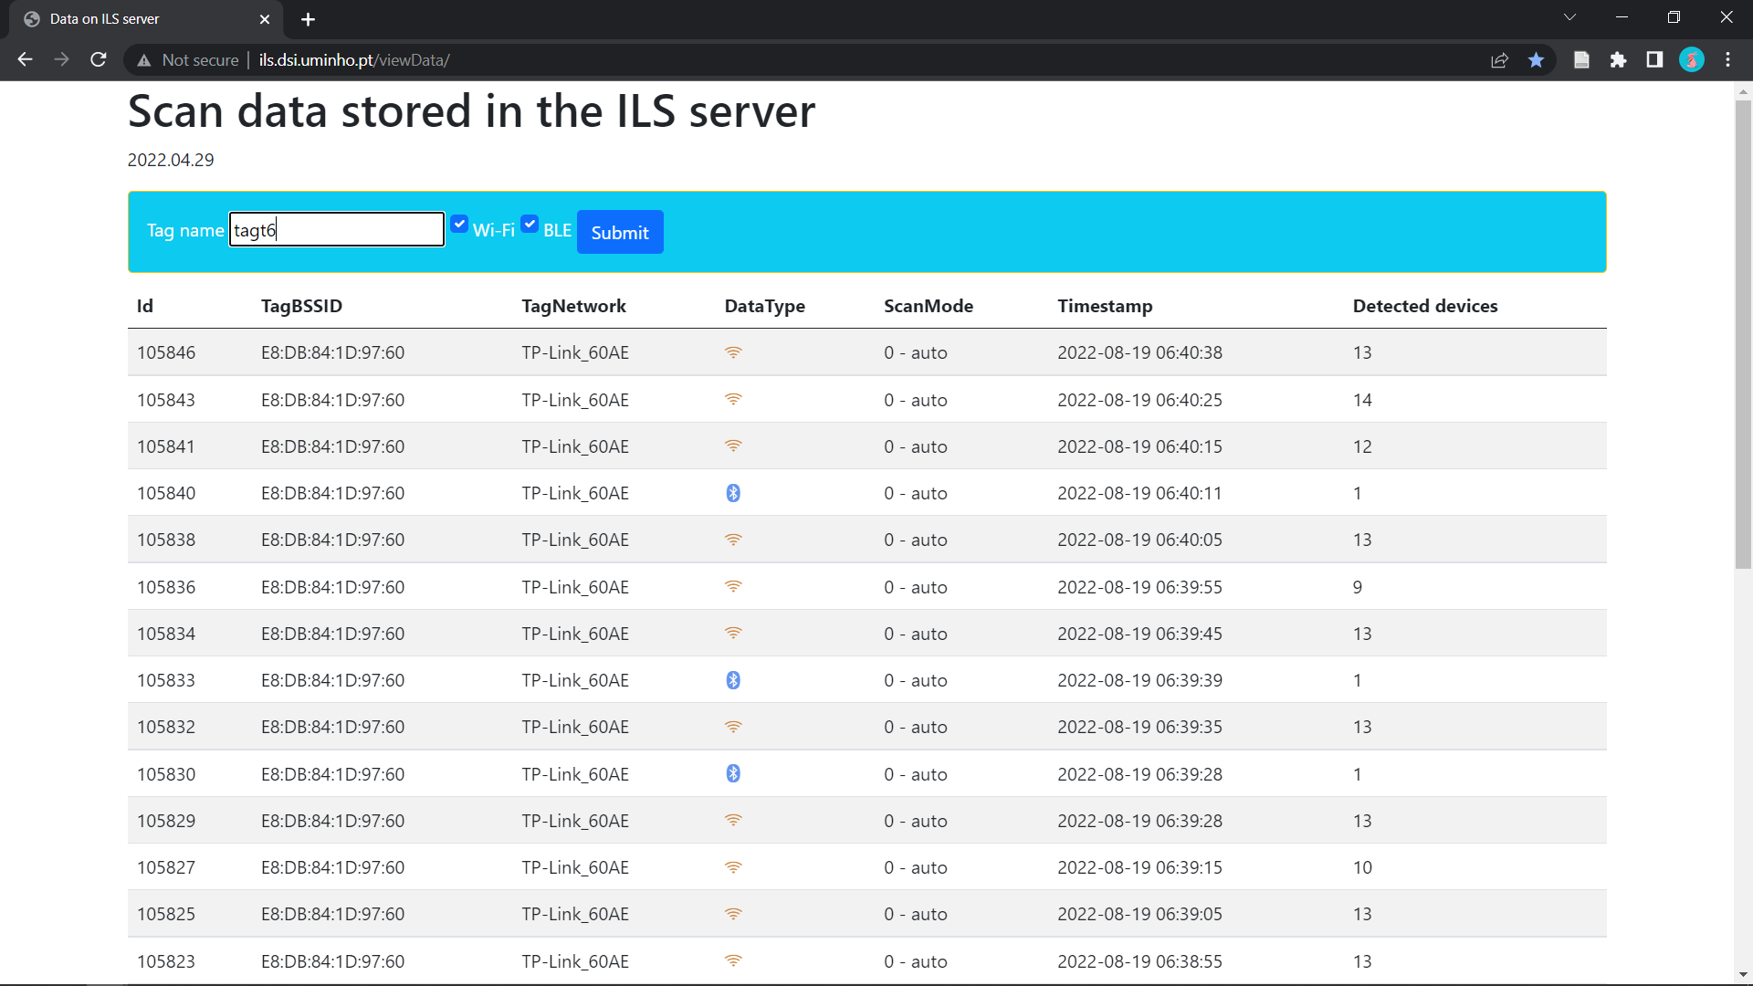

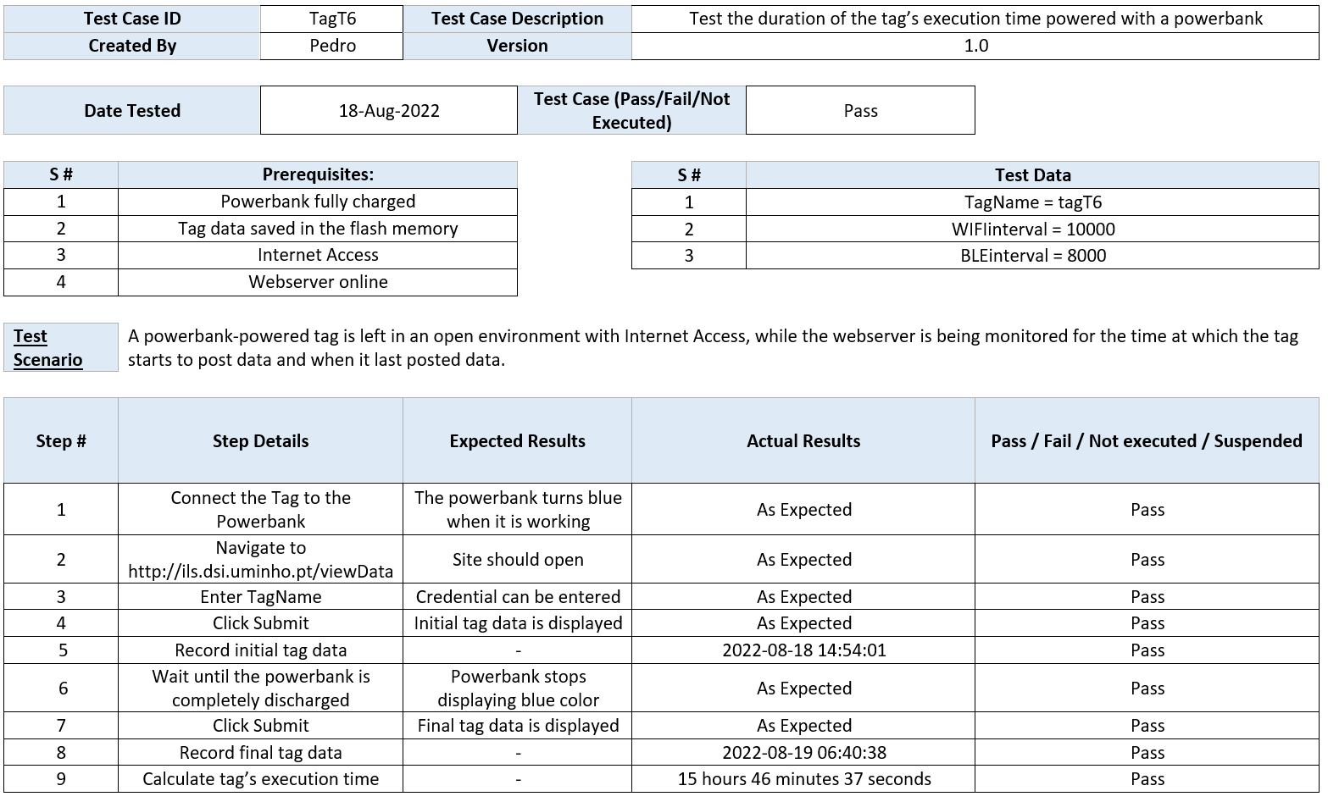

* **tagT7**

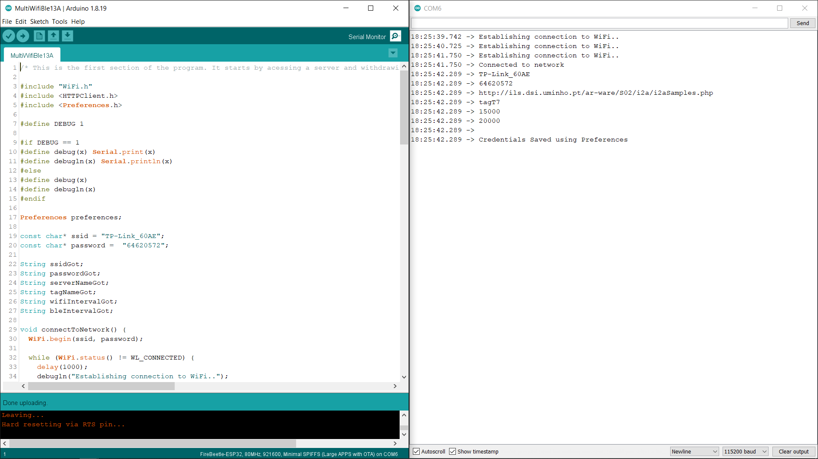

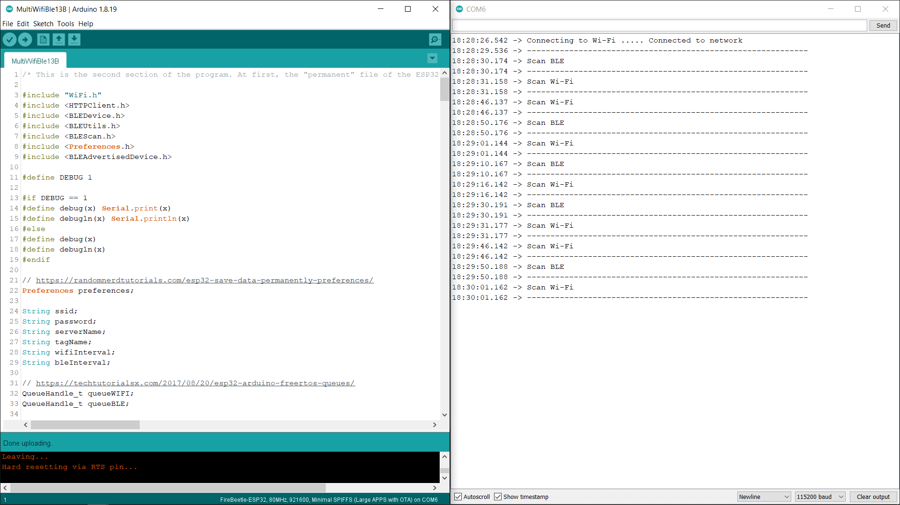

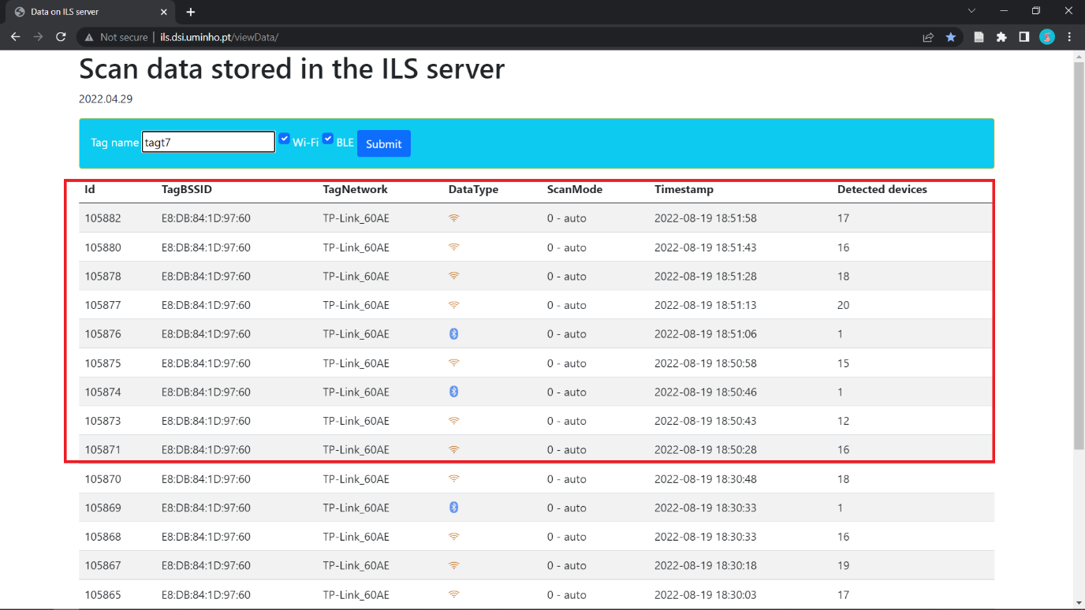

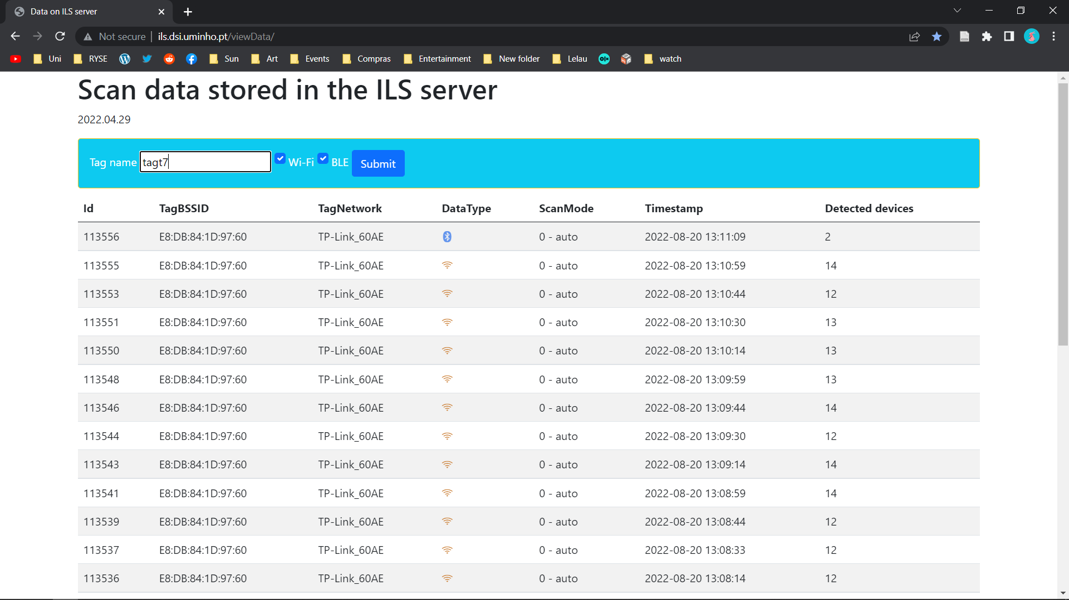

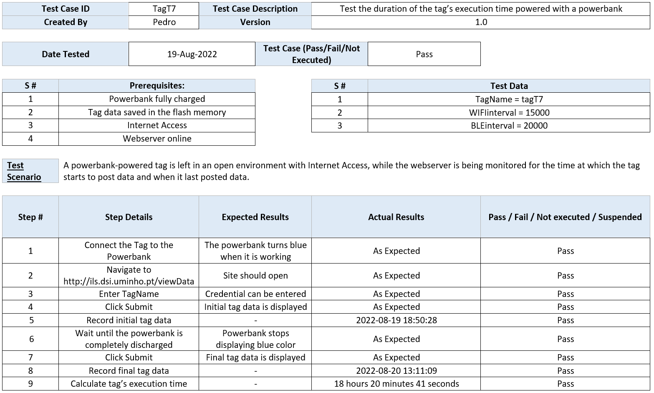

* **tagT8**

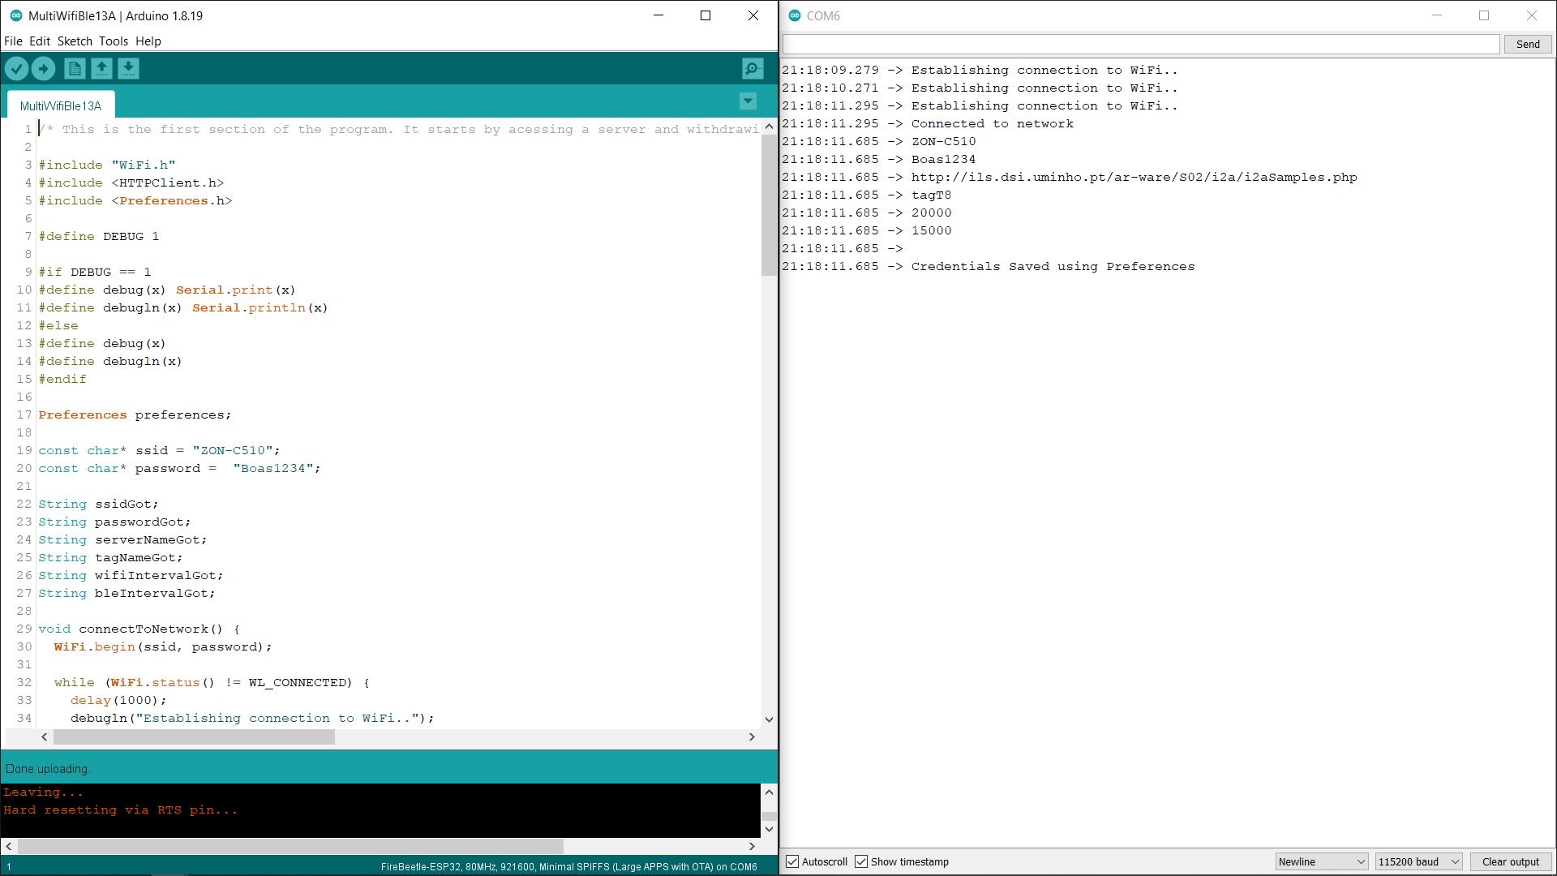

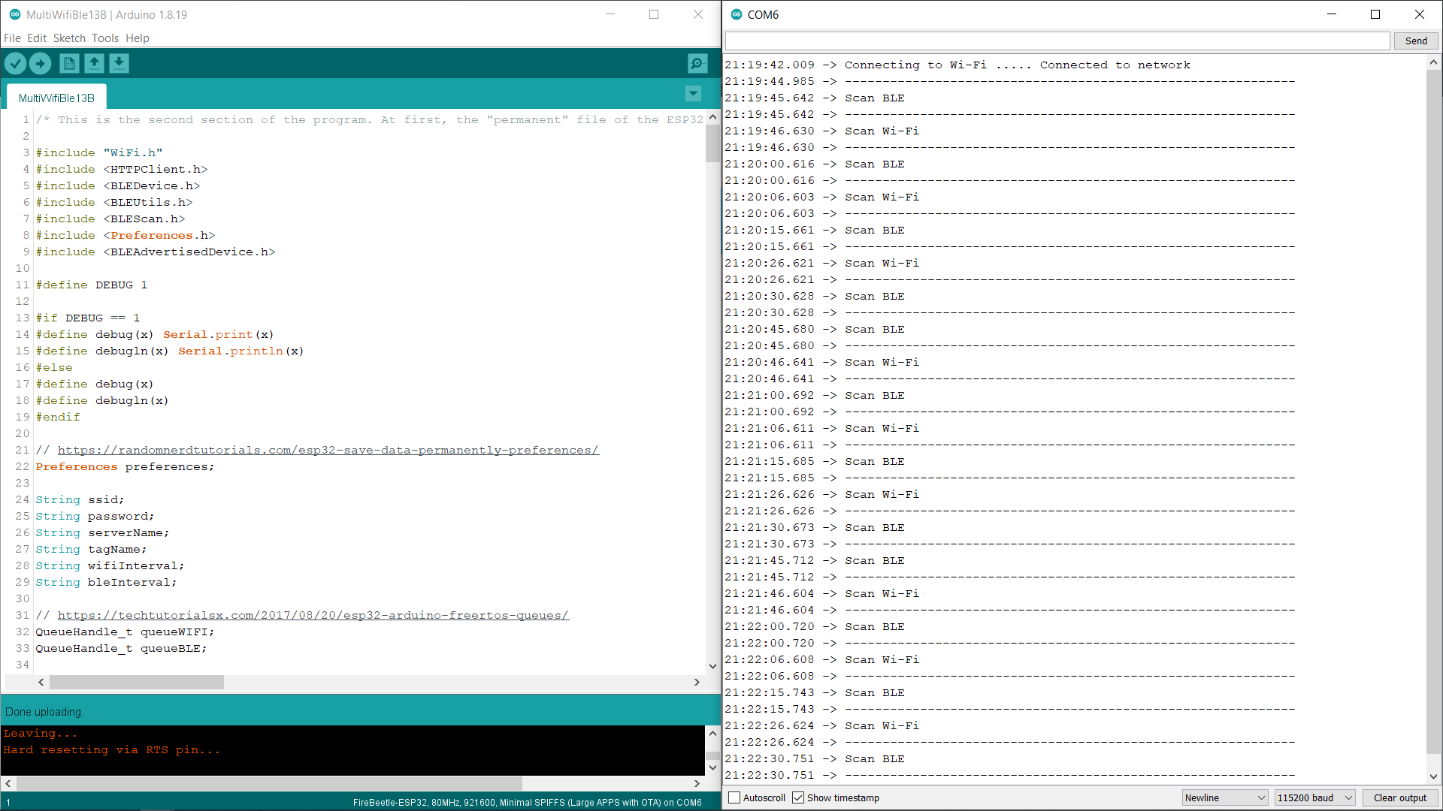

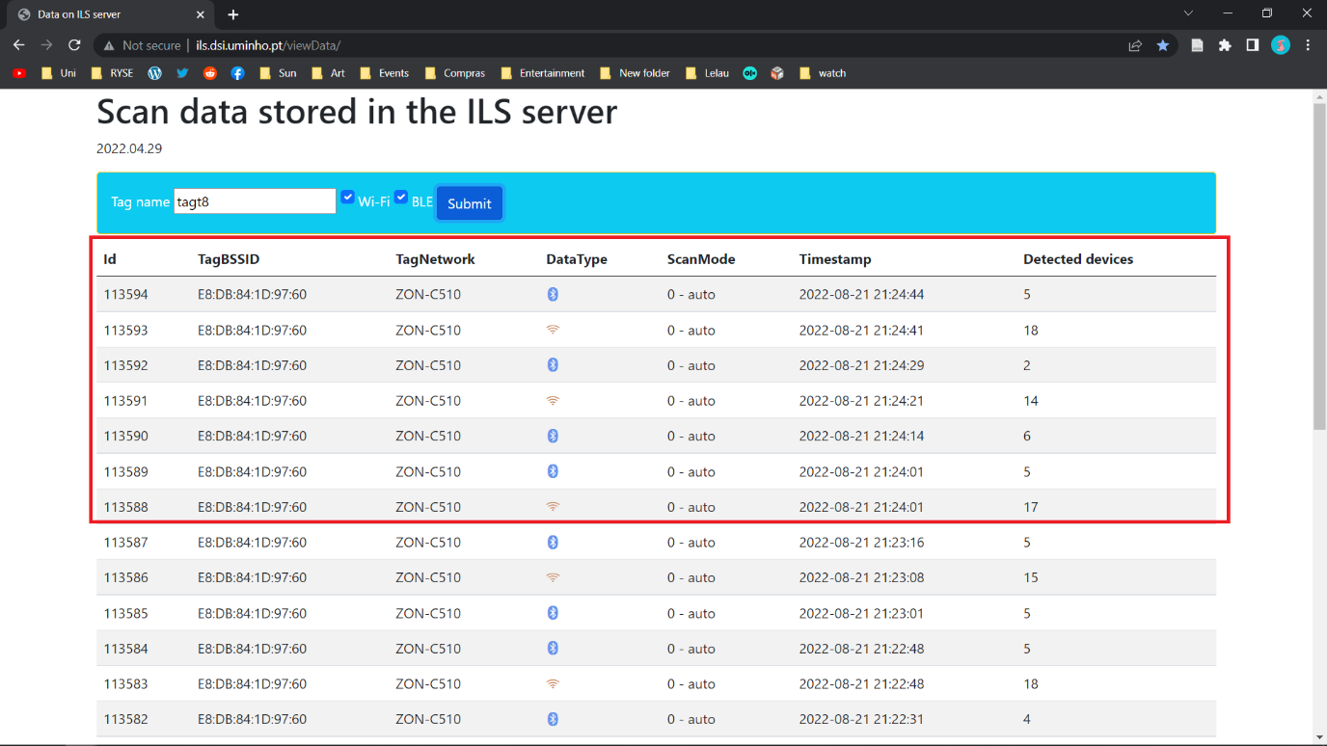

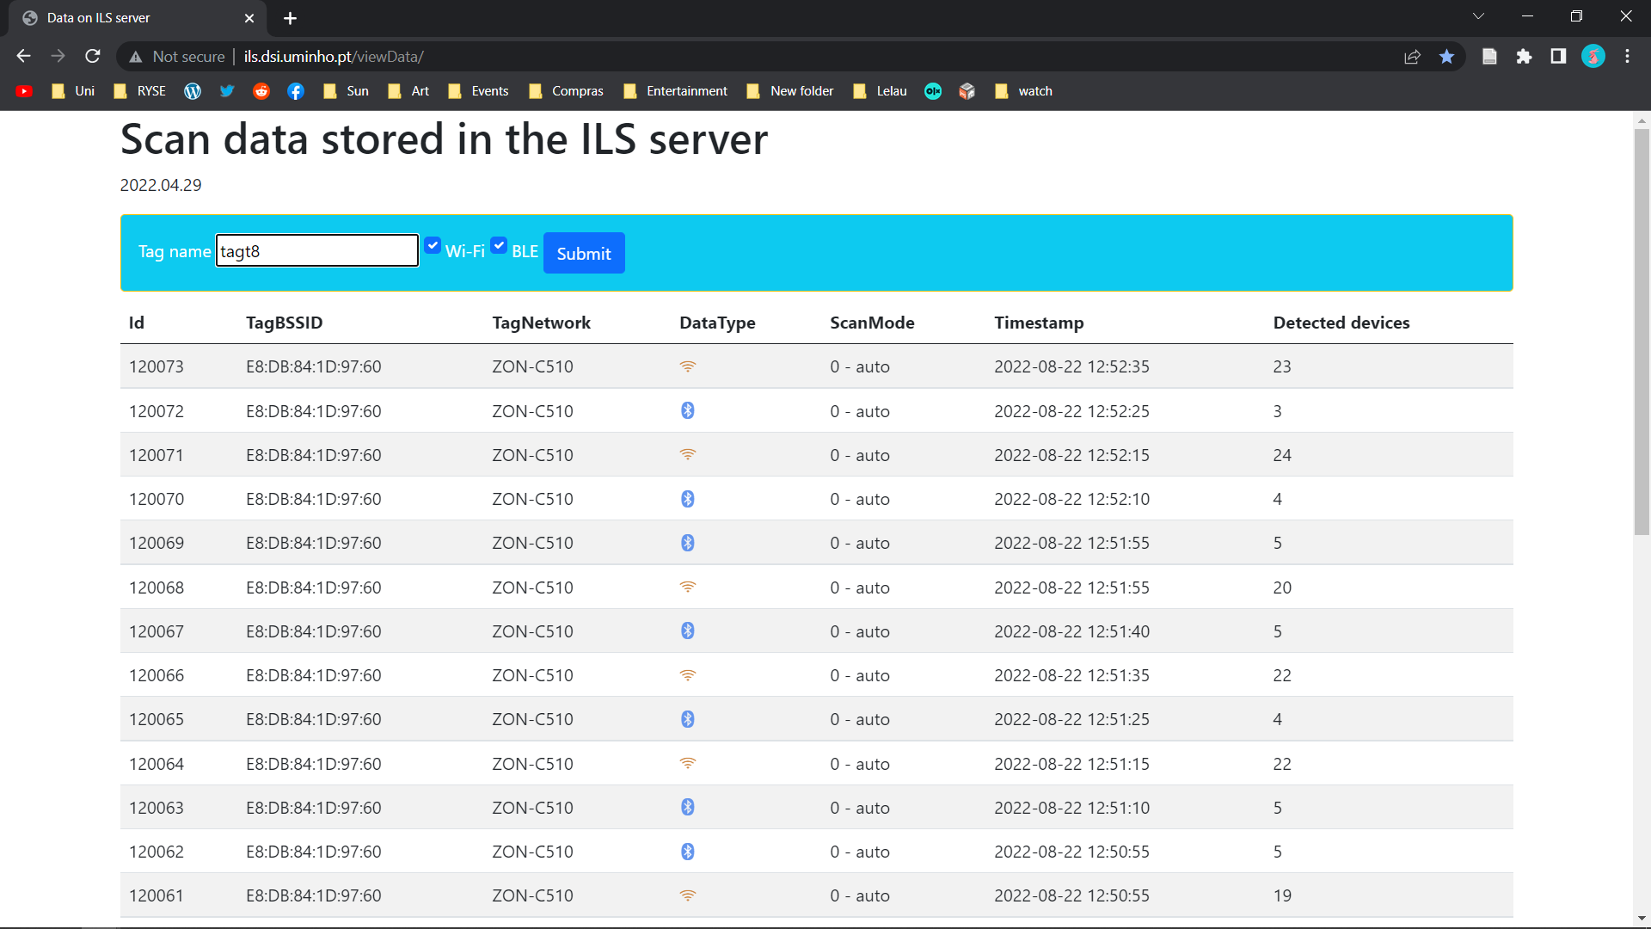

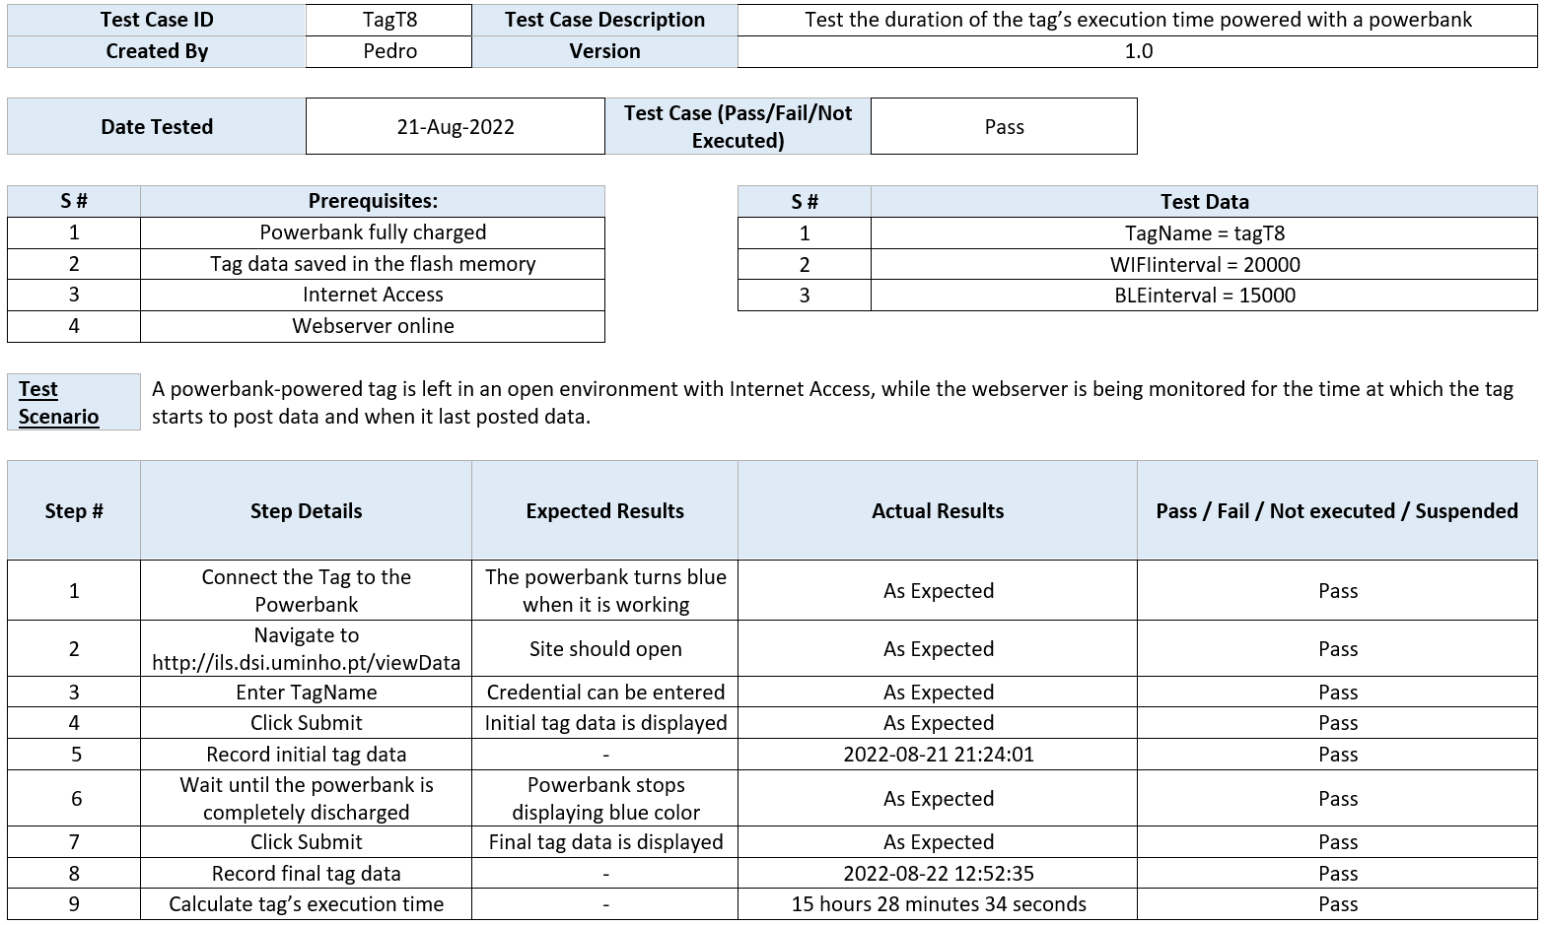

* **tagT9**

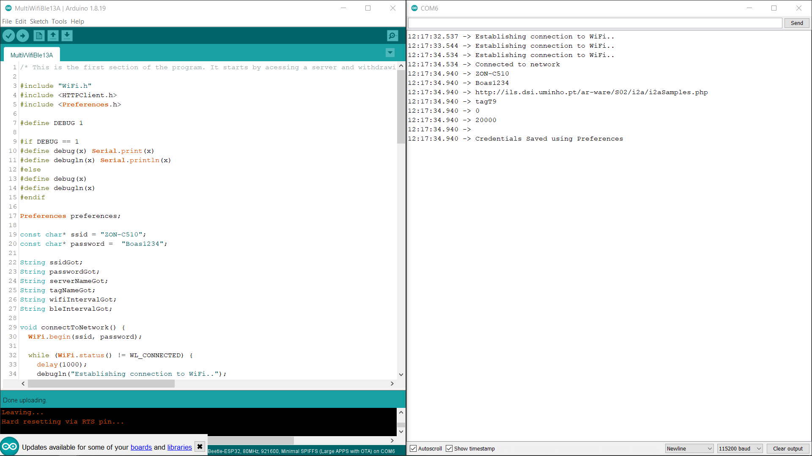

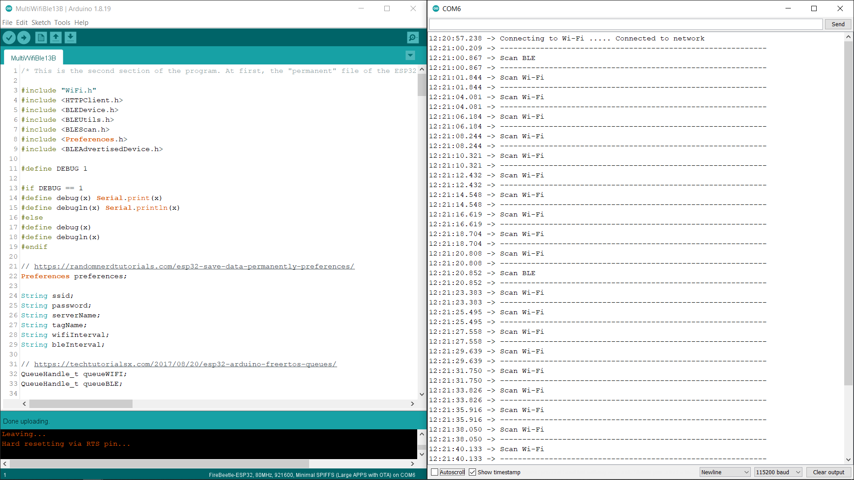

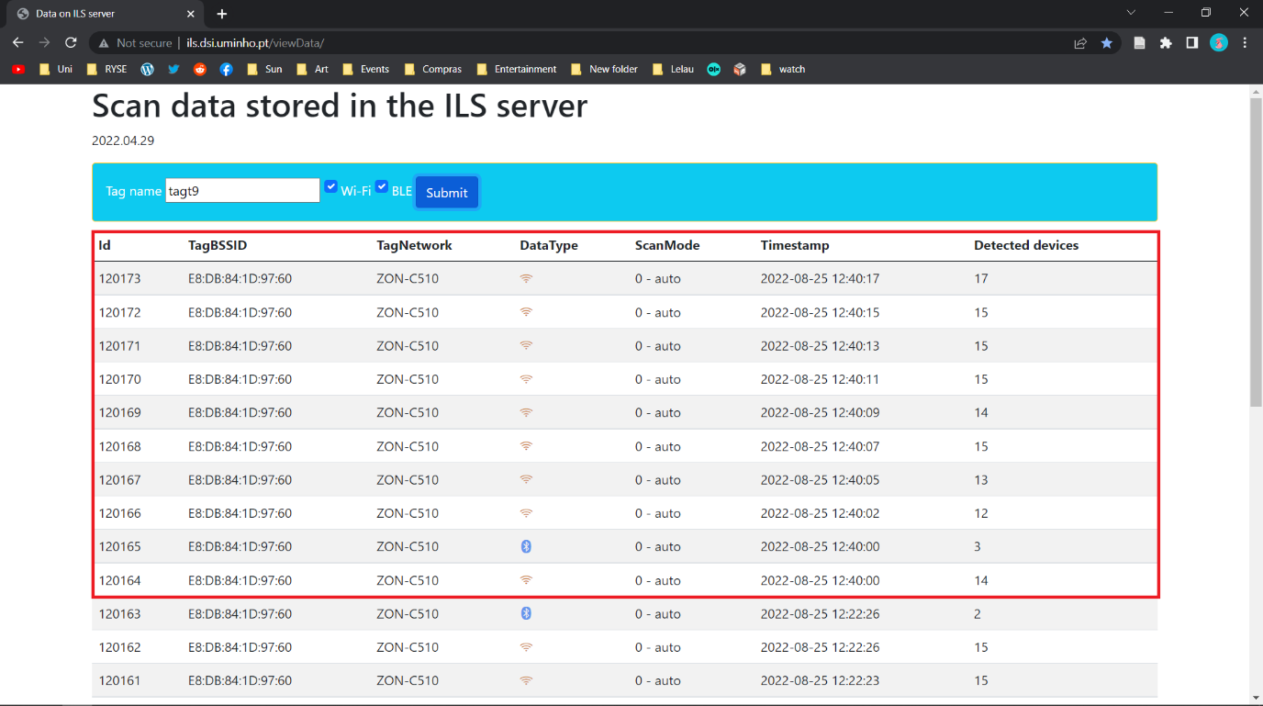

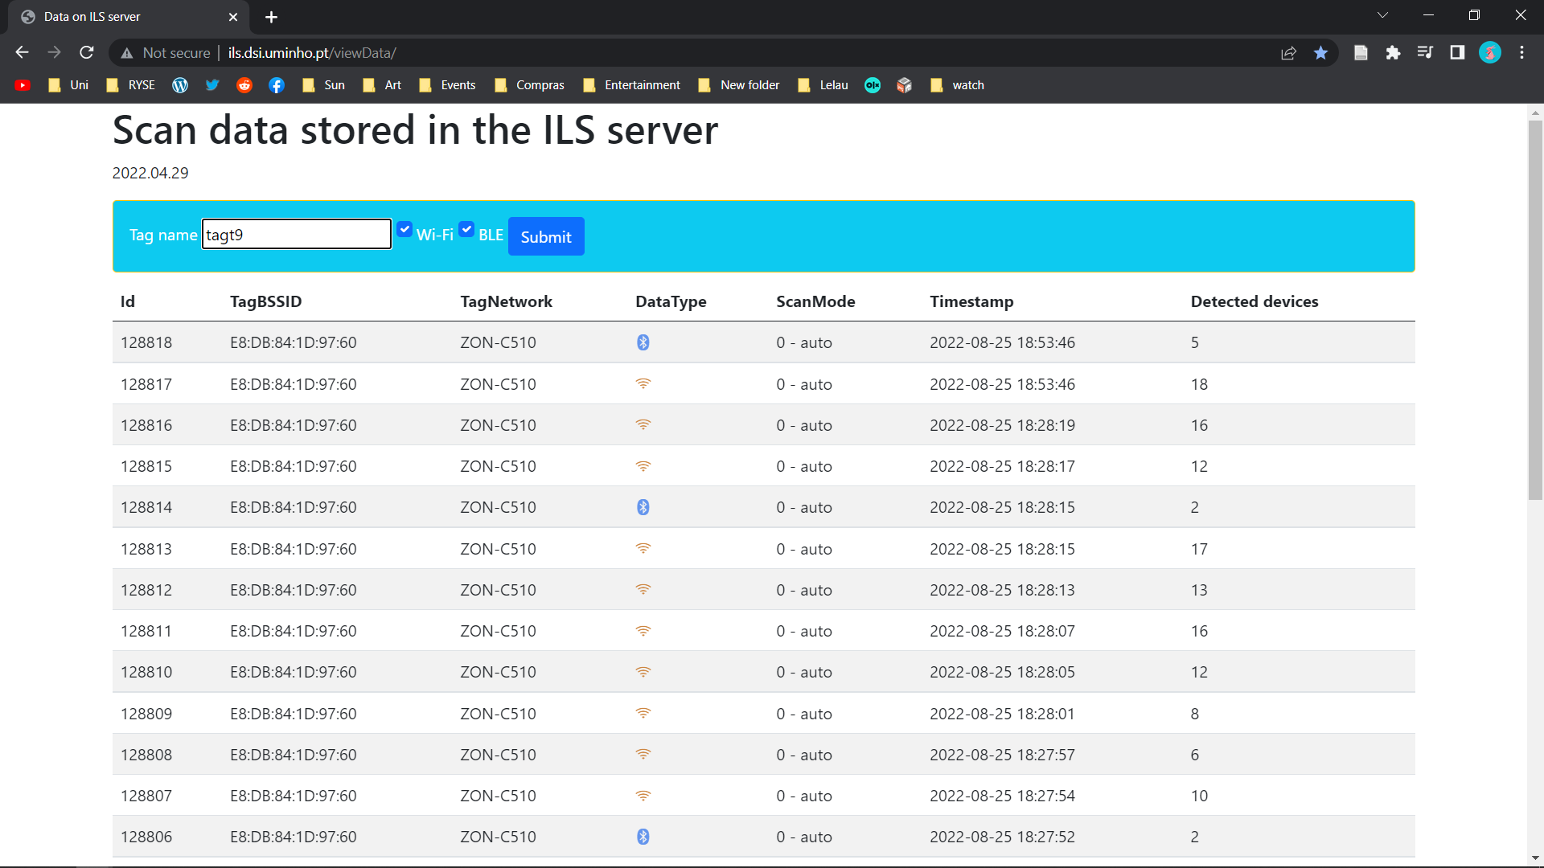

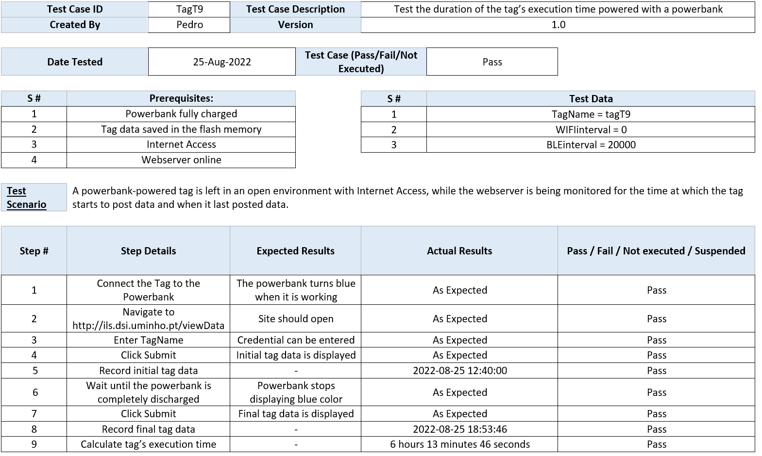

* **tagT10**

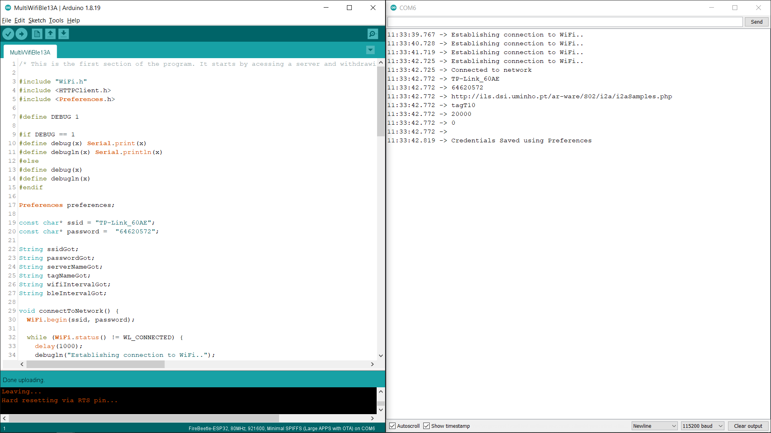

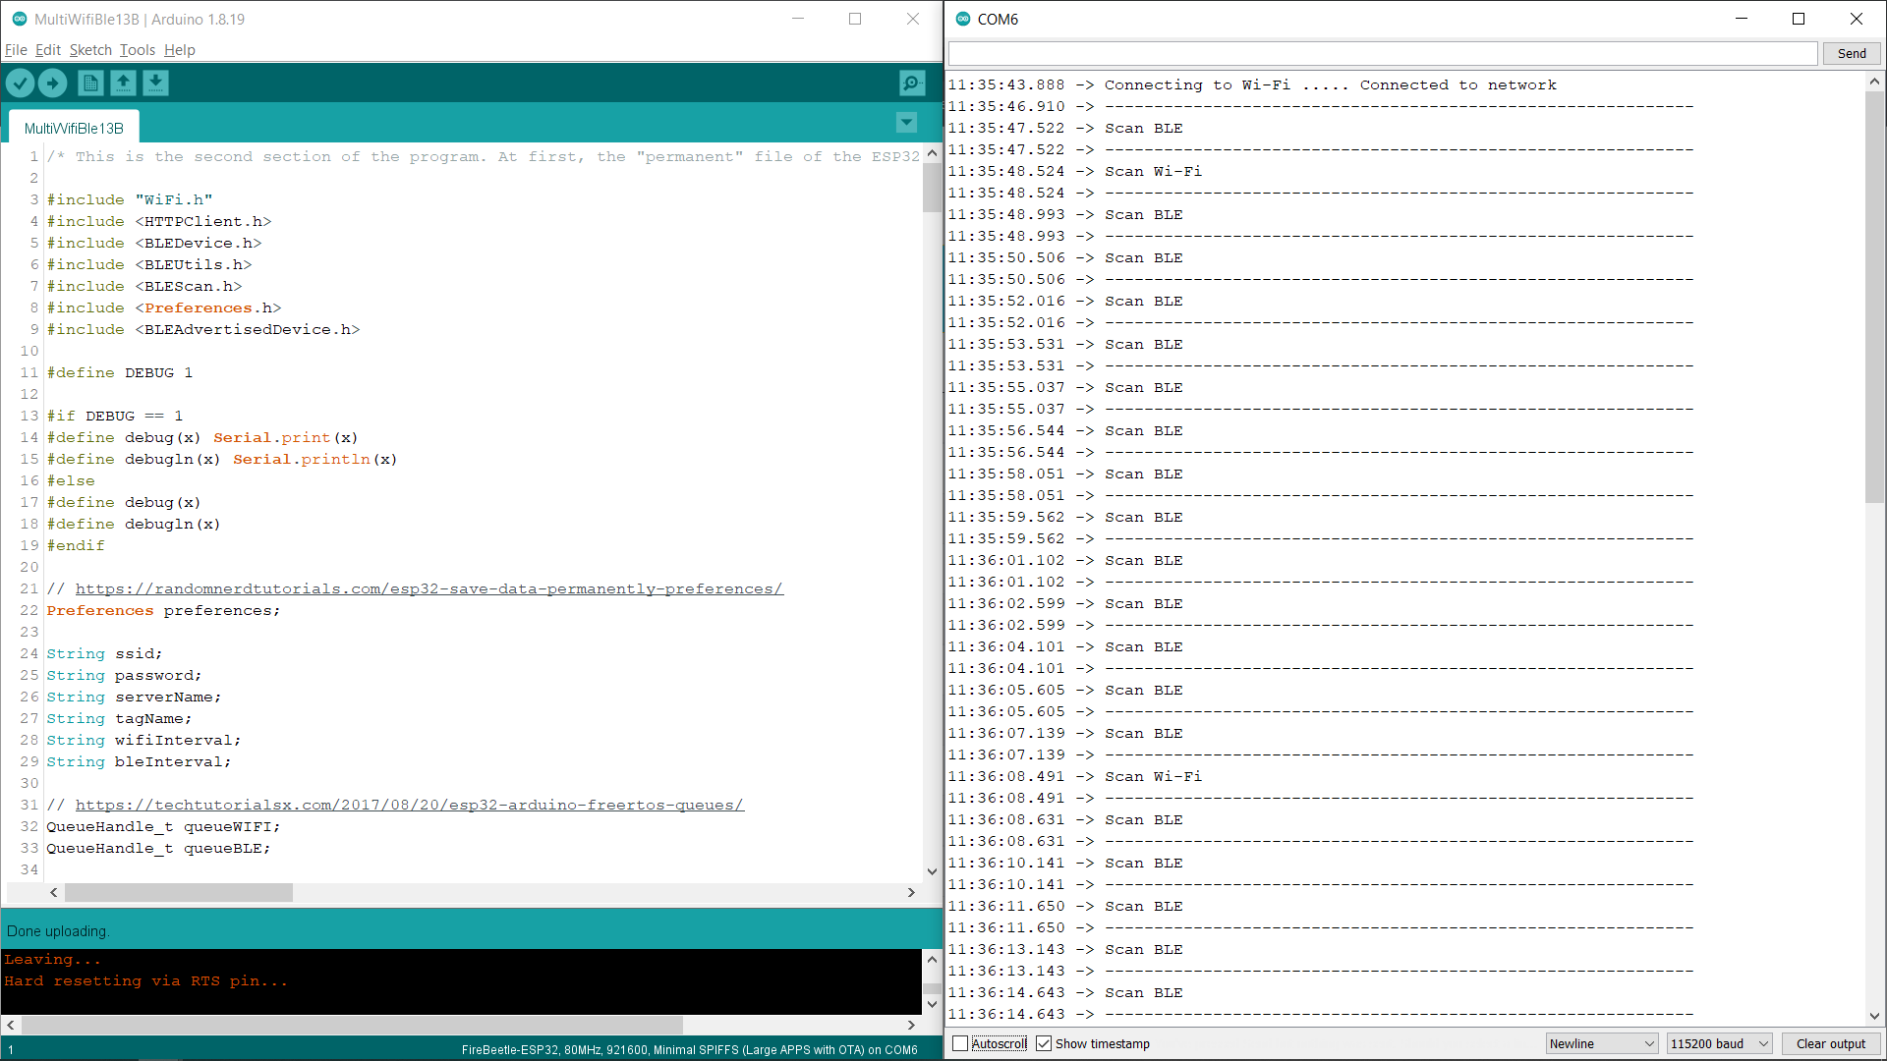

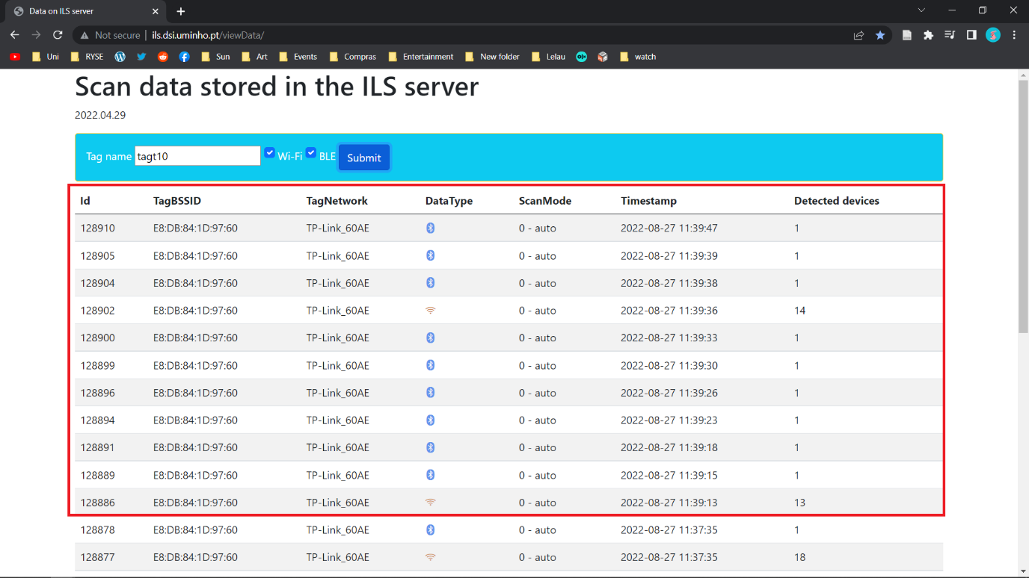

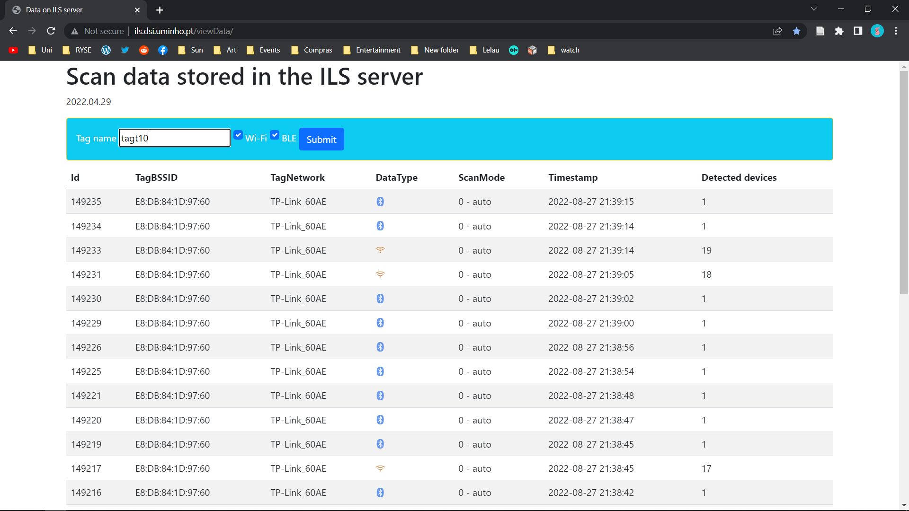

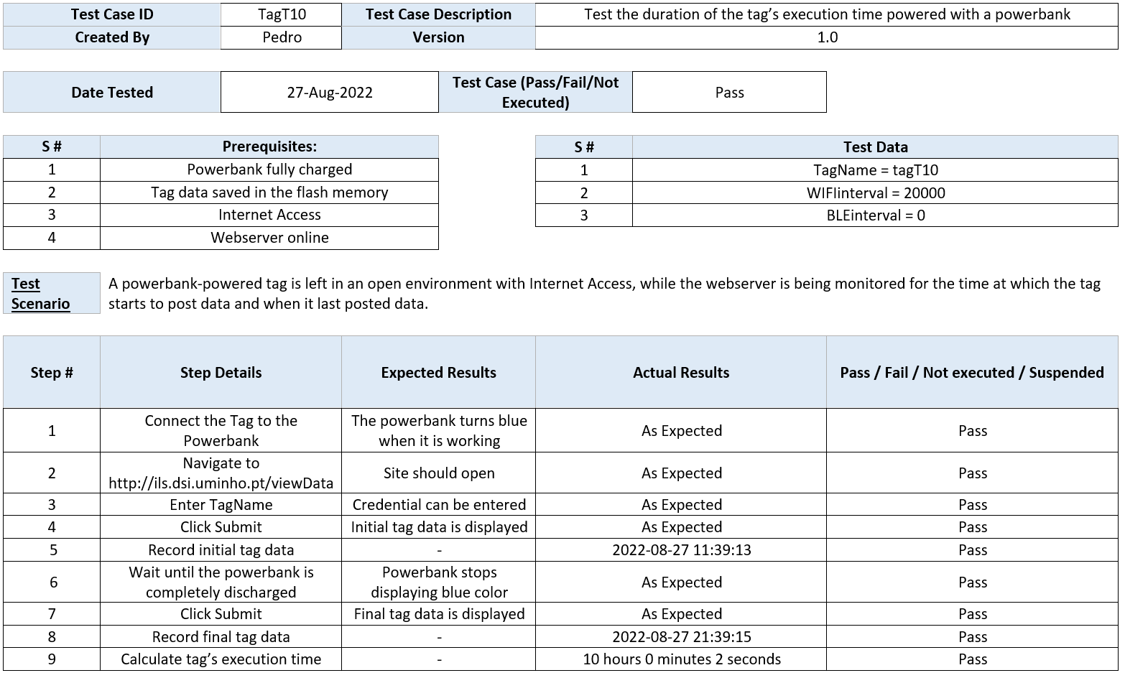

* **tagT11**

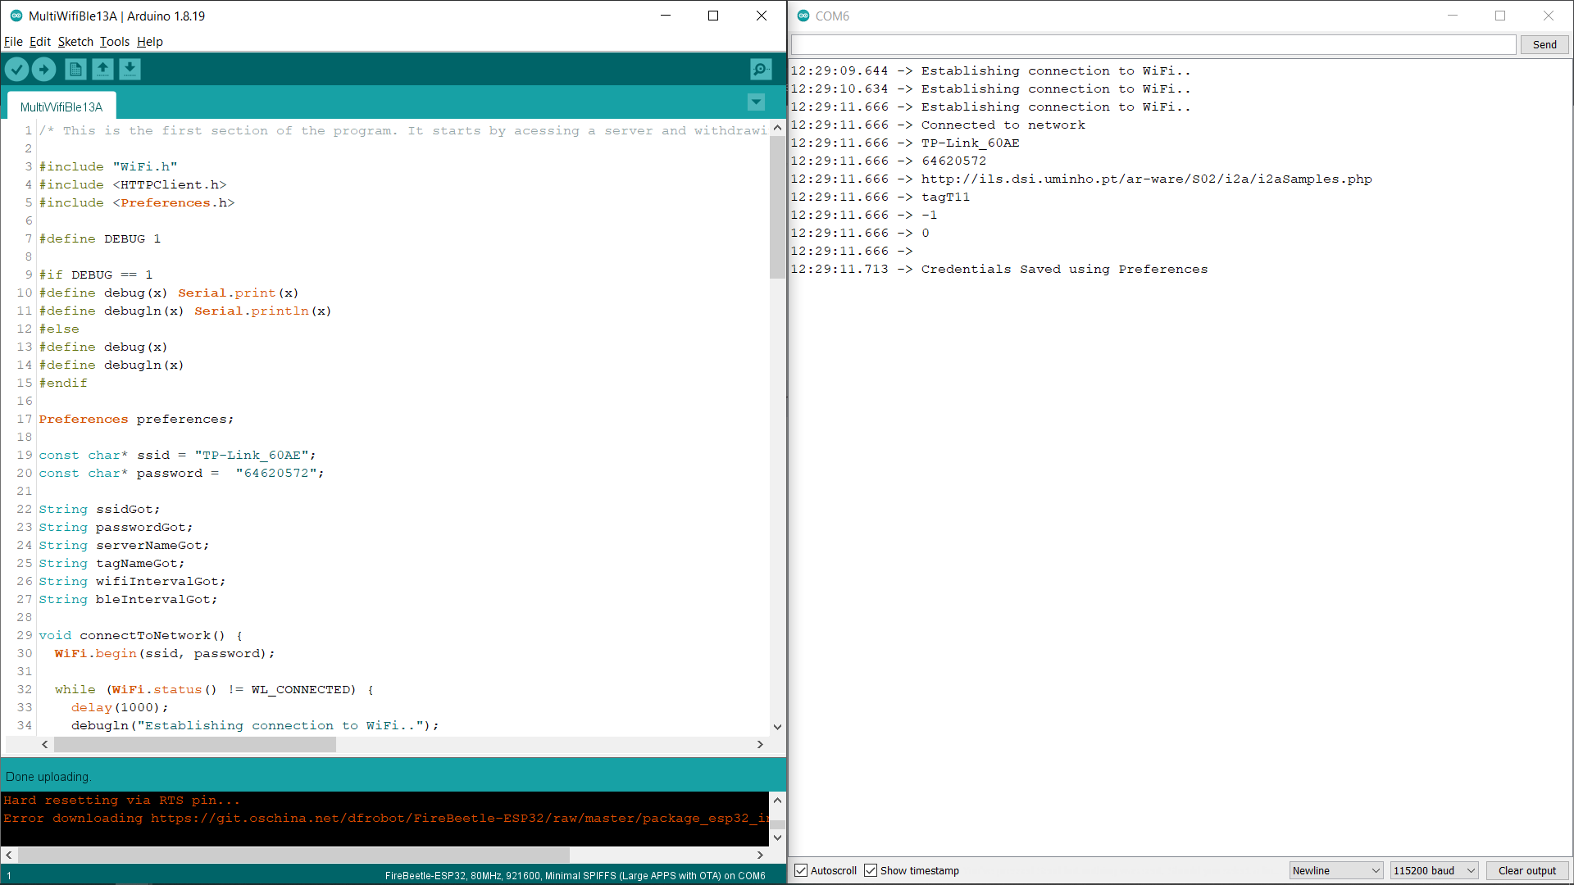

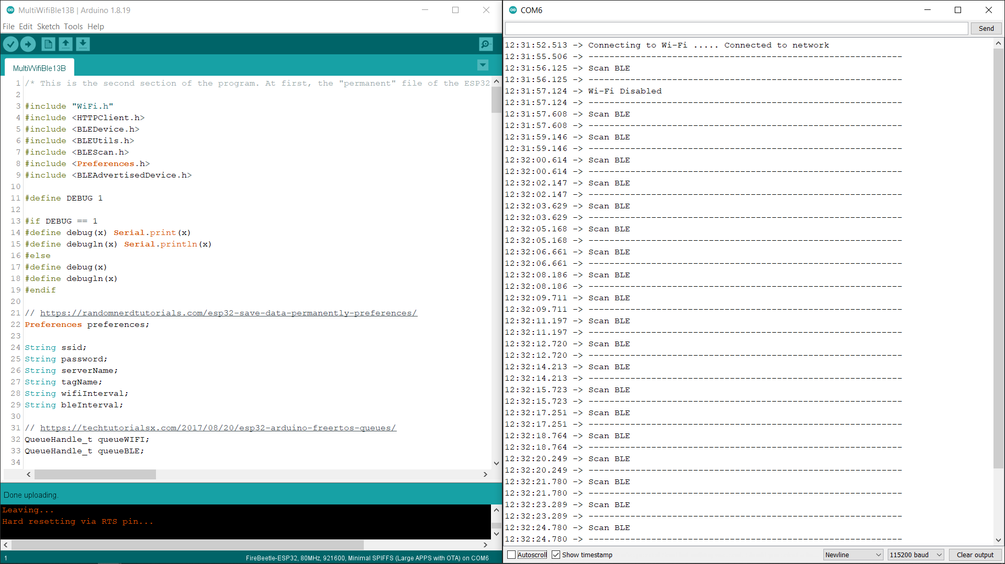

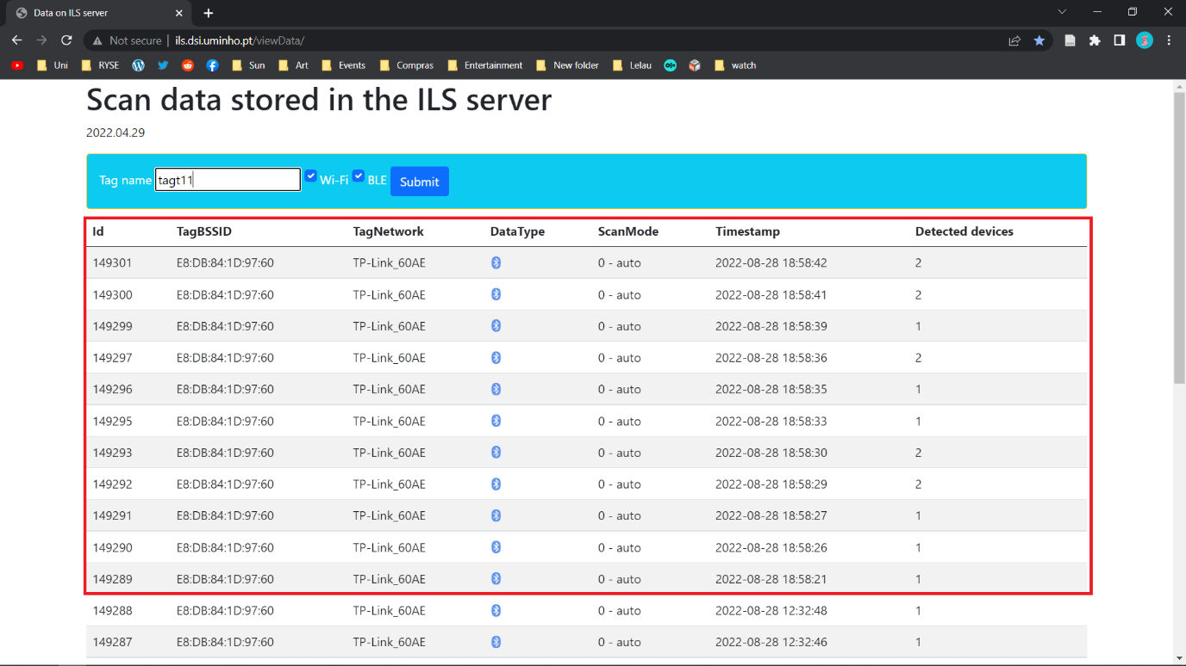

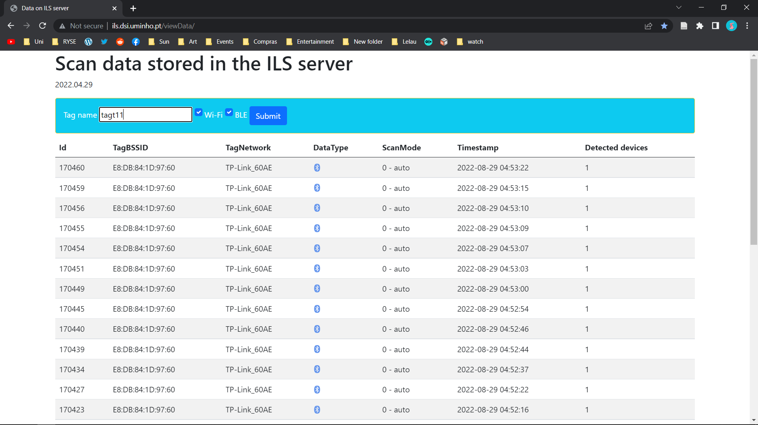

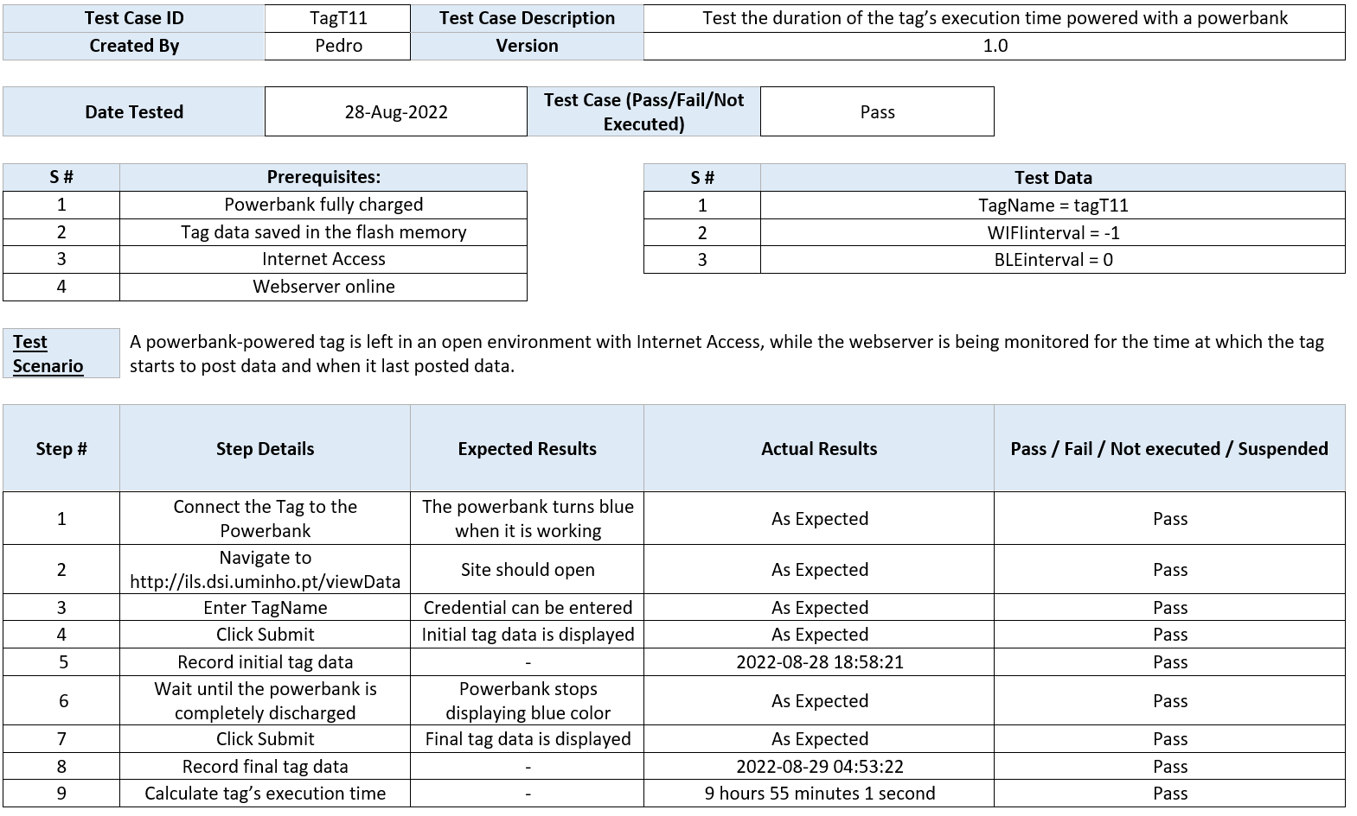

* **tagT12**

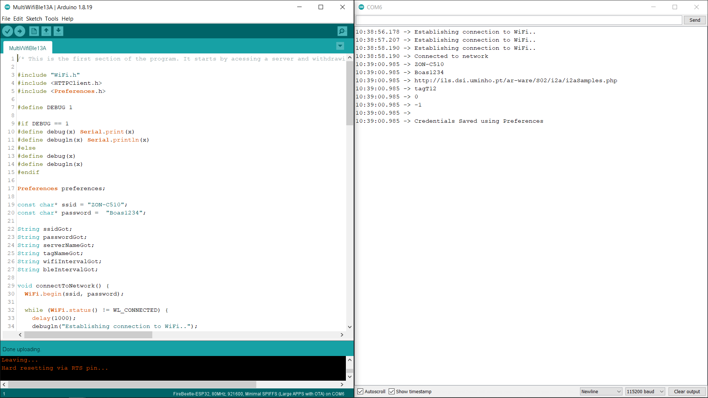

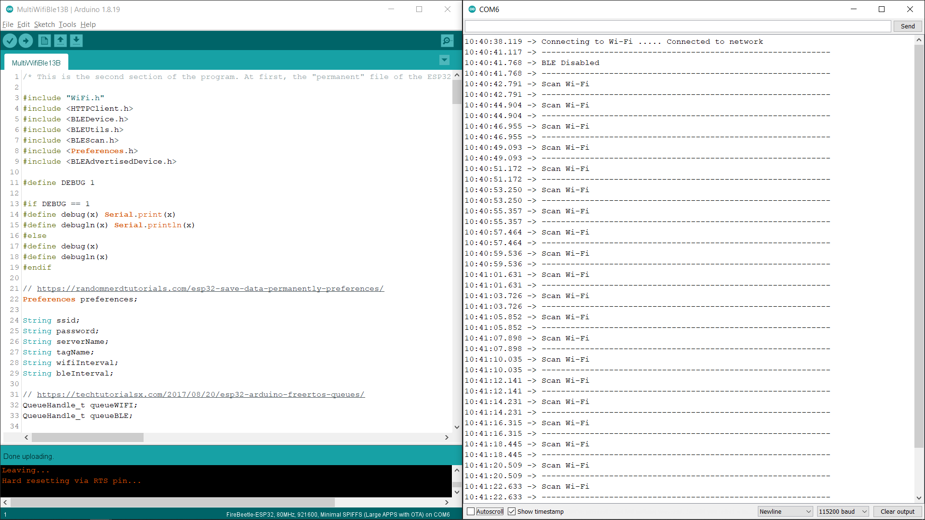

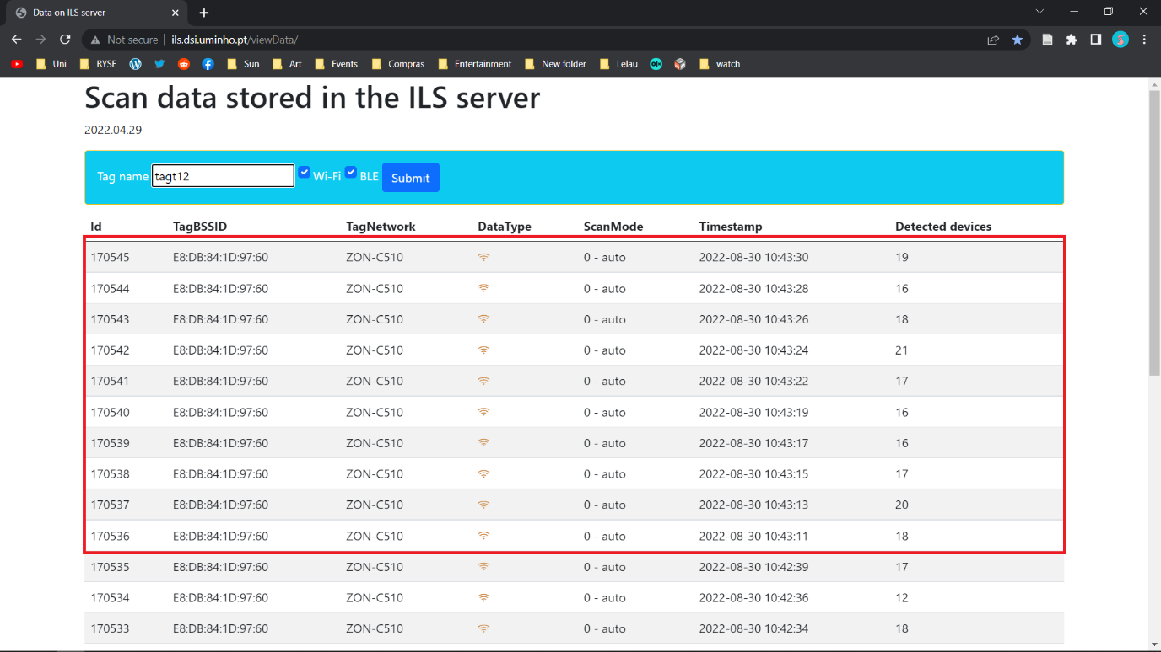

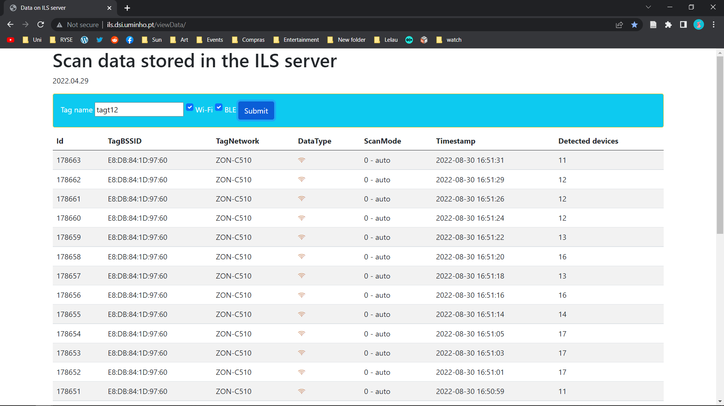

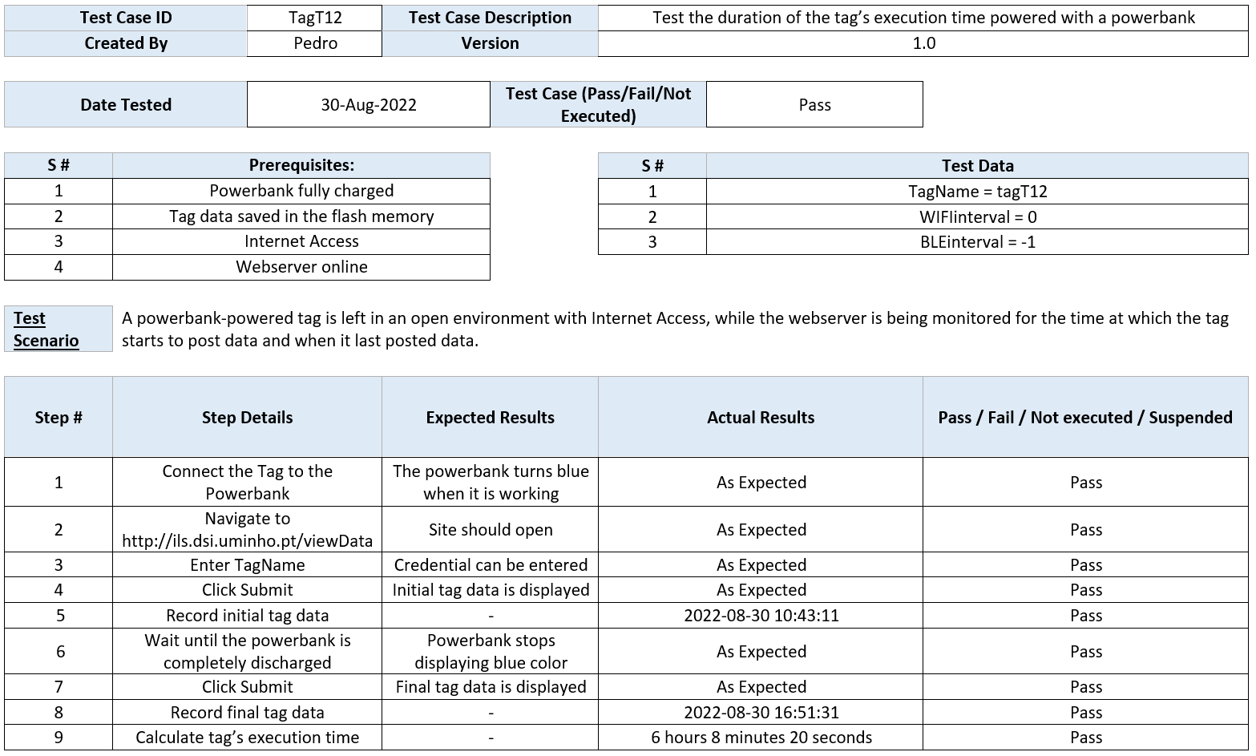

* **tagT13**

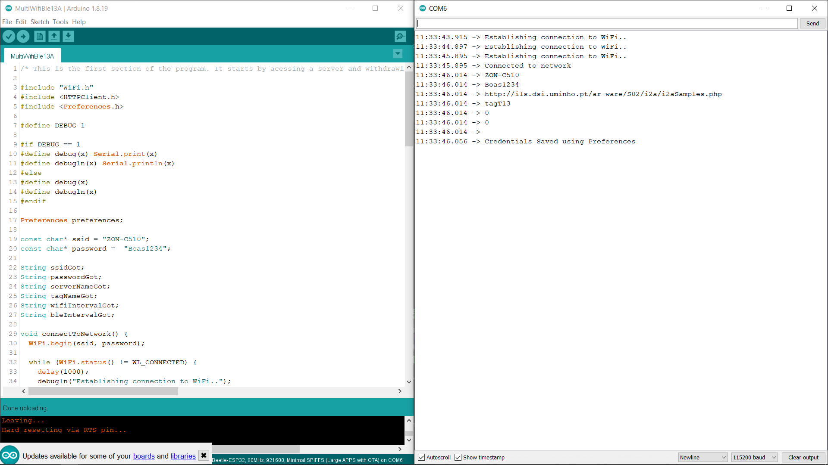

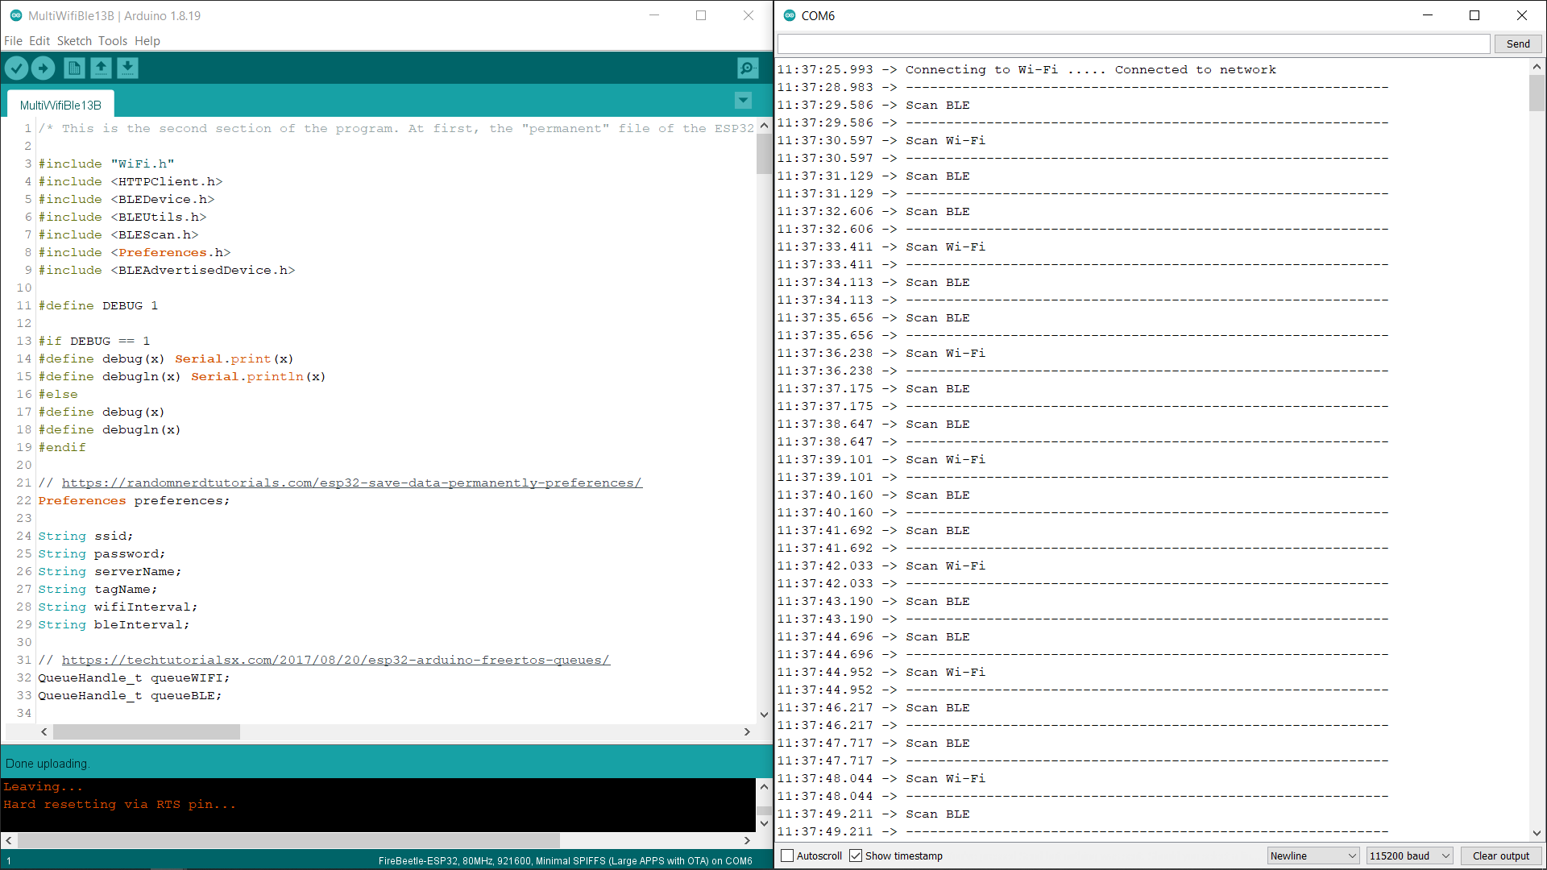

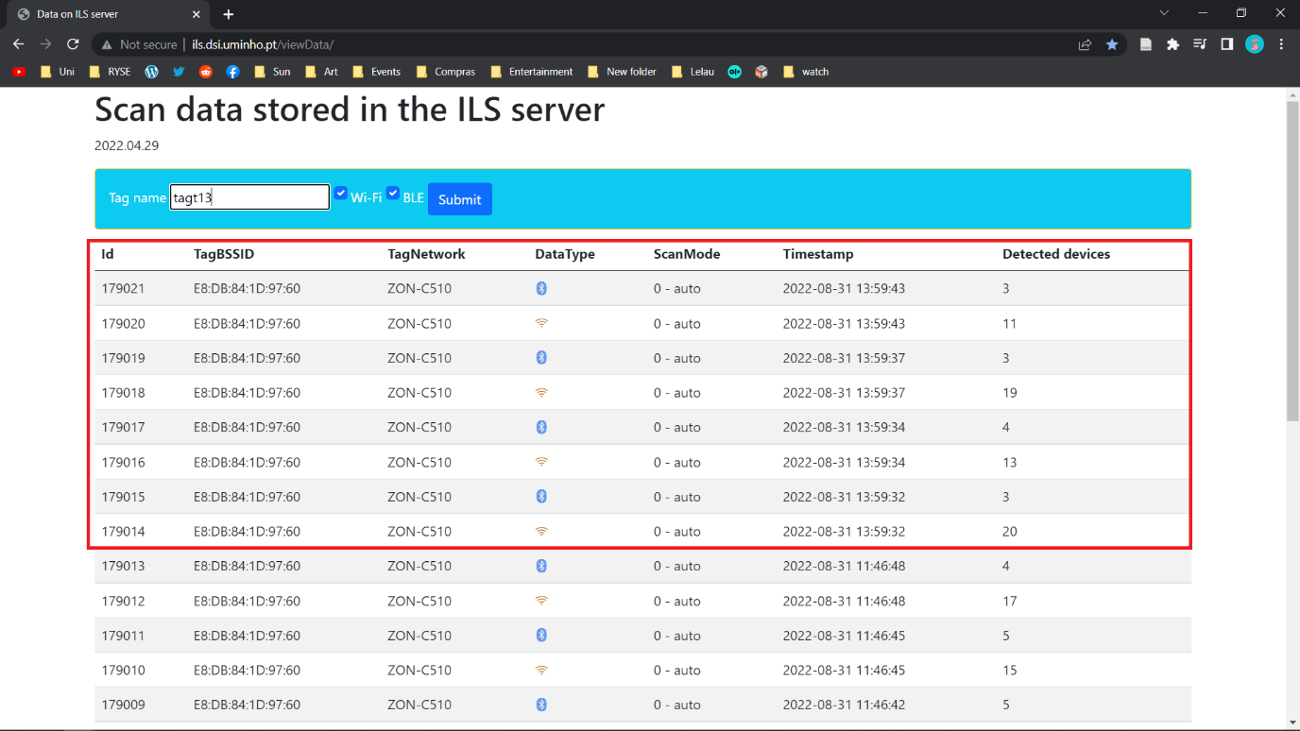

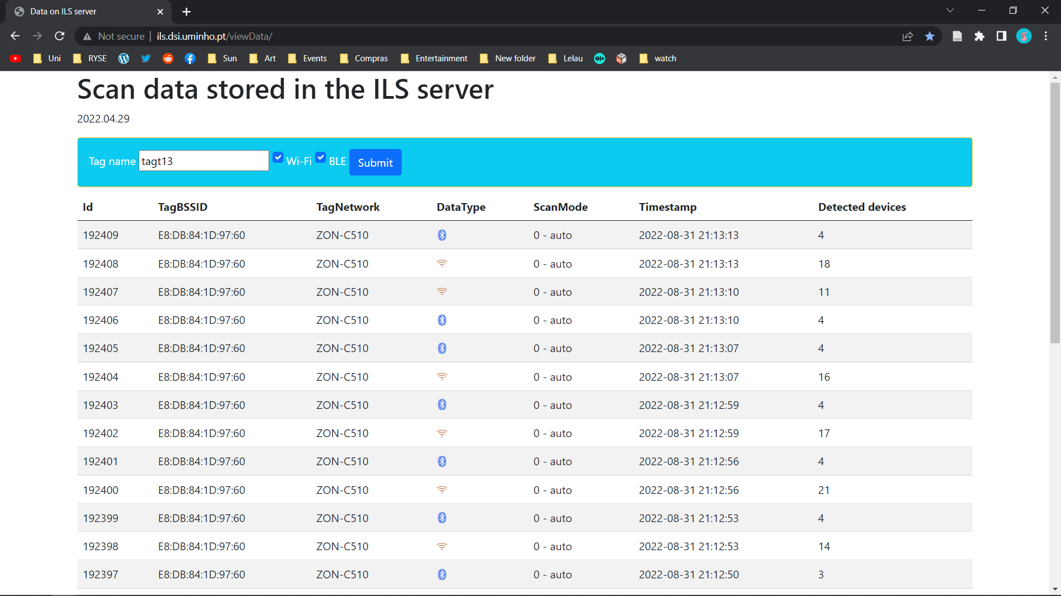

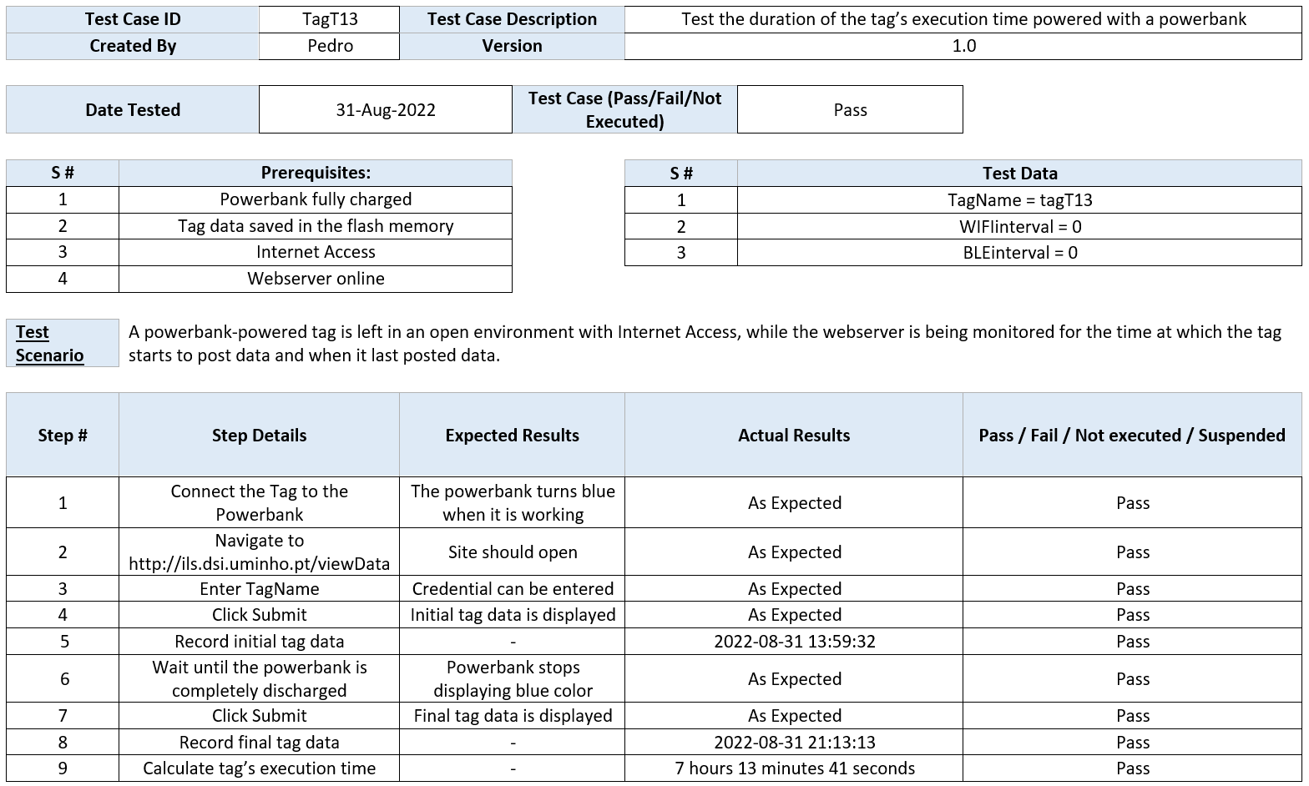

# Activity Plan

As a result of the research and planning covered in this chapter, more efficient work management will be accomplished by reducing errors and planning the necessary activities.

## Gantt chart

The work to be developed is designed for a 12-month extension (beginning in October 2021 and ending in October 2022). It is anticipated that this work will involve performing the following tasks:

1. **Familiarisation with the area of positioning and navigation in indoor spaces. [M1 – M3]**

(Reading of Articles; Relate the articles; Study of actual cases)

1. **Identify desirable (optimal) characteristics for the tag and possible hardware solutions. [M4 – M6]**

(State of the art; List of requirements and features; Weighting of possible solutions)

1. **Tag development (hardware and programming). [M7 – M9]**

(Device construction; Server implementation; Microcontroller programming; Deployment)

1. **Evaluation of the performance of the developed solution. [M10 – M11]**

(Data collection in a natural environment; Reliability tests and scenario development; Analysis of the data collected; Autonomy tests)

1. **Dissertation writing. [M4 - M12]**

(Pre-thesis; Thesis)

1. **Writing and submission of one or more scientific articles describing the innovative parts of the work done. [M12 - M13]**

The present Gantt chart, depicted in Fig. 7, demonstrates better the planning of the work to be developed.

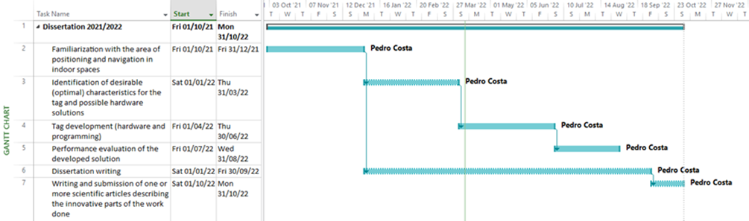

Figure 42 - Gantt Chart

## Risk Table

This artefact comes as a list of known and critical risks to capture the perceived risks to the project's success, sorted in order of importance and associated with specific mitigation and contingency actions (Table 10). It is required to identify the risks' probability and impact (on a scale of 0 to 10) to mitigate them.

Table 10 - Risk Table

| **ID** | **Description** | **Probability (P)**  **[0…10]** | **Impact (I)**  **[0…10]** | **Magnitude**  **(P × I)** | **Mitigation Strategies** |
| --- | --- | --- | --- | --- | --- |
| **1** | Inexperience with the tools | 8 | 10 | 80 | The tools used must be studied timely, and ask for assistance in case of doubts. |
| **2** | Project development delay | 5 | 8 | 40 | Establish the tasks at the outset of a project plan. |
| **3** | Project requirements change | 4 | 7 | 28 | Discussing reshaping the project to conform to the new specifications with the supervisor. |
| **4** | Unreliable ScanData | 4 | 7 | 28 | ScanData needs to be thoroughly analysed to produce consistent, high-quality scans. |
| **5** | Data Transmission errors | 5 | 6 | 30 | Reduce data redundancy and identify primary sources of inaccuracy while regularly updating the system. |
| **6** | ESP32 or Powerbank malfunction | 2 | 8 | 16 | Avoid leaving the hardware on prolonged charge/use as this may cause it to overheat, and keep it in a safe and dry place away from heat sources, moisture and dust. |
| **7** | Server Crashes | 2 | 6 | 12 | Server-side optimisation prevents the server from being overwhelmed and crashing under normal operating conditions. |
| **8** | Integration issues | 5 | 7 | 35 | Operating system updates can disable the database engine, so be quick to notify the supervisor of the process. |
| **9** | Fatal firmware | 4 | 8 | 32 | Write programs in a well-defined way so that executions will not be interrupted. |

# Conclusion

In Chapter 7, the general and specific objectives of the project are analysed. Difficulties encountered during the development of the system are also presented. Finally, some suggestions for future improvements are proposed.

## Summary

Indoor localisation has already been used to improve customer experience in indoor areas. This work focused on the main problems of the present time, where an extensive system such as the GPS fails in indoor environments. Therefore, it was necessary to think about the dimension of this problem and a way to solve it.

A framework is presented on themes that encompass Indoor Localisation systems and what they represent in the functioning of an environment. Subsequently, evaluations and research were developed to identify which tags could respond to the problem. Then, the results are shown, identifying advantages and possibilities inherent to using different microcontroller boards. To conclude this study, it is possible to identify a set of tags, relating them to the work to be carried out in the future.

At the end of the study, it was possible to conclude that the fingerprinting technique presented a high quality and is increasingly used in indoor localisation. However, additional efforts are required to improve these systems' performance so that applications highly dependent on user location can provide better services to their users.

Once this report was completed, an exploratory analysis was carried out on the quality of the microcontroller boards and an investigation and experience of the same, which is quite a difficult task due to the high knowledge requirements needed.

## Contributions

text

## Future Research

text

REFERENCES

1. Apache. (2022). *Apache VS16*. https://www.apachelounge.com/download/
2. Arduino. (2022). *Software*. https://www.arduino.cc/en/software
3. Dev, M. N. (2022). *Exception Stack Trace Decoder* [Java]. https://github.com/me-no-dev/EspExceptionDecoder (Original work published 2016)
4. DFRobot. (2022a). *Arduino Boards Distributor*. https://www.dfrobot.com/topic-277.html
5. DFRobot. (2022b). *ESP32(ESP-WROOM-32)*. https://www.dfrobot.com/product-1559.html
6. Eisa, S., Peixoto, J., Meneses, F., & Moreira, A. (2013). Removing useless APs and fingerprints from WiFi indoor positioning radio maps. *International Conference on Indoor Positioning and Indoor Navigation*, 1–7. https://doi.org/10.1109/IPIN.2013.6817919
7. eSpares. (2021). *Portable Power Bank 2200mAh*. https://www.espares.co.uk/product/es1742456/portable-power-bank-2200mah
8. Espressif. (2022). *Aditional Boards Manager*. https://dl.espressif.com/dl/package_esp32_index.json
9. Flavor Of The Month (Director). (2020, November 2). *Install & Set Up Apache Web Server*. https://www.youtube.com/watch?v=oJnCEqeAsUk
10. G6EJD - David (Director). (2018, May 30). *Runtime Error Debugging*. https://www.youtube.com/watch?v=323CS87h6WU
11. Hamilton, T. (2020, January 22). *Test Case Template*. https://www.guru99.com/download-sample-test-case-template-with-explanation-of-important-fields.html
12. ILS. (2022a). *Data on ILS server*. http://ils.dsi.uminho.pt/viewData/
13. ILS. (2022b). *ILS*. http://ils.dsi.uminho.pt/ar-ware/S02/i2a/i2aSamples.php
14. Khanh, T. T., Nguyen, V., Pham, X.-Q., & Huh, E.-N. (2020). Wi-Fi indoor positioning and navigation: A cloudlet-based cloud computing approach. *Human-Centric Computing and Information Sciences*, *10*(1), 32. https://doi.org/10.1186/s13673-020-00236-8
15. LaunchDarkly. (2021, April 6). *Test Environments 101: Definition, Types, and Best Practices*. LaunchDarkly. https://launchdarkly.com/blog/test-environments-101-definition-types-and-best/
16. Liu, F., Liu, J., Yin, Y., Wang, W., Hu, D., Chen, P., & Niu, Q. (2020). Survey on WiFi-based indoor positioning techniques. *IET Communications*, *14*(9), 1372–1383. https://doi.org/10.1049/iet-com.2019.1059
17. Maker Tutor (Director). (2018, December 9). *Installing the ESP32 Board in Arduino IDE*. https://www.youtube.com/watch?v=hjJx6QOWVkU
18. Marques, N., Meneses, F., & Moreira, A. (2012). Combining similarity functions and majority rules for multi-building, multi-floor, WiFi positioning. *2012 International Conference on Indoor Positioning and Indoor Navigation (IPIN)*, 1–9. https://doi.org/10.1109/IPIN.2012.6418937
19. Planetpromo. (2022). *Flash power bank 2200mAh*. Promotional Items and Corporate Gifts - Planetpromo.Eu. https://www.planetpromo.eu/en/12357101.html
20. Polykanine, A. (2021). *Request failed, httpCode: -11*. https://community.blynk.cc/t/request-failed-httpcode-11/26544/5
21. Postman. (2022). *Postman API Platform*. https://www.postman.com/
22. qualitylogoproducts. (2022). *Customized Charge-It-Up Power Bank Chargers (2200 mAh, UL Listed)*. Www.Qualitylogoproducts.Com. https://www.qualitylogoproducts.com/tradeshow-promotions/charge-it-up-power-bankcharger.htm
23. Rajkumar. (2016, February 10). *How to Write Test Cases*. Software Testing Material. https://www.softwaretestingmaterial.com/test-case-template-with-explanation/
24. Sakpere, W., Adeyeye Oshin, M., & Mlitwa, N. (2017). A State-of-the-Art Survey of Indoor Positioning and Navigation Systems and Technologies. *South African Computer Journal*, *29*, 145. https://doi.org/10.18489/sacj.v29i3.452
25. Subedi, S., & Pyun, J.-Y. (2020). A Survey of Smartphone-Based Indoor Positioning System Using RF-Based Wireless Technologies. *Sensors*, *20*(24), 7230. https://doi.org/10.3390/s20247230
26. Vijay. (2012, December 12). *Sample Test Case Template*. Software Testing Help. https://www.softwaretestinghelp.com/test-case-template-examples/
27. Wolph. (2018). *What does response code -3 mean?* Cookiebot Support. http://support.cookiebot.com/hc/en-us/community/posts/4410841627154-What-does-response-code-3-mean-
28. XTronical (Director). (2020, April 14). *ESP32—Out of memory—How to solve this compiler error and get more of the memory you paid for!* https://www.youtube.com/watch?v=5VoXNloOwZE
29. Yassin, A., Nasser, Y., Awad, M., Al-Dubai, A., Liu, R., Yuen, C., & Raulefs, R. (2016). Recent Advances in Indoor Localization: A Survey on Theoretical Approaches and Applications. *IEEE Communications Surveys & Tutorials*, *PP*, 1–1. https://doi.org/10.1109/COMST.2016.2632427
30. Zafari, F., Gkelias, A., & Leung, K. (2017). A Survey of Indoor Localization Systems and Technologies. *IEEE Communications Surveys & Tutorials*, *PP*. https://doi.org/10.1109/COMST.2019.2911558
31. Zghair et. al. (2019). Indoor Localization System Using Wi-Fi Technology. *Iraqi Journal of Computer, Communication, Control and System Engineering*, 69–77. https://doi.org/10.33103/uot.ijccce.19.2.8

ANNEX

Preliminary Research

| **Product** | **Brand** | **Wi-Fi** | **Bluetooth** | **Cost** | **Size** | **Weight** | **Board** | **Microcontroller** | **USB Connector** | **PINS** | **Connectivity** | **Sensors** | **Communication** | **Clock Speed** | **Memory** |
| --- | --- | --- | --- | --- | --- | --- | --- | --- | --- | --- | --- | --- | --- | --- | --- |
| **Nano RP2040 Connect** | Arduino | 802.11b/g/n | Bluetooth® and BLE v4.2 | 21 € | 45mmx18mm | 6g | Nano RP2040 Connect | Raspberry Pi RP2040 | MicroUSB | 22 digital, 20 with PWM and eight analog | ATECC608A-MAHDA-T Crypto IC | LSM6DSOXTR (6-axis) | UART | 133 MHz | 16MB Flash IC |
| I2C |
| SPI |
| **Black Wireless** | BeagleBone | 802.11b/g/n 2.4GHz | Bluetooth 4.1 plus BLE | 100 € | - | - | Nano RP2040 Connect | 2x PRU 32-bit | USB client/USB host | 2x 46-pin headers | - | - | - | 800MHZ | 4GB 8-bit eMMC on-board flash storage |
|
| **Blue** | BeagleBone | 802.11bgn | Bluetooth 4.1 and BLE | 118 € | - | - | AM335x 1GHz ARM® Cortex-A8 | 2x PRU 32-bit 200MHz microcontrollers | USB2client/USB2host | 2x 46-pin headers | - | Sensors: 9 axis IMU (accels, gyros, magnetometer), barometer, thermometer | GPS, DSM2 radio, UARTs, SPI, I2C, 1.8V analog, 3.3V GPIOs | 2×32-bit 200-MHz programmable real-time units (PRUs) | 4GB 8-bit eMMC flash storage |
| **AI** | BeagleBone | 2.4/5GHz Wi-Fi | Bluetooth | 113 € | 8.9cm x 5.4cm x 1.5cm | 48g | - | - | USBtypeC | - | - | - | - | 533 MHz | 16GB on-board eMMC flash |
| USBtypeA |
| **Green Wireless** | BeagleBone | WiFi 802.11 b/g/n 2.4GHz | Bluetooth 4.1 with BLE | 56 € | - | - | AM335x 1GHz ARM® Cortex-A8 | 2x PRU 32-bit microcontrollers | USB client/USB host | 2x 46-pin headers | - | - | 2x Grove connectors (I2C and UART) | - | 4GB 8-bit eMMC on-board flash storage |
|
| **Enhanced** | BeagleBone | ? | ? | 100 € | - | - | TI AM3358 ARM® Cortex A8 | 2x PRU 32-bit microcontrollers | USB client/USB host | 2x 46-pin headers | - | - | - | - | 4GB 8-bit eMMC on-board flash storage |
|
| **Thing Plus** | SparkFun | 802.11 BGN | Integrated dual-mode Bluetooth (classic and BLE) | $20.95 | 2.30 x 0.90 Inches | - | Dual-core Tensilica LX6 | - | MicroUSB | 38 pins | - | - | high-speed SPI, UART, I2S and I2C | Up to 240MHz clock frequency | 16MB of flash storage |
|
| **C3 WROOM Module** | ESP32 | IEEE 802.11 b/g/n-compliant | Bluetooth LE: Bluetooth 5, Bluetooth mesh | $3.50 | 18.0 × 20.0 × 3.2 mm | - | - | 32-bit RISC-V single-core processor, up to 160 MHz | - | - | - | - | GPIO | 160 MHz | 4 MB SPI flash |
| SPI |
| UART |
| I2C |
| I2S |
| **C3 WROOM Development Board** | ESP32 | WiFi IEEE 802.11 b/g/n-compliant | Bluetooth LE: Bluetooth 5, Bluetooth mesh | $10.00 | - | - | - | 32-bit RISC-V single-core processor, up to 160 MHz | MicroUSB | - | - | - | - | 160 MHz | 4 MB SPI flash |
|
| **ESP32** | GeekCreit | 2.4 GHz dual-mode | ? | 8.25 € | - | - | Tensilica Xtensa® Dual-Core 32-bit LX6 | - | - | 48 pins | - | - | ADC | - | - |
| UART |
| PWM |
| DAC |
| SPI |
| I2C |
| I2S |

Outlining Possibilities

| **Arduino Nano RP2040 ConnectName** | **Picture** | **Number of pins** | **Length** | **Width** | **Module** | **Wi-Fi** | **Bluetooth** | **IDE** | **Soldering** | **Price** | **Link** | **DataSheet** |
| --- | --- | --- | --- | --- | --- | --- | --- | --- | --- | --- | --- | --- |
| **SparkFun Thing Plus** | SparkFun Thing Plus - ESP32 WROOM | 28 | 59mm | 24mm | ESP-WROOM-32 | Yes | Yes | Arduino | No | 18,50€ | [Link1](https://www.sparkfun.com/products/15663) | [Datasheet1](https://github.com/sparkfun/Graphical_Datasheets/blob/main/Datasheets/ESP32/ESP32ThingPlusV20.pdf) |
| **Arduino Nano RP2040 Connect** | Arduino Nano 33 IoT | 30 | 45mm | 18mm | Nina W102 uBlox | Yes | Yes | Arduino | No | 21 € | [Link2](https://store.arduino.cc/collections/boards/products/arduino-nano-rp2040-connect) | [Datasheet2](https://content.arduino.cc/assets/ABX00053-datasheet.pdf?_gl=1*1ygvc8y*_ga*MjAyNTUyOTU3MC4xNjM3ODQwNzIz*_ga_NEXN8H46L5*MTYzOTcwNzcwNi4yMS4xLjE2Mzk3MDgwMjQuMA) |
| **Arduino Nano 33 IoT** | Arduino Nano 33 IoT | 30 | 45 mm | 18 mm | Nina W102 uBlox | Yes | Yes | Arduino | No | 16 € | [Link3](https://store.arduino.cc/products/arduino-nano-33-iot?_gl=1%2Ahmax6e%2A_ga%2AMjAyNTUyOTU3MC4xNjM3ODQwNzIz%2A_ga_NEXN8H46L5%2AMTYzOTcwNzcwNi4yMS4xLjE2Mzk3MDc4MTcuMA) | [Datasheet3](https://docs.arduino.cc/resources/datasheets/ABX00027-datasheet.pdf?_gl=1*1ygvc8y*_ga*MjAyNTUyOTU3MC4xNjM3ODQwNzIz*_ga_NEXN8H46L5*MTYzOTcwNzcwNi4yMS4xLjE2Mzk3MDgwMjQuMA) |
| **Beetle ESP32 MicrocontrollerESP32-C3 WROOM Development BoardAngled shot of rectangular microcontroller.Arduino MKR WiFi 1010A picture containing text, electronics, circuit  Description automatically generatedA picture containing electronics, circuit  Description automatically generatedA close-up of a circuit board  Description automatically generated with medium confidenceA picture containing electronics  Description automatically generatedA picture containing electronics, circuit  Description automatically generatedA close-up of a computer chip  Description automatically generated with medium confidenceModulo ESP32 WIFIArduino MKR Wi-Fi 10** | Arduino MKR WiFi 1010 | 28 | 61.5 mm | 25 mm | Nina W102 uBlox | Yes | Yes | Arduino | No | 27,90€ | [Link4](https://store.arduino.cc/products/arduino-mkr-wifi-1010?_gl=1%2Ar9akdu%2A_ga%2AMjAyNTUyOTU3MC4xNjM3ODQwNzIz%2A_ga_NEXN8H46L5%2AMTYzOTcwNzcwNi4yMS4xLjE2Mzk3MDc4MjYuMA..) | [Datasheet4](https://content.arduino.cc/assets/Pinout-MKRwifi1010_latest.pdf?_gl=1*l87wcg*_ga*MjAyNTUyOTU3MC4xNjM3ODQwNzIz*_ga_NEXN8H46L5*MTYzOTcwNzcwNi4yMS4xLjE2Mzk3MDgwMjQuMA) |
| **BEETLE** | Beetle ESP32 Microcontroller | 14 | 35mm | 34mm | ESP-WROOM-32 | Yes | Yes | Arduino | No | 15,95 € | [Link5](https://www.botnroll.com/pt/esp/3313-beetle-esp32-wifi-bluetooth-microcontroller.html) | [Datasheet5](https://wiki.dfrobot.com/Beetle_ESP32_SKU_DFR0575%23target_5) |
| **ESP32 Development Board** | ESP32-C3 WROOM Development Board | 36 | 57mm | 28mm | - | Yes | Yes | Arduino | No | 15 | [Link6](https://www.botnroll.com/pt/ethernet-wi-fi/2452-placa-de-desenvolvimento-esp32-espressif.html) | [Datasheet6](https://docs.espressif.com/projects/esp-idf/en/latest/esp32/hw-reference/esp32/get-started-devkitc.html) |
| **Adafruit HUZZAH32** | Angled shot of rectangular microcontroller. | 28 | 51.0mm | 22.7mm | ESP-WROOM-32 | Yes | Yes | Arduino | No | 17.62 | [Link7](https://learn.adafruit.com/adafruit-huzzah32-esp32-feather) | [Datasheet7](https://cdn-learn.adafruit.com/downloads/pdf/adafruit-huzzah32-esp32-feather.pdf) |
| **Realtek** |  | 16 | 24mm | 16mm | RTL8720DN | Yes | Yes | Arduino | Yes | 7,10 € | [Link8](https://mauser.pt/catalog/product_info.php?cPath=1667_2604_2607&products_id=096-8726) | [Datasheet8](https://files.seeedstudio.com/products/102110419/Basic%20documents/bw16_product_specification_en.pdf) |
| **TTGO** |  | 32 | 40.27mm | 31.07mm | - | Yes | Yes | Arduino | No | 15,87 € | [Link9](https://www.ptrobotics.com/wifi/8512-modulo-ttgo-t7-esp32-wifi-mini32.html) | [Datasheet9](https://github.com/LilyGO/ESP32-MINI-32-V1.3) |
| **FireBeetle** |  | 36 | 53mm | 24mm | ESP-WROOM-32 | Yes | Yes | Arduino | No | 19,90 € | [Link10](https://www.botnroll.com/pt/arduino-controladores/2680-firebeetle-esp32-iot-wifi-microcontroller.html) | [Datasheet10](https://github.com/Robert-MARKII/Document/raw/master/FireBeetle%20Board-ESP32%20User%20Manual%20update.pdf) |
| **E-paper** |  | 32 | 48.25mm | 29.46mm | ESP-WROOM-32 | Yes | Yes | Arduino | No | 13,95 € | [Link11](https://www.botnroll.com/pt/esp/3508-controlador-wifi-esp32-para-displays-e-paper-ws.html) | [Datasheet11](https://www.waveshare.com/wiki/E-Paper_ESP32_Driver_Board) |
| **LuaNode** |  | 30 | 51.45mm | 23.37mm | ESP-WROOM-32 | Yes | Yes | Arduino | No | 9,95 € | [Link12](https://www.botnroll.com/pt/ethernet-wi-fi/3554-placa-de-desenvolvimento-esp32-esp32-wroom-32d-compat-vel.html) | [Datasheet12](https://github.com/Nicholas3388/LuaNode/blob/master/LuaNode_Esp32/LuaNode32_document.docx) |
| **NodeMCU** |  | 36 | 48mm | 26mm | ESP-WROOM-32 | Yes | Yes | Arduino | No | 12 | [Link13](https://www.makers.pt/produto/esp32-node-mcu-wifi-bluetooth-placa-de-desenvolvimento-2/) | [Datasheet13](https://www.espressif.com/sites/default/files/documentation/esp32_datasheet_en.pdf) |
| **ESP32 Module** | Modulo ESP32 WIFI | 36 | 25.2mm | 18mm | - | Yes | Yes | Arduino | Yes | 10 | [Link14](https://www.botnroll.com/pt/ethernet-wi-fi/2453-modulo-esp32-wrover-i-wifibluetooth.html) | [Datasheet14](https://www.espressif.com/sites/default/files/documentation/esp32_datasheet_en.pdf) |

Final Decision

|  |  |  |  |  |  |  |  |  |  |  |  |  |  |  |
| --- | --- | --- | --- | --- | --- | --- | --- | --- | --- | --- | --- | --- | --- | --- |
| **Preference** | **Arduino Nano RP2040 ConnectName** | **Picture** | **Number of pins** | **Length** | **Width** | **Module** | **Wi-Fi** | **Bluetooth** | **IDE** | **Soldering?** | **Price** | **Link** | **DataSheet** | **Justification** |
| **1** | **BEETLE** | Beetle ESP32 Microcontroller | 14 | 35mm | 34mm | ESP-WROOM-32 | Yes | Yes | Arduino | No | 15,95 € | [Link1](https://www.botnroll.com/pt/esp/3313-beetle-esp32-wifi-bluetooth-microcontroller.html) | [Datasheet1](https://wiki.dfrobot.com/Beetle_ESP32_SKU_DFR0575%23target_5) | A small-scale electronic device with a great range of benefits such as low power consumption, an enticingly small form factor, a surprising amount of functionality and much computational power |
| **2** | **SparkFun Thing Plus** | SparkFun Thing Plus - ESP32 WROOM | 28 | 59mm | 24mm | ESP-WROOM-32 | Yes | Yes | Arduino | No | 18,50€ | [Link2](https://www.sparkfun.com/products/15663) | [Datasheet2](https://github.com/sparkfun/Graphical_Datasheets/blob/main/Datasheets/ESP32/ESP32ThingPlusV20.pdf) | An easy-to-use, robust, scalable and adaptable microcontroller unit. Enabled with the Qwiic Connect System, no soldering or shielding is required. |
| **3** | **Arduino Nano RP2040 Connect** | Arduino Nano RP2040 Connect | 30 | 45mm | 18mm | Nina W102 uBlox | Yes | Yes | Arduino | No | 21 € | [Link3](https://store.arduino.cc/collections/boards/products/arduino-nano-rp2040-connect) | [Datasheet3](https://content.arduino.cc/assets/ABX00053-datasheet.pdf?_gl=1*1ygvc8y*_ga*MjAyNTUyOTU3MC4xNjM3ODQwNzIz*_ga_NEXN8H46L5*MTYzOTcwNzcwNi4yMS4xLjE2Mzk3MDgwMjQuMA..) | A versatile plug&play board with dual-core, connectivity, audio and machine learning capabilities. It also takes less time to compile with the benefits of a full Arduino Cloud support |
| **4** | **ESP32 Module** | Modulo ESP32 WIFI | 36 | 25.2mm | 18mm | - | Yes | Yes | Arduino | Yes | 10 | [Link4](https://www.botnroll.com/pt/ethernet-wi-fi/2453-modulo-esp32-wrover-i-wifibluetooth.html) | [Datasheet4](https://www.espressif.com/sites/default/files/documentation/esp32_datasheet_en.pdf) | Based on its value for money, wide range of features, small size and relatively low power consumption, it is well suited to the IoT application. A good understanding of soldering is required. |

1. This image was taken from the article “A state-of-the-art survey of indoor positioning and navigation systems and technologies” (Sakpere et al., 2017).
2. This image was taken from the article “A state-of-the-art survey of indoor positioning and navigation systems and technologies” (Sakpere et al., 2017).
3. This image was taken from the article “A Survey of Smartphone-Based Indoor Positioning System Using RF-Based Wireless Technologies” (Subedi & Pyun, 2020).
4. This image was taken from the article “A Survey of Smartphone-Based Indoor Positioning System Using RF-Based Wireless Technologies” (Subedi & Pyun, 2020).
5. This image was taken from the article “Recent Advances in Indoor Localisation: A Survey on Theoretical Approaches and Applications” (Yassin et al., 2016).
6. This image was taken from the article “Recent Advances in Indoor Localisation: A Survey on Theoretical Approaches and Applications” (Yassin et al., 2016).
7. This table was taken from the article “A state-of-the-art survey of indoor positioning and navigation systems and technologies” (Sakpere et al., 2017).
8. This table was taken from the article “A state-of-the-art survey of indoor positioning and navigation systems and technologies” (Sakpere et al., 2017).
9. In accordance with the manufacturer’s website (DFRobot, 2022a)
10. Third-party board platforms to be added to the Board Manager (Espressif, 2022)
11. Apache Lounge official website (Apache, 2022)
12. Using the video as a guide (Flavor Of The Month, 2020)
13. Receiver Interface (ILS, 2022b)
14. Web Interface (ILS, 2022a)
15. API platform for building and using APIs (Postman, 2022)
16. Negative Response Codes (Polykanine, 2021)
17. Failing Requests (Wolph, 2018)
18. From the operator’s official GitHub (Dev, 2016/2022)
19. In line with the website’s description (Hamilton, 2020)